WorkWell Prevention and Care and ErgoSystems Present:

Office Ergonomics:
Introduction for Health Care Professionals (Online)

Course developed by:
Mark A. Anderson, MA, PT, CPE
Physical Therapist
Certified Professional Ergonomist
ErgoSystems Consulting Group, Inc.
7421 West Shoreline Drive
Waconia, MN 55387
Voice: 952-401-9296
Mark.Anderson@ergosystemsconsulting.com
www.ergosystemsconsulting.com

The information contained in this training workbook has been developed in good faith and is believed to present good ergonomics principles and practices. ErgoSystems Consulting Group, Inc. and all other participating organizations make no representations or warranties as to the completeness or accuracy of the materials thereof. Persons using this information must make their own determination as to its suitability for their purposes. ErgoSystems Consulting Group, Inc. and all other participating organizations are in no way responsible for damages of any nature resulting from the use of this information.

Copyright 2001-2020 ErgoSystems Consulting Group, Inc.
All Rights Reserved
Version 1109282020

Table of Contents
Table of Contents 2
Course Developer 4
Mark A. Anderson, MA, PT, CPE 4
Course Overview 4
Intended Audience 4
Schedule 4
Learning Objectives 5
Program Delivery 5
Logistics 4
Faculty 5
Deirdre “Dee” Daley, PT, DPT 5
Robin Peterson, PT 6
Marc Yeager, PT, MPT 6
Disclosure 6
Non Discrimination 7
Participation Attendance Policy 7
Attendance Sheets 7
Certificates of Completion 7
Course Evaluation 7
Record Retention 7
Important Contact Information 8
Other Questions and Inquiries 8
Complaints 8
Office Ergonomics: Introduction for Health Care Professionals 9
Welcome! 9
General Objectives 9
It’s all about relationships! 9
Where do we use computers? 10
Typical office components 10
User population profile 10
User –Single/Multi 10
Tasks: Single-task or Multitask 11
Floor space 12
Office Ergonomics Workstation Evaluation Worksheet 12
Chair 13
Chair solutions 17
Worksurface 18
Foot support/clearance 22
Sharp edges 23
Work organization 23
Computer equipment 24
Keyboards 24
Keyboard Trays 26
Mouse 26
Computer (CPU, computer case, hard drive) 30
Monitor 30
Document holder 35
Laptops 35
Telephone 36
Handwriting/Reading 37
Office equipment 38
Storage 38
File cabinet types 39
Conference rooms 39
Light 40
Recommended Specifications 41
Selected References 43
Office Ergonomics 43
Primary Ergonomics References 43
Journals (Selected) 43
Professional Organizations 43

Course Developer

Mark A. Anderson, MA, PT, CPE
Mark A. Anderson is the president and founder of Minneapolis, Minnesota based ErgoSystems Consulting Group, Inc. Anderson is a Certified Professional Ergonomist certified by the Board of Certification in Professional Ergonomics (www.bcpe.com). His background also includes licensure as a physical therapist. He has consulted in ergonomics for over 25 years.
Anderson has developed and implemented ergonomics strategies for a wide range of companies and organizations. (Including Emerson Process Management, Tescom, Tennant Company, General Electric, Alliant Techsystems, Quaker Oats, Pepsi-Cola, General Mills, Bluestem Brands, Fingerhut, Panama Canal Commission, United States Navy and Marine Corps, United States Customs Service, Social Security Administration, USDA Animal and Plant Health Inspection and state and local governments.)
Anderson has worked with manufacturing and engineering design firms to integrate ergonomics principles into the design and manufacture process. Adding the elements of ergonomics as part of the design equation enhances the effectiveness of the overall process and final outcome.
He has written a number of publications and spoken nationally and internationally on ergonomics. He has been active in the Upper Midwest Chapter of the Human Factors and Ergonomics Society serving as the secretary and past co-program chair.

Course Overview
Online Introduction to Office Ergonomics for Health Care Professionals offers a framework to help Physical Therapists, Occupational Therapists, Occupational Health Nurses, and other health care professionals perform office ergonomics analyses and generate reasonable and feasible recommendations.
This introductory course helps attendees discover what Office Ergonomics is all about, identify components that make up a successful office workplace, learn how to analyze and set up office workspace and acquire confidence in using the system through a case study.
Participants come away with simple and detailed assessment and reporting templates they can immediately apply in practice.

Intended Audience
Licensed health professionals ‐ Physical Therapist, Occupational Therapist, Physical Therapist Assistant, Occupational Therapist Assistant, Athletic Trainer, Physician, Physician Assistant, Chiropractor, Occupational Health Nurse. Certified/Registered Kinesiologist, Exercise Physiologist or Case Manager. Consideration of other health/safety personnel based on space and background.

Course Logistics
- Download link for materials in registration email and from Dashboard
- Overview of online delivery method and dashboard
- Attendance log
- Course schedule
- Break/s
- Telephones and use of mute

Schedule
Single Session - Duration 3 Clock Hours
- Topics
  - Relationships in ergonomics
  - Typical office components
  - Office ergonomics evaluation (worksheet review)
  - Recommended specifications
  - Office Video Case – Grain Elevator
- Downloadable Handouts and Forms
- Workstation Evaluation Worksheet (Word/.pdf)
- Short ErgoSystems Office Ergo Assessment
- Common Keyboard Shortcuts
- Grain Elevator Sample Ergonomics Assessment
- Post Course Online Assessment (link sent following training)
(10 min. break approx. mid way through class - at faculty discretion)

Learning Objectives
At the end of the training, participants will be able to-
- Describe the physical relationship between office workers and common office components that minimized ergonomics risk, including work surface, chair, and computing devices/peripherals.
- Distinguish 3 office ergonomics musculoskeletal risk factors relevant to the work set up and frequently performed work tasks in a case scenario
- Propose 2 office ergonomics interventions to reduce risks identified during ergonomic analysis.

Program Delivery

Faculty

Deirdre “Dee” Daley, PT, DPT
Dee Daley, PT, DPT is a graduate of the University of North Carolina- Chapel Hill and Quinnipiac College physical therapy programs. Dee is currently employed by WorkWell in New Ipswich, NH as Director of Clinical Practice. Dee has been a member of the WorkWell faculty since 2003, and intermittently teaches as a guest lecturer for PT and PTA schools on topics related to Work Injury Prevention and Management. Dee also holds a degree in Health Professions Education from North Carolina State University.
In addition to clinical practice, Dee has been active in the New Hampshire and North Carolina Chapters of the American Physical Therapy Association (APTA) as President and other roles in the area of Education and Policy. In addition to helping develop training materials for WorkWell, she has coauthored several publications on the Role of PT in Occupational Health and Wellness, and Safety in Functional testing. She has also served as a member of the APTA as a working member of the Occupational Health Special Interest Group and Work Rehab Clinical Practice Guideline group.

Robin Peterson, PT
Robin Peterson PT is a graduate of the University of Minnesota Physical Therapy Program. Robin is currently employed by Regions Hospital in St. Paul MN as Physical Therapist and Supervisor. Robin has been a faculty member and consultant for WorkWell since 2008. Robin also holds a Bachelor of Arts degree in Distributive Sciences and Psychology from Gustavus Adolphus College in St. Peter MN.
In addition to clinical practice and consulting, Robin Peterson has been an active member in the MN chapter of the APTA since 1987 and has served as the physical therapy alternate member for the MN Medical Services Review Board with the Department of Labor and Industry since 2002. Robin Peterson is also a member of the National Association of Occupational Health Providers and Human Factor Society. She co-authored Smart Tracks patient management system, Volumes I and II.

Marc Yeager, PT, MPT
Marc Yeager, MPT, is a graduate of Loma Linda University, where he received a bachelor’s degree in Life Sciences and a Master of Physical Therapy degree in June 1993. Marc is the Managing Principal of Injury Prevention & Management Consulting.
Marc has been a member of the American Physical Therapy Association since 1994 and the Georgia Physical Therapy Association since 1997. He has been a faculty member for WorkWell Systems since 2006. He achieved the distinction of WorkWell Master Clinician in 2001 with certifications in Functional Capacity Evaluations, Functional Job Analysis, Return to Work Clinical Pathways, Functional and Office Ergonomics. Marc founded Highland Park Physical Therapy in 2001, shortly before joining WorkWell Systems as an Occupational Health Specialist developing injury prevention and management programs, including Rapid Return to Work, Stress Factor Analysis, and supportive training materials, in addition to implementing internet-based injury prevention and management programs for industrial clients. Marc has assisted in the development and implementation of on-site ergonomic programs for a Silicon Valley-based high-tech Fortune 100 Company and served as a member on their ergonomic safety committee as an external consultant. Early into his profession, Marc’s clinical experience included providing on-site physical therapy services for several companies in the Silicon Valley area of California. He has utilized that experience to help incorporate functionality into his client’s rehabilitation program and provides practical insight during the return-to-work decision process

Disclosure
All faculty are paid by WorkWell and have non-financial relationships with WorkWell. Non-financial relationships include a preference for WorkWell evaluation, prevention and work rehabilitation programs.
WorkWell has some degree of financial and non-financial relationships with providers through our business model. WorkWell focuses sales of services on predominantly national companies and not on local corporations, contracting with provider groups instead of operating a brick and mortar operation business model. While contracting with providers and facilities that employ clinicians trained by WorkWell allows WorkWell to have a basic understanding of quality of site service provision, there is no exclusivity requirement against sites participating in training from other vendors, nor any requirement to accept work on individual contract/s. WorkWell also does contract with providers who have not been formally trained by WorkWell to meet basic service provision such as performance of standardized post offer testing, provided the testing protocol is strictly defined and the providers have skills, training or experience to complete the limited work scope (with a manual and training for consistency of performance).
WorkWell has a commercial interest in both delivering educational programs (to various healthcare and safety oriented individuals) and delivering prevention and work disability rehabilitation/management programs (generally to employers).
Clinics who foster local employer contracts and seek to expand the footprint of those contracts may negotiate with WorkWell to help leverage resources and/or partner to expand, grow and execute regional or national contracts. There is not an implied or specific promise of additional contracting or business opportunities related to participant attending educational programs.
WorkWell offers FCE and work analysis equipment for sale to providers which meet designated safety standards/consultant measurement needs. Providers have the option to seek appropriate equipment described in the equipment list/s from any vendor.

Non Discrimination
WorkWell is committed to accessibility and non-discrimination in professional development activities. WorkWell complies with laws and rules regarding discrimination relevant to learning activities and does not discriminate on the basis of race, color, national origin, religious affiliation, sex, gender, disability, military status, sexual orientation or age. Participants who have special needs are encouraged to contact WorkWell so that reasonable efforts to accommodate these needs can be made.

Participation Attendance Policy
Participation in the entire training is Mandatory. Registrants who arrive late or miss portions of the workshop will NOT be eligible for certificate or refund. WorkWell wants to ensure a suitable learning environment and conditions free from distraction to optimize participation.

Attendance Sheets
Participants should sign in and sign out using the WorkWell Attendance log (additional site attendance logs may also be required). Log in signatures will be completed prior to the first break and sign out will be completed following the final break to document attendance.

Certificates of Completion
Certificates of completion will only be provided to individuals who meet the course requirements and attend all training sessions. Individuals who do not complete the training sessions will not be eligible for certificates of completion.

Course Evaluation
A course evaluation must be completed by each participant, prior to issuing a certificate of completion or certificate of attendance. Course evaluations will be distributed electronically (or mailed in cases where the participant does not have an email).

Record Retention
Course records are kept in a secure, electronic location. Individual participant information and forms may only be disclosed to the participant or WorkWell personnel in the course of their duties. Information may be released to other designated individuals or entities with a written request submitted via mail or fax by the participant which includes the name and date of the relevant training, contact information of the participant, contact information for the intended recipient, and signature of the participant.
Participant may contact WorkWell via email (michelle.anderson@workwellpc.com), by mail (11 E. Superior St. Suite 410, Duluth MN 55802), by fax (320-323-4495) or by phone (866-997-9675) to request records.

Important Contact Information
Clinical Help  P: (866) 997-9675  F: (320) 323-4423  E: clinicalhelp@workwell.com | Internet Tool Help  P: (800) 535-6760  F: (320) 323-4393  E: customercare@workwell.com | Referral Help  P: (866) 997-9675  F: (320) 323-4423  E: referralcenter@workwell.com

Other Questions and Inquiries
11 E. Superior St. Suite 410
Duluth, MN 55802
P: (866) 997-9675
F: (320) 323-4423
E: network@workwell.com
www.workwell.com

Complaints
Complaints regarding any part of program sales, registration and course delivery should be directed toward WorkWell. All attempts will be made to resolve complaints in a timely and professional manner. Complaints will be forwarded to Dee Daley (Director of Clinical Practice) and Kristen Cederlind (Director, WQP Network). Complaints may be submitted via the following methods:
Email: dee.daley@workwellpc.com or kristen.cederlind @workwellpc.com
Phone: Toll Free 1-866-997-9675
Mail: 11 E. Superior St. Suite 410, Duluth, MN 55802

Office Ergonomics: Introduction for Health Care Professionals

Welcome!
Office Ergonomics: Introduction for Health Care Professionals offers a framework to help Physical Therapists, Occupational Therapists, Occupational Health Nurses, Physicians and other health care professionals perform office ergonomics analyses and generate reasonable and feasible recommendations.

General Objectives
- Discover what Office Ergonomics is all about
- Identify components that make up successful office workspace
- Learn how to analyze and setup office workplace
- Acquire confidence in using system through practice

It’s all about relationships!
The relationships we form are a very important part of life. In the context of office ergonomics, relationships between the user, chair, workstation and equipment are also critical.
For example, what do you see as potential problems in this example? (Look closely – some may not be very obvious)

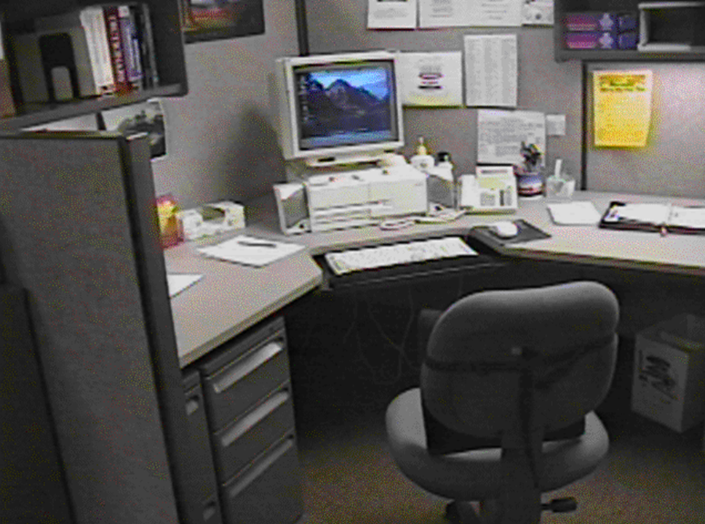

More than likely you discovered a number of things. One is that you already know a good deal about office ergonomics! Another is that you really can’t tell a whole lot until you see the workspace in use!

Where do we use computers?
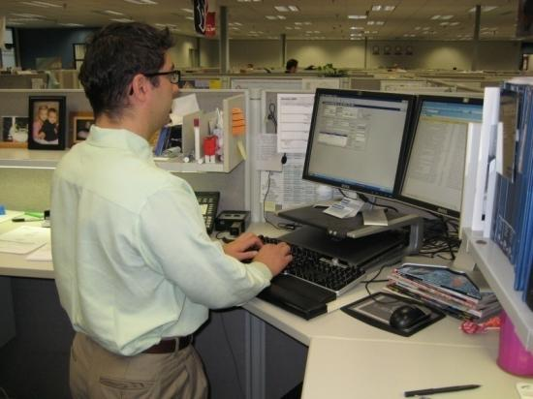
In many ways there seems to be a love-hate relationship with computers.
Think for a moment about how important computer use has become in our world. Computer use is an integral and pervasive part of our society.
Where do we use computers . . .
EVERYWHERE!
Let’s build an office!

Typical office components
From the ergonomics perspective, our next goal is to apply the ergonomics foundations and principles we have been discussing.
Earlier we alluded to the components that make up the typical office, let’s spend a minute and outline them in some detail.
They include:
- User population profile  - User – Single/Multi  - Tasks – Single/Multi  - Floor space  - Chair  - Worksurface | - Floor surface  - Computer  - Telephone  - Office equipment  - Storage | - Conference tables/chairs  - Light  - Noise  - Temperature

User population profile
An important step is to accurately define the user population. Specific points of information include:
- Age range  - Gender  - Stature  - Vision | - Physical fitness levels  - Hand dominance  - Work experience (level and scope) | - Training (technical and safety)  - Other
We may find we have a very homogenous group or one that is quite diverse. The user population may be one individual, or it could number in the thousands. In any case we need to define it.
For example, we need to understand the makeup of the user population including stature, reach and other anthropometric data along with any other special needs a particular individual may have. Inadequately defining the user population impedes the design of new workstations and the analysis of existing ones.
Defining the user profile lays the foundation for the remainder of the process.

User –Single/Multi
In terms of the workstation it is critical to be aware if a single person will primarily use the workstation or if two or more individuals will share it on a regular basis.
We also need to determine how often the changeover occurs.
We need to determine if the workstation is a single user or multi-user workstation.

Single user
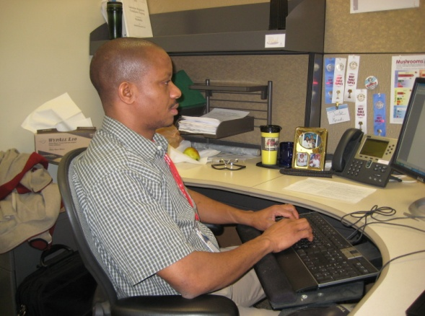
By definition the workstation is designated for use by one individual only. For the single-user workstation we are less influenced by the need for adjustability of the workstation itself. For example, once we determine the proper height of the worksurface it can be fixed at this height with little or no need for adjustability.
For instance, a fixed height or adjustable/fixed worksurface (i.e. worksurface can be height adjusted but once adjusted is not readily changed; e.g. wall panel mounted worksurfaces) makes for a viable workstation.

Multi user
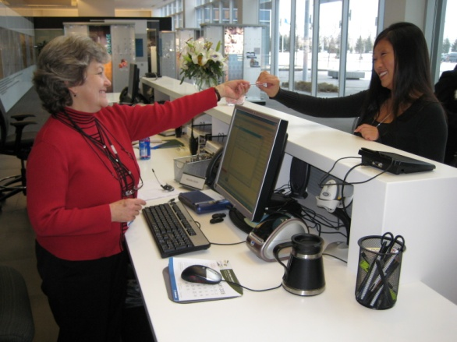
On the other hand, multi-user workstations (e.g. reception counters) by definition require a significantly greater degree of adjustability.
To make the workstation effective, it is critical that the changeover from one user to the next be accomplished quickly and easily. An adjustable/adjustable worksurface is desired. In this case, either through a spring balanced manual system or a powered system, the height of the worksurface can be readjusted within seconds.

Tasks: Single-task or Multitask
Specific tasks performed in the office workstation will help to determine the office workstation configuration and setup. Typically, we can categorize job demands as single task or multitask.

Single-task
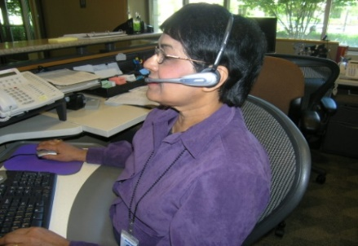
An office workstation designated as single-task is defined as one where the majority of the work time is spent accomplishing a specific, focused task. For example, a customer service representative may spend a majority of the day on the computer and telephone performing computer lookup activities. Physically the job demands are concentrated in a single area.
The efficient set up of the single-task workstation is critical because the user tends to maintain a sustained position to perform their activities. Other examples of single-task workstations are data entry and CADCAM.

Multi-task
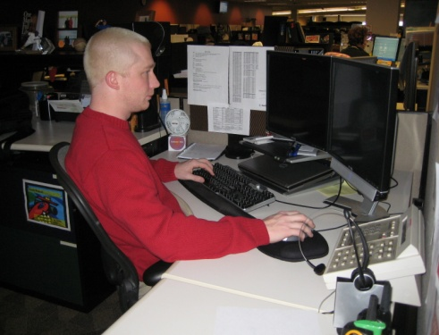
In the workstation designated as multi-task, a number of different tasks need to be accomplished. For example, the user may spend some of the day at the computer, on the telephone, at a writing workstation, attending meetings and so on. Physically, the job demands may be spread across several areas if the workspace is available to accomplish this.
However, in many situations the space is not available, and the user tries to multitask in a confined workstation. The efficient set up of the multi-task workstation either provides for separate workstations for separate tasks or makes it extremely easy for the user in the same workstation area to shift from one task to the next.
Other examples of multi-task workstations include supervisory positions, technicians, etc.

Specific task (percentage breakdown)
Part of our assessment will include identifying the percentage breakdown that specific tasks are performed to accomplish the overall job demands. We will ask the user to estimate the percentage based on an average week or month, recognizing that extreme variations can occur from day-to-day.
Activity | % | Note: the total may not necessarily equal 100%; it is possible to perform two or more activities at one time – computer and telephone use at the same time for example.
Computer
Telephone
Handwriting
Reading
Meetings
Miscellaneous

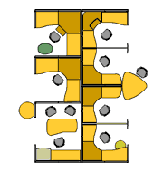
Floor space
In the ideal world, the dimensions of the office workstation are determined exclusively by the job tasks.
For example, in some very focused single-task workstations 48 square feet may be sufficient. In other cases, a multitask workstation may require 120 square feet or even more to effectively accomplish the job tasks.
However, as we all recognize we do not live in the ideal world. Floor space may be determined by a host of factors not relative to job task.
This does not negate the need to perform an effective job analysis to make recommendations but does cause us in many cases to be quite creative!

Office Ergonomics Workstation Evaluation Worksheet
Demographics |  | Work Activity | % | Reason
Evaluated by |  | Computer |  | New employee  New workstation  Medical issue  Equipment/furniture issue  Other (comment below)
Eval Date |  | Telephone
Last Name |  | Handwriting
First Name |  | 10 key
Job Title |  | Read-hard copy
Dept |  | Meetings
Location |  | Other
Stature (shoeless) |  | Work Activity Comments |  | Other Information
Heel height
Handedness | Right/Left/Ambidextrous
Job demands | Sedentary/Manual
Work hours | Full/Part time
User | Single/Multi
Vision | No correction//Reading/Distance/ Bi/trifocal/Computer/Contacts

Chair

Objectives of chair
- Support body and limbs to provide relief from weight bearing.
- Provide a stable base or platform for the body and limbs.
- Position the user at the correct height and reach relationship to the worksurface and tasks at hand.
- Allow for easy change in position/movement of the user.

Types of seating systems
A number of seating systems are available in the office workplace and include office chairs, stools, lean platforms and other miscellaneous seating.
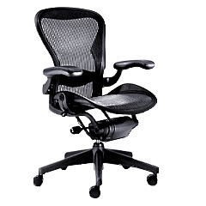 | 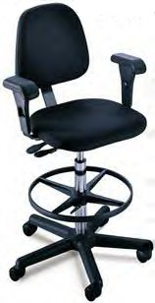 | 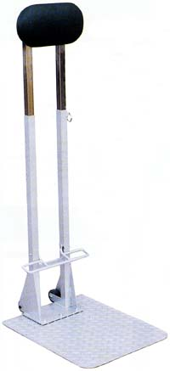
Without question the traditional office task chair is the most commonly used seating system in the office workstation.

Chair criteria
In the office environment, the type, use and efficiency of the chair are critical elements. The acceptable chair criteria are determined by the type of job activities performed, the size and shape of the user and the duration of time spent in the chair. These criteria are typically considered necessary for an adequate office task chair (Note: First we will discuss the chair’s feature and then will go through chair feature adjustment based on the user’s specific needs.):

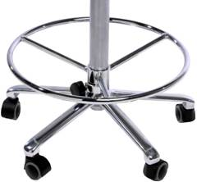
Legs
Minimum 5-point support system for the chair legs. This is specifically intended to reduce the likelihood of inadvertently tipping over the chair.

Casters
Appropriate casters for the floor surface – hard caster on a soft surface such as carpet, soft caster on a hard surface such as tile.

Seatpan
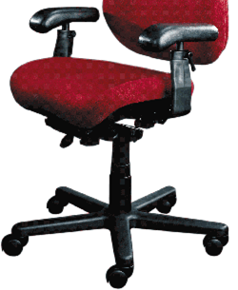
Height, tilt and tension adjustability needs to be suited for the individual user's body segment length and size.
- If the height of the seatpan is not fixed, the type of mechanism to raise or lower the seatpan could be spin up/down but in a modern chair will be a gas pneumatic cylinder.
- A seatpan slide is also a recommended feature. This allows for the apparent depth of the seatpan to be changed to fit the user.
- The seat pan height and angle establish the relationship between you, your work surface and the floor
- The seat pan tension allows you to adjust the seat so that you are stable in your chair. The seat pan tension provides a balance between adequate support and movement in the chair.

Back support
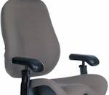
Adjustable back support height and angle needs to be suited for the individual user's body segment length and size.
- The back support angle and height influence the angle between your upper and lower body as well as your relationship to your work surface.
- The back support angle allows you to adjust the lumbar support built into the back support so that it can comfortably support your upper body weight.

Cushion
Suitable cushion - in terms of foam density, wearability and breathability, type of material (fabric or rubberized) - for the seatpan and back support should be in the chair. A number of chairs have introduced web or mesh fabrics in place of the traditional cushion.

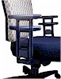
Armrests
Armrests may be used to support the weight of the arms and upper body. If used, the armrests need to be adjustable in height, lateral position and axial rotation. (Non-adjustable armrests on office task chairs are essentially non-functional.)
- he armrest adjustments allow you to position the armrests where they will provide adequate support for your arms and shoulders in neutral postures.

Adjustment levers/knobs/controls
Adjustment levers/knobs/controls for the chair should generally be within easy reach of the user when seated in the chair. The levers should be easy to manipulate and not be so complicated that they discourage use.

Cervical support
Additional modifications are possible for chairs. In some situations, the user may require cervical and head support in addition to mid and low back support.

Exercise ball chairs
Therapeutically, exercise balls have been used in clinical settings as treatment modalities to improve spinal stability. Over the past several years, the use of exercise balls in the workplace in place of or in addition to task chairs has taken place. At this point, primarily only anecdotal evidence exists to support the full-time use of them. Most ergonomists continue to advocate for properly sized and properly adjusted office task chairs rather than the use of ball chairs.

Micro-breaks
Recalling that frequent and regular body movement is one of the ergonomics principles the 30/30 Rule of Physical Movement (physically active micro-breaks 30 seconds in length taken about every 30 minutes) is supported by research to reduce tissue compression and joint stiffness, enhance circulation and overall improve comfort levels.

Art of sitting
The body is not designed to sit - particularly for long periods of time. Studies have determined that even when seated in well-supported postures, individuals want to move to gain relief within a few minutes. Let’s cover the art of sitting.

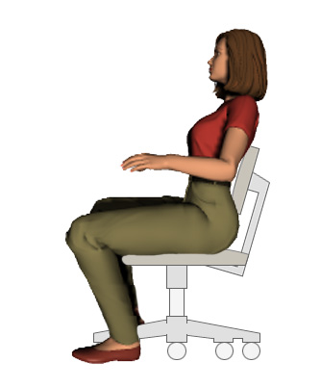
Three point contact

Trunk

Thighs/buttocks

Feet

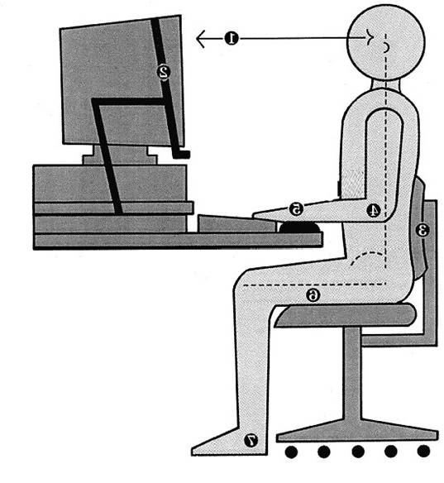
90/90 seated posture?
You probably have seen illustrations of an office workstation where the person is seated at the chair with their hips and knees at 90 degrees.
In all practicality very few people actually sit this way.
A much more commonly accepted seated posture is 105 to 110 degrees at the hips and knees. Let’s take a look at how people sit.

Sitting styles
Sitting styles can be quite varied from person to person. Let’s look at some potentially problematic sitting styles:
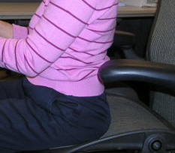 | 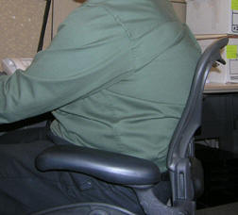
Percher | Sloucher

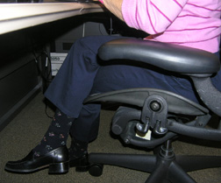 | 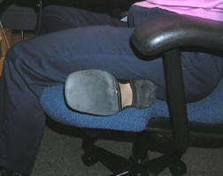
Sit crossed leg | Sit on leg
The particular sitting style observed needs to be assessed to determine why it is being used. It may be a habit that has been developed over time; it may be in response to a poor workstation setup or a combination of both.
What drives the problem is the frequency and duration of the seated position. If the individual only occasionally sits in an undesirable position it may not be a concern; however, if that is their habitual manner of sitting it could lead to problems.

Functional seated positions
A general guideline in the art of sitting is to provide for different acceptable seated postures that a person can rotate throughout the day on a regular basis.
They can include:
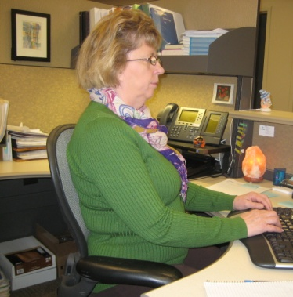 | 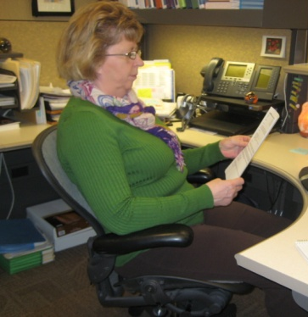 | 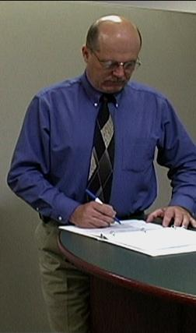
Upright Keyboard Position | Semi-reclined Conversation Position | Standing*
(* We recognize this is not a seated posture, but it makes the point that an individual needs to get out of the chair and either stand or walk around the workplace on a regular basis.)

Adjustment Anxiety
Chairs can be pretty expensive. They can have all kinds of bells and whistles. So, let’s see what this baby will do! It seems that the answer is nothing until we do something to the chair.
Sometimes we overemphasize what a chair can do, and forget to emphasize what it is we need to do to make it work. The truth is that a chair is only as good as what we choose to do with it.
Some people have never adjusted their chair? They just sit down and go to work.
The bottom line is people need to be able to adjust their chair to fit them as well as throughout the day to provide the body with a break.

Chair solutions

Manual
Look for the chair manual for specific information about the chair or to talk to someone who handles chairs in the work area.
Better yet, just start playing with the adjustments. Most people learn best by the “hands-on” approach anyway.

Position and support body in neutral
Here is a series of steps along with tips and techniques when adjusting chairs:
- Adjust the seat pan/back support tension to hold body in a solid neutral position.
- Adjust the pan seat height to get feet on the floor with even pressure on hips and thighs.
- If feet do not touch the floor adjust the seat pan height to get feet on the floor with even pressure on hips and thighs – if still not possible to get the seatpan low enough a footrest will be needed. Another option is replace the chair with one that will go low enough.
- Adjust the height and angle of the back support to fill in the low back curve.
- Add a back cushion to provide better support for spine – although many times this means the chair does not fit right and a replacement chair may need to be considered.
- If needed, add a seat cushion to elevate the user to a more appropriate height – although many times this means the chair does not fit right and a replacement chair may need to be considered.
- If the back of knees run into the front of the chair see if a back cushion to move the body forward on the chair and still have adequate back support, will work. Firmly fix the cushion to the chair, one way to do this is with Velcro tape. Although many times this means the chair does not fit right and a replacement chair may need to be considered.
- For the case where hips and thighs don’t fit on the seat - the seat pan is too short or too narrow; see if you can find a chair that better fits.
- If the armrests are adjustable, see if they can be adjusted to provide neutral support for. the arms based on particular job tasks.
- Build up the armrests by putting pads on them if more height is needed.
If you identify maintenance problems with the chair make sure you contact the appropriate people in your organization to get them taken care of.
Remember, no matter how perfectly you can adjust your chair to fit you; it still comes down to the fact that you need to move on a regular basis to keep your body healthy and safe.

Chair |  | Issue | Comment | Recommendation
Chair ID |  | No  Yes | Chair fit/adjustment OK  Chair not properly adjusted  Back support not OK  Armrests not OK  Chair too small  Chair too large  Maintenance issue (comment)  Other (comment) | None  Chair adjusted with instructions provided  Replace chair - refer to Recommended Specifications  Repair chair (comment)  Other (comment)
Legs | 4 / 5 / 6
Casters | Carpet/Hard surface
Seatpan | Ht/Tilt/Tension/Slide
Back | Ht/Angle
Armrest | Ht/Side/Rotate
Fit | OK No/Yes
Maint Issue | No/Yes

Worksurface

Worksurface objectives
The objectives of the worksurface include:
- Provide functional workspace (depth, width)
- Support and position equipment
- Provide access to work materials
- Achieve the desired relationship match between user/work

Types of workstation layouts
Three types of workstation layouts are typically recognized.
Straight line (desk/table)  The straight in-line configuration is suited for single task activities with minimal reach requirements for other office equipment and materials. | 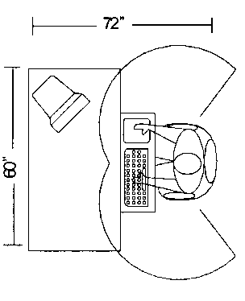
L-shape (two work surfaces)  The L-shaped configuration is suited for single to multitask activities that require two or more separate workspaces. For example, one workspace may be used as the computer workstation and another as a writing or collating workstation. | 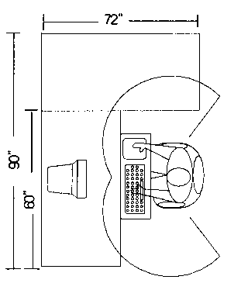
Corner/Cockpit (middle with two side pieces)  The corner/cockpit configuration is well suited for multitask activities in the same workspace with significant requirements to frequently reach other office equipment and materials. | 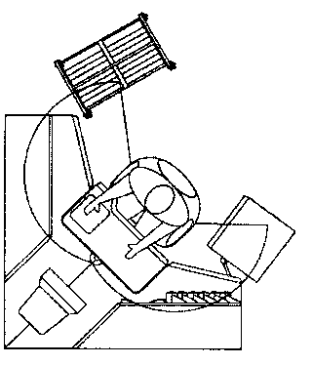

Worksurface adjustability (height and angle)
Height and angle adjustability of the worksurface can be a critical component. In general terms, three different types of worksurface adjustability are recognized:
Fixed  We admit fixed means nonadjustable, but we need to include it in our discussion. An example is the traditional desk at a fixed worksurface height of 29 inches. There are literally millions of these types of worksurface in workstations. In this case fixed means that they are not designed to be changed in height or angle.  We should note that it is generally possible to raise a fixed height worksurface on supports but also generally very difficult to lower it. (Although we have been known to actually cut off legs off traditional desks!) | 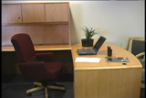
Fixed/adjustable  An example of a fixed/adjustable worksurface is a wall panel mounted system where the worksurface is hanging on the wall panel or a worksurface on legs where the height can be adjusted by loosening screws and sliding sleeves up or down in the legs.  These worksurfaces are termed fixed/adjustable because they can be adjusted within a given range but once adjusted, they are fixed in that position and not readily moved. | 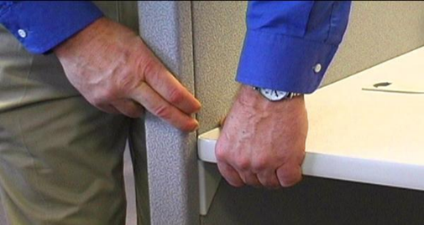
Adjustable/adjustable  Adjustable/adjustable indicates that the user – as needed throughout the day - can readily and easily adjust the worksurface.  Examples of these worksurfaces are sit/stand workstations that are controlled by mechanical springs or powered mechanisms. | 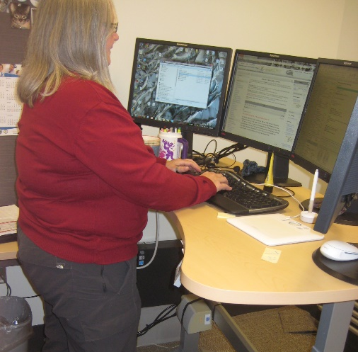

Other Considerations
Other considerations for the worksurface include:
- Eliminate a sharp edge by specifying a rounded or radius edge of the worksurface
- Reduce glare by providing a non-glare surface of the worksurface
- Enhance durability through proper construction and use of materials.

Worksurface solutions

Wrong desk height
Here are some possible solutions if the issue is the wrong desk height in relation to the position at desk:
- If work height is adjustable, adjust it. For example, modular work surfaces that can be adjusted on the wall panels or a stand-alone desk that can be adjusted.
- A simple option is to raise the height of the work surface by putting it up on a couple of blocks. (Just make sure that the desk or work surface is solidly placed on the blocks and won’t fall off.) It may be advisable to get maintenance or someone else to help do it safely.
- An option is to adjust chair height. Once again, make sure the feet are supported either on the floor or with a footrest.
- Add a height adjustable keyboard tray mounted underneath the work surface.

Not enough layout space
Occasionally, or possibly quite frequently, there is not enough space on the worksurface to lay out materials.
Now, one option is to get a bigger desk, and a bigger office.
Assuming that this is probably not a realistic option, we may need to be a bit more creative.
- Try a little house cleaning and see if this frees up more available space on the desk.
- Look around to see if there are other worksurfaces available for use, for example a file cabinet at a standing height to review documents or perform other work. If there is available space, see if any more worksurface can be added to the workstation. This can be a small worktable.
- If it doesn’t need to be readily available, relocate some of the equipment on the desk to see if it provides more space.
- Make use of any pullout drawers already in the desk.
- A computer monitor stand can be added to provide more clearance on the desk.

Sit/Stand Workstations
Sit/stand workstations are becoming more and more prevalent in offices these days. Office jobs are very sedentary in nature with resulting negative impact on general health and wellness.
Several options exist for creating sit/stand workstation that range all the way from makeshift ones created by putting boxes on the desk to full-fledged powered sit/stand workstations and other options in between.
The same setup principles for office ergonomics in general remain in effect: neutral body position and support, reach zones, control exposure to sustained positions by promoting movement throughout the day, etc.
Here are some ways to create a viable sit/stand workstation.
Fixed worksurface at standing height  The correct height of the worksurface when the user is standing at it is determined.  A stool and footrest are provided to allow for an elevated seated position. |  | 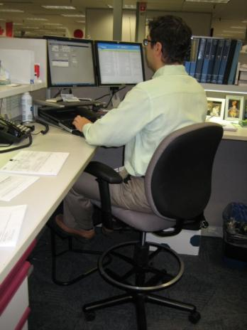

Portable system placed on desk
Portable desktop systems are now available to be placed on the worksurface. The system can be height adjusted to alternate between a seated and standing position.
Sit/Stand workstation  The entire workstation is height adjustable allowing for seated and standing height work positions. | 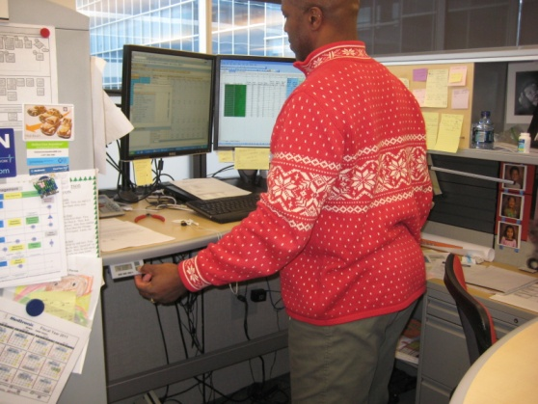 | 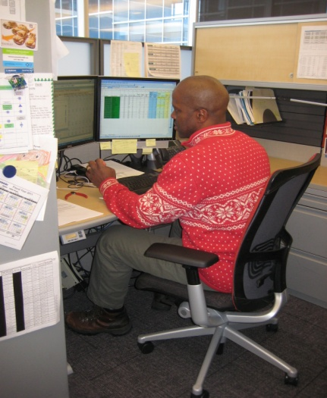

Tips for Sit/Stand Worksurfaces
Here are some tips to obtain the most benefits from sit-stand workstation.
- Employ the adjustment strategies to make sure seated and standing worksurface heights are correct.
- Utilize footwear that has significant cushioning and support. If they are good walking shoes, they also will be good standing shoes.
- Use a footrest that will allows one foot up on the rest and then alternate with the other foot. This promotes varied standing postures and intermittently redistributes weight-bearing stresses.
- Shift weight forward to the balls of the feet and backwards to the heels when standing on both feet or alternately when standing with one foot in front of the other.
- Perform “heel lifts” frequently. This will improve lower extremity circulation.
Remember to provide a break-in period if new to sit/stand workstations. Start with a specific schedule for the first week; for example, 10-15-minutes of standing followed by a 30-second walk, then 45-minutes seated work followed by a 30-second walk and repeat.
And then modify the time periods based on the response. Remember the mantra . . . “Don’t wait until it’s too late!”
Move on a regular basis.

Worksurface |  | Issue | Comment | Recommendation
Config | Straight/Corner/  L-shape/U-shape | No  Yes | Worksurface is appropriate  Worksurface is too low  Worksurface is too high  Worksurface does not have enough work area.  Other (comment) | None.  Lower worksurface - see Recommended Specifications  Raise worksurface - See Recommended Specifications.  Reorganize to provide additional worksurface area.  Other (comment)
Type | Fixed/Adjust
Height | Sit/Stand: ( “)

Foot support/clearance

Foot support
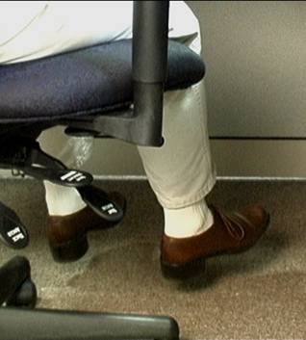
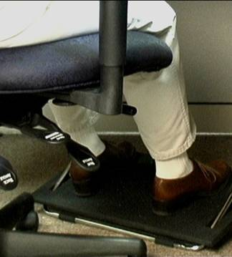
In the ideal world the best foot support when seated in the chair is the floor. However, based on work at a fixed height worksurface where the chair needs to be adjusted upwardly or work at a standing height workbench where a stool is used, a foot support will be needed.

Clearance
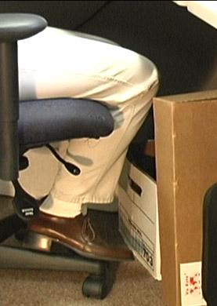
A real common issue is not enough access or clearance under the worksurface. For example, file drawers that are in the way or boxes piled under the desk.
Survey the work area and determine what is blocking access. For example, it may be a pencil drawer that needs to be removed to make that space accessible for the legs.
Determine what is really needed in the immediate work area. Move what is not needed to some other storage position or get rid of it.
Use vertical files or other stands to get materials off the worksurface. Use secondary shelf or other platform on the worksurface to free up primary worksurface.

Foot support/clearance |  | Issue |  | Comment | Recommendation
Feet | Dangling/Supported/ Clearance | No  Yes | Foot support is appropriate  Feet dangling – not supported  Inadequate foot/knee clearance  Other (comment) |  | None.  Add footrest  Lower worksurface - see Recommended Specifications  Raise worksurface - See Recommended Specifications.  Remove foot/knee obstruction (comment).  Other (comment)
Footrest | No/Yes

Sharp edges
It is a problem if sharp edges in contact with the wrists and forearms.
Make sure that you are at the proper work height in relation to the worksurface edge. Simply getting at the proper work height may change the contact point of your desk and distribute the pressure more evenly.
Another option is to pad the sharp edge. This may be as home grown as a small washcloth or dishtowel folded up or a commercially available edge added to the worksurface edge itself.

Work organization
Organize work in a way that allows work goals to be achieved as efficiently as possible. This takes into account all aspects that make up the workspace including your chair, desk, computer, telephone and other materials used through the day. This also includes the organization and structure of tasks and activities performed throughout the workday.

Work organization solutions
Unorganized desk, huh? Well, the simple solution for the problem of an unorganized desk is pretty clear. Organize it! Ha, if it were that simple our desks and our lives would be much more organized. Keeping this in mind, here are some tips that might help. Space in most companies is a premium but try to store infrequently used items outside of the immediate work environment. You may need to be a bit creative!
Things can get cluttered even in the electronic world. Purge unneeded items. How many files do you have in your computer that you never or rarely use, but that make it hard to find the files you need to access frequently? Back up these files and get them out of your hair.
You might try something that we try to get our kids to do, and that is to clean up their rooms at the end of each day. You know how stressed out you can get when you open the door and see total chaos…and we don’t even have to work there. This same emotion can greet you in the morning if you walk in to your work area and the first thing you have to deal with is clutter.

Floor surface
The floor surface of the workstation is important to consider in terms of providing ease of rolling the chair on the floor surface, a nonskid surface to prevent slips and follows and a non-glare surface to reduce overall glare in the workstation.

Computer equipment
The next step is to properly position the computer equipment (keyboard, pointing device, monitor, CPU, hard copy holder, etc.) To put this into perspective, let’s take a brief look at the differences between modern keyboards and old-style typewriters. In the “olden days” you had to actually insert paper, hit the shift bar and physically stop what you were doing to correct mistakes. Not only that, but you also couldn’t go too fast or the keys would stick together. In essence, the task had built in breaks that kept it from becoming too much of a problem.
Now it is possible with a modern keyboard to come in at 7 in the morning, start keying as fast as you can, never take a break, and keep this up until 5 o’clock without a break. Because we have lost a lot of the natural breaks and position changes that were associated with the old style typewriter, we have to actively make good choices during our day.
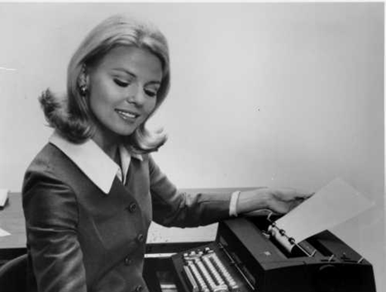 | 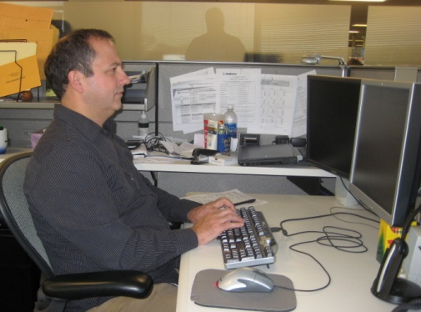

Keyboards

Keyboard types
Keyboards come in a variety of configurations. While intuition may indicate that keyboard configuration influences hand/arm position and consequently physical stressors, studies have indicated that proper position of the keyboard in relation to the user (height and reach) has been shown to be more important than the configuration. Personal preference and specific issues also can drive the type of keyboard used.
Straight line | 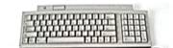
Curved | 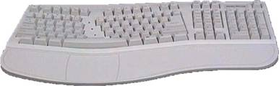
Articulated | 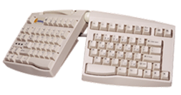

Keyboard solutions

Neutral positioning
If your keyboard position does not allow neutral hand/arm/shoulder/ neck and upper back positioning, remember your goal is to work in as neutral a position as feasible. Identify your particular keyboarding style or technique. This may be the:

Free float piano playing style
Use of the worksurface for forearm support | 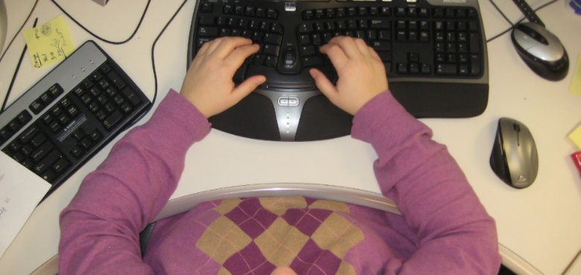
Now, based on your technique, you need to obtain correct height, reach and angle of the keyboard so that you are able to work in neutral.
If you can, adjust the keyboard height and position, either by adjusting the worksurface height itself or through the use of a keyboard tray. If you cannot adjust your keyboard height, you will need to position your chair height to place your hands in neutral posture in relation to the keyboard. This may require support for your feet if they no longer touch the floor.
NOTE: A wrist rest can be a good addition to a keyboard. Remember that it is called a wrist ‘rest’ not wrist ‘anchor’. In other words, it should provide some weight-bearing supports for your arms, as you need rest. You should NOT anchor your wrists to the rest and then move your hands and fingers side to side out of a neutral wrist position.

Poor Technique
If you have really bad technique, you may want to consider investing in one of the computer training programs that teach improved technique.

Take a break
One of the biggest problems with the modern computer is that it does not cue you to take a break. There are a number of human movements, such as reaching your arms over your head, arching your back or rotating your neck, that are normal human movements, but are not a normal part of your day. The computer workstation is notorious for discouraging much movement. For that reason, people need to recognize the need for adding stretching to your day.
Create some type of system to key you or remind you to stop and stretch. Or change positions. Or work on a different activity that does not involve use of the keyboard. This could be:
- A little post it note put on your computer monitor
- Software is also available to load on your system or network that reminds you to stretch
- Team up with someone else in the office to remind each other to stretch and change positions.
- Take advantage of natural breaks between activities. And if it makes sense, create breaks at regular intervals to give your body a chance to move and stretch.

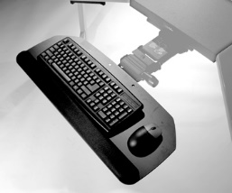
Keyboard Trays
- Keyboard tray configurations
- Keyboard tray size
- Height adjustment
- Angle adjustment
- Knee clearance
Keyboard Tray |  | Issue | Comment | Recommendation
Tray | No/Yes | No  Yes | Keyboard tray appropriate  Keyboard tray limits reach access to worksurface  Keyboard tray type does not allow neutral arm/hand position  Keyboard tray location does not allow neutral hand/arm position  Other (comment) | None  Adjusted keyboard tray position and provided user instruction  Remove tray - place keyboard directly on worksurface  Other (comment)
Ht adjust | No/Yes
Angle adjust | No/Yes
Size fits | Keyboard only  Keyboard-mouse

Keyboard |  | Issue | Comment | Recommendation
Type | Straight/Curved/ Articulated/Other | No  Yes | Keyboard type and location appropriate  Keyboard type does not allow neutral arm/hand position  Keyboard location does not allow neutral hand/arm position  No wrist rest in use for support  Other (comment) | None  Adjusted keyboard position and provided user instruction  Replace keyboard - see comments  Add gel keyboard wrist rest  Other (comment)
Shortcuts | Used: No/Yes
Maint | No/Yes

Mouse
No . . . not that kind of mouse!
The type of mouse we are talking about is one of a number of different types of pointing devices used to navigate through software programs.
In all practicality the best way to use a mouse is to use it as little as possible. In other words, make full use of keyboard shortcuts as possible for navigation purposes. (Dual control – mouse and/or keyboard – are often incorporated as part of the software.)
Slide 82
Emphasis on use of the keyboard limits the amount of time spent reaching to the mouse and also has a positive impact on productivity.

Pointing device technique

Neutral positions
The pointing device should be positioned so it is in the same plane as the keyboard. Here are some simple solutions to make it easier to work with your mouse. If your mouse position does not allow neutral hand/arm/shoulder/neck and upper back positioning, remember your goal is to work in as neutral a position as feasible. Identify your particular mousing style or technique. This may one of the following.
- Free float piano playing style
- Use of the worksurface for forearm support
Based on your technique, adjust your position to get the correct height, reach and angle of the mouse so that you are able to work in neutral. If you can, adjust mouse height and position (either by adjusting the worksurface height itself or through the use of a mouse tray)

Pointing device solutions
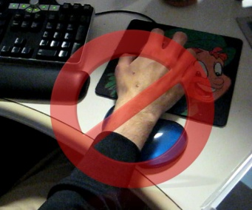
Based on proper chair position, position the mouse so that shoulder/hands/wrists are in neutral. If you cannot adjust mouse height and position, position the chair height to place your hands at the proper height and position in relation to the mouse. This may require support for your feet if they no longer touch the floor.

Mouse wrist rests
While wrist rests for keyboard use (if used correctly) are often a good idea in most case use of wrist rest for mouse use is not. The wrist rest tends to “anchor” the wrist with excessive deviation of the hand side-to-side.
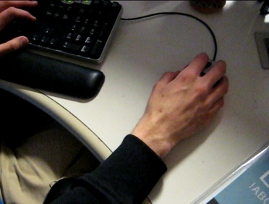
Generally recommended use of the mouse is to allow straight in access allowing the forearm, wrist and hand moving as unit to manipulate the mouse. Think of the mouse as an extension of the arm NOT just an extension of the wrist.

Variety of pointing devices
There is no doubt that the traditional mouse is by far the most commonly used pointing device. When properly positioned and setup it works well. However, there are a wide variety of pointing devices available with different shapes and styles that include touchpads, rollerballs, joysticks, pens and so on. Multiple buttons can be programmed to minimize keying. There are some even specifically designed for lefties. Workers should try different models and choose one that suits their needs.
The type of pointing device that works the best is based on the setup of the workstation, the job task and the personal preference of the user. With many mouse designs available here are general suggestions for selection:
Size - The mouse should fit into the hand and the fingers should be able to curl around it comfortably.
Shape - Find a mouse that reduces the need to place the heel of your hand on the desk. Some mice are larger, especially at the rear, and can support your entire hand.
Buttons - The location of the buttons is important. They should not be cramped nor too spread out. The pressure needed to click the buttons should not be so great that it tires the fingers but neither should it be so sensitive that it is too easy to activate the buttons
Scroll wheel – allows for easy scrolling within a document.
Don't squeeze the mouse. Hold it loosely in your hand and relax your grip. A tight grip will not help to position the pointer any more accurately or quickly.
Program your mouse to manipulate the speed at which the cursor moves or the sensitivity of the buttons.
Wireless - a number of pointing devices are wireless, which increases the flexibility of where it can be positioned.
A button that is too sensitive can force you to keep your fingers slightly elevated off the buttons and for some people this can lead to eventual fatigue and discomfort in the muscles and tendons of the forearm.
If your mouse is sticking, you may need to clean it. Your owner’s manual will instruct you how to do this without causing any damage to the mouse.

Mouse Pros and Cons
Pros and cons for each type of pointing device are outlined in the table below.
Pointing Device | Pros | Cons
Shell mouse  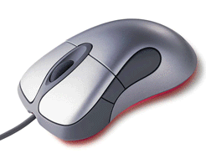 | Relatively easy to learn how to use.  Installed base is huge with most computer users first exposed to traditional mouse.  Inexpensive. | Promotes “skating” of the mouse with subsequent out of neutral hand/wrist/arm/shoulder positions.  Hand size is important to consider matching the correct size shell with hand size.  Often poorly positioned in relation to user and keyboard.
Roller ball/Track ball  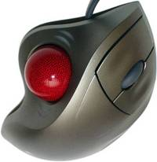 | Can provide a stable platform for the hand that eliminates ‘skating’ of the traditional mouse.  May be very effective in controlling wrist and elbow problems.  Available in a variety of configurations with ball controlled by either the thumb or fingers or in some cases either. | Acceptance curve is quite steep. Minimum of one week trial basis to determine benefit is recommended.  Some users never accept it.  Hand size is important to consider matching the correct size shell with hand size.  Typically, more expensive than a traditional mouse.
Touch pad  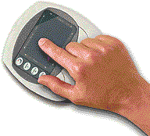 | Provides an alternative to the traditional and roller ball styles. | Learning curve may be quite steep for some users.  Typically, more expensive than a traditional mouse.
Pen/Tablet  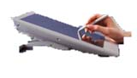 | Often used by graphics designers who require the ability to ‘draw’ on the tablet. | Can be cumbersome for some users.  Typically, more expensive than a traditional mouse.
Joystick  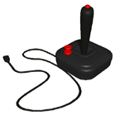 | Designed to place the hand in neutral position during use. | Limited acceptance to date.  If frequent reach to the keyboard is part of the job task may result in excessive hand/arm movement.
Vertical  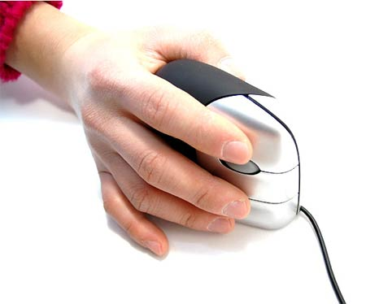 | Designed to place the hand in neutral position during use. | If frequent reach to the keyboard is part of the job task may result in excessive hand/arm movement.

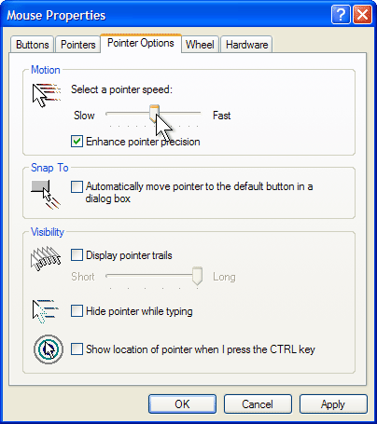
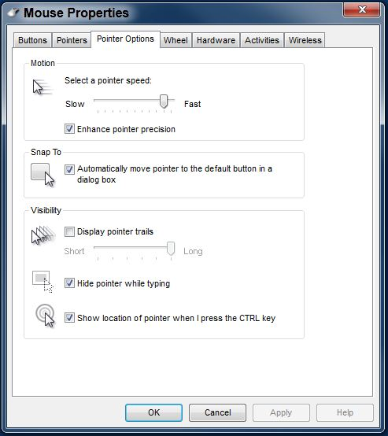
Mouse set-up
Slide 96
- Buttons
- Pointers
- Pointer Options
- Wheel
- Hardware

Mouse |  | Issue | Comment | Recommendation
Type | Shell/Rollerball/ Vertical/ Joystick/ Touchpad/Other | No  Yes | Mouse type and location appropriate  Mouse type does not allow neutral arm/hand position  Mouse location does not allow neutral hand/arm position  Mouse wrist rest in the way  Other (comment) | None  Adjusted mouse position and provided user instruction  Replace mouse - see comments  Remove mouse wrist rest  Other (comment)
Location | Work surface/Tray
Scroll | No/Yes
Maint | No/Yes
Slide 97

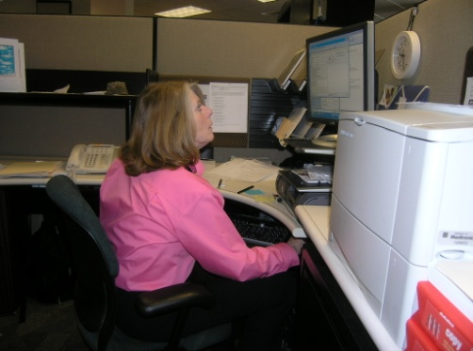
Computer (CPU, computer case, hard drive)
Many people tend to put the computer underneath the monitor. In some cases, this may be appropriate but in a lot of cases, it’s not – it may position the monitor at too high a level. When you decide where to position your computer think about your particular needs.
Do you need to keep the computer close in terms of the on-off switch and access to the disk drives on the computer? In that case you may want to position the computer on your worksurface or maybe on the floor on a computer stand with easy reach. On the other hand, if it really doesn’t make much difference then position it so it is out of your way.
Remember that the computer does generate heat and has vents on the case. Make sure you don’t block ventilation around the computer – this could result in overheating problems.

Computer |  | Issue | Comment | Recommendation
Type | Desktop/Laptop | No  Yes | Computer type and location are appropriate  Computer in the way  Other (comment) | None  Reposition computer out of way  Other (comment)
Location | Work surface/Floor

Monitor
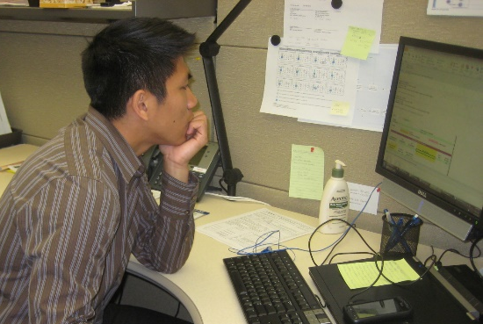
Things have changed dramatically from the days when we used to spend our day reading/writing reports on paper. Now, for most of us, everything we need access to can be viewed through the monitor on our desks. While this has made our lives a bit easier, the demands of looking at a monitor all day long can create some problems if not used appropriately.
Ever watch people when they are sitting looking at their monitors. It’s almost like the monitor is a vacuum cleaner. They turn it on and it sucks their head right in!

Monitor solutions

Alignment
When you think about the alignment of your monitor in relation to your body position, the first thing to recognize is the importance of directly facing your primary work task.
If you are doing primarily data creation or manipulation, it makes sense to have your monitor directly in front of you.
If, on the other hand you are doing primarily data entry and your main focus is on paper documents, you would want your monitor slightly off to the side and utilize a copy stand to place your paper documents directly in front of you.

Glare
Ways to control glare are to position the monitor so that a light source is not behind you or at an angle that can be reflected by the monitor.
Ideally the light should be overhead, or perpendicular to the monitor. If an overhead light is a bit behind you and can be seen in the monitor, you may want to place a glare hood on top of your monitor to shield it from the light.
A glare screen added to the monitor will also control glare. In this case you truly get what you pay for. An inexpensive glare screen is generally just wire mesh; it will cut the glare but also will make it harder to read the text on the screen. Look for a good quality optical glass glare screen. (Also, privacy screens are available that limit viewing of the screen from the side as well as control glare.)
You don’t want to have a light source such as window directly behind the monitor. Your eyes try to adjust to the level of light coming in, and your eyes have trouble adjusting to the light coming in from outside and the light generated from your monitor. If you can’t place the monitor perpendicular to the light source, close the shades when working on the computer.
Adjust the monitor screen brightness and contrast based on your perception of the overall quantity and quality of light in the workstation and the need to see what’s on your monitor clearly and comfortably

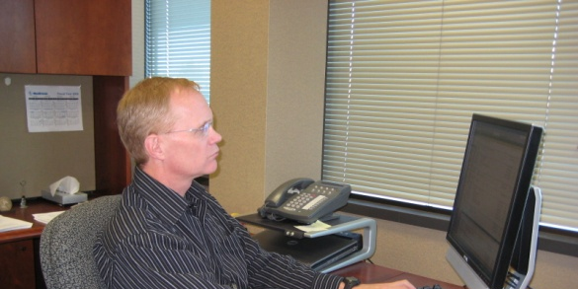
Height
A general guideline for the height of the monitor screen is to position it so that it is at eye level or slightly lower.
Trying to look at a screen higher than eye-level is uncomfortable because it forces you to open your eyes wider than usual causing discomfort as well as a tendency for your eyes to become drier.
Also, with a monitor that’s too high, your tendency will be to tip your head back putting an additional strain into your neck and shoulders.
Remember that it’s all about relationships. Make sure you have set your chair at the correct height and that you are in your typical seated posture as a guide to position the height of your monitor screen.

Lower monitor
Most monitor are on adjustable height stands or arms that can be adjusted. If not on an arm if the monitor is too high, you may try either tipping the monitor forward a bit which in effect lowers the viewing area, or raise your chair slightly (as long as this doesn’t affect your ability to have adequate foot support.).
Remember, as a final option you may need to consider actually lowering the surface that the monitor is on. This is particularly true as monitors of larger size are more commonly in use. Recall this will influence the relationships you have established between yourself and your workstation. For example, you may need to re-examine your chair height keyboard location and so on.

Raise monitor
There are a number of methods for raising your monitor including monitor stands.
There are a variety of types including those that come in 1” increments, stands that have a space to put your keyboard when not in use, and monitor arms that actually suspend your monitor above your desk and allow you to place it in an infinite number of positions.
A simple and effective solution for raising your monitor, is to place it on an old phone book or other material that places it at the desired height

Distance
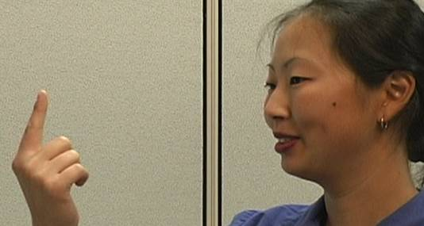
Here’s a general guideline for monitor screen distance: get the screen as far away from you as you can and still be able to read it clearly with good posture. Either move the monitor closer or increase the character size.
To demonstrate this, focus on a finger at arm’s reach, slowly bring your finger toward your nose maintaining focus and notice the increase in stress in eyestrain the closer your finger gets to your eyes. The same thing will be true the closer your monitor gets to your eyes.

Adjustments
Bringing your monitor closer is generally as simple as sliding the screen towards your body. Moving it farther is generally a bit more complicated if simply sliding it farther away isn’t an option.
First, figure out why you can’t get your monitor farther away. It may be that you can reorganize what’s on your worksurface and get the monitor farther away.
If it’s not possible to reorganize your worksurface, consider reconfiguring how you place your monitor on the desk. For example, you might be able to place the monitor more in a corner of the worksurface to gain greater distance.
Another option you may have is to add a keyboard tray to the existing worksurface; this will let you to sit more comfortably at a greater distance from the monitor. Remember also that a keyboard tray will push you farther away from the rest of your worksurface and may put some items out of a comfortable reach.
If you have a freestanding desk that is backed up to a wall, another option is to actually pull the desk a few inches away from the wall and slightly overhang the base of the monitor off the worksurface. If you do this, make very sure that the monitor will not fall off the worksurface.
At a minimum, when you’re not doing a great deal of keyboard data entry but are primarily reviewing documents on your monitor, simply push your chair farther back from your worksurface to give your eyes a bit of a break

Clean screens
Dirty monitor screens are a lot like dirty eyeglasses, it isn’t until you clean them that you realize they needed to be cleaned.
On a regular basis get into the habit of cleaning your monitor screen. There are a variety of sprays/cloths that are commercially available that are made specifically to safely clean the monitor screen.

Dual Monitors
More and more use of dual monitors is coming into play. The second monitor provides for open programs to be viewed concurrently and comparison between two documents is much easier.
Typically, the monitors are positioned as Primary/Primary or Primary/Secondary setups. Also maintain a consistent viewing distance to the monitors by positioning the monitors in an array fashion as opposed to a straight-line manner.

Primary/Primary
In a Primary/Primary setup both monitors are viewed about 50% of the time each. The monitors should be positioned so they are centered on the user.
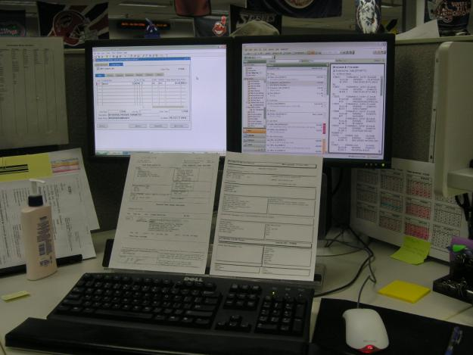 | 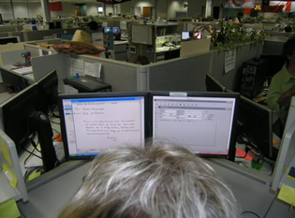

Primary/Secondary
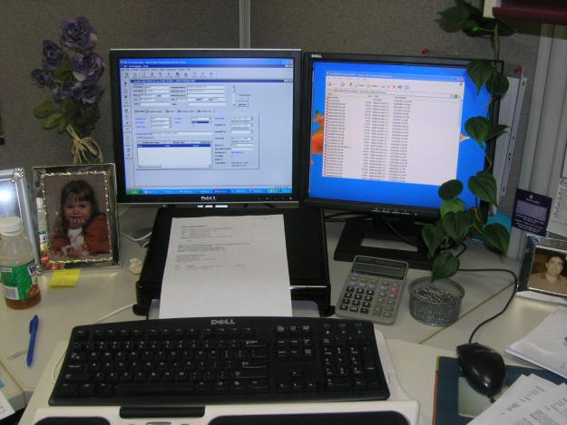 | 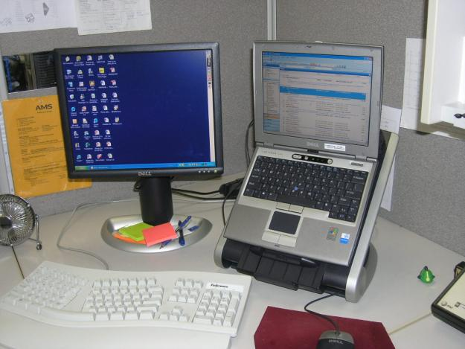
In the Primary/Secondary setup one monitor is viewed most of the time with the second monitor viewed only occasionally.
The primary monitor should be positioned directly in front of user and the secondary monitor positioned off to the side directly next to the primary monitor.

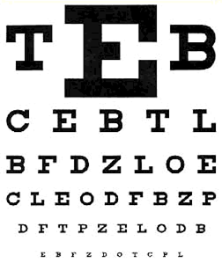
Eye Examinations
If you do a lot of computer work, you want to make sure you have periodic eye examinations. When you do so make sure you tell the examiner the amount and type of computer work you do. You may even think about taking a measurement of the distance from your eyes to the screen and take that into the person performing the examination. This will allow them to have information needed to provide a proper prescription for computer glasses.)

Presbyopia
During middle age, usually beginning in the 40s, people experience blurred vision at near points, such as when reading, sewing, or working at the computer. There's no getting around it — this happens to everyone at some point in their life, even if they never had a vision problem before.
When people develop presbyopia, they find they need to hold books, magazines, newspapers, menus and other reading materials at arm's length in order to focus properly. When they perform near work, they may have headaches or eyestrain, or feel fatigued.
Presbyopia is caused by an age-related process, rather than the way light is refracted, or bent, by the eye. Presbyopia is caused by a slow loss of flexibility within the lens inside the eye.
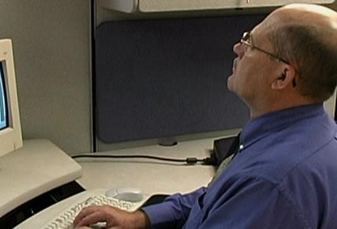
Glasses with bifocal or progressive addition lenses (PALs) are the most common correction for presbyopia. Bifocal means two points of focus: the main part of the spectacle lens contains a prescription for nearsightedness or farsightedness, while the lower portion of the lens holds the stronger near prescription for close work. Progressive addition lenses are similar to bifocal lenses, but they offer a more gradual visual transition between the two prescriptions.
Always be aware that bifocals may result in awkward head and neck position when viewing a computer screen. Options are to reposition the monitor to a lower level, trifocals where the middle of the lens is set for monitor viewing and separate computer glasses used only when at the computer.
Reading glasses are another choice. They may be worn just while doing close work, and may even be prescribed to wear over top of contact lenses (usually worn for distance correction). These glasses may be purchased over-the-counter at a retail store, or higher-quality versions may be prescribed by your eye care practitioner.
There are contact lenses for presbyopes, called multifocal lenses. Multifocal contact lenses in gas permeable or soft lens materials are available.
Another type of contact lens correction for presbyopia is monovision, in which one eye wears a distance prescription, and the other wears a prescription for near vision. The brain learns to favor one eye or the other for different tasks. But while some people are delighted with this solution, others complain of dizziness or nausea, or miss the depth perception they once had.
Monitor |  | Issue | Comment | Recommendation
Type | CRT/LCD | No  Yes | Monitor type and location appropriate  Monitor too low  Monitor too high  Monitor too close  Monitor too far away  Monitor resolution not appropriate.  Other (comment) | None  Adjusted monitor position and provided user instruction  Adjusted monitor resolution and provided user instruction  Add monitor riser (comment)  Other (comment)
Number | Single/Dual/More
Adjustable Stand | No/Yes
Resolution | OK No/Yes
Position | OK No/Yes

Document holder
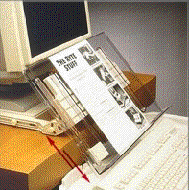
If material is read from hard copy, the hard copy should be placed on a document or hard copy holder. This can be placed either directly in front of the user between the monitor and keyboard if enough room is available or can be placed on a hard copy stand placed adjacent to the monitor.
It is not essential that the document be the exact same distance from the user. In fact, many times if you try to put a holder right next to the monitor you put it out of the desired reach zone.

Document holder |  | Issue | Comment | Recommendation
Holder | No/Yes | No  Yes | No document holder in use - not needed  No document holder in use - awkward head/neck position  Other (comment) | None  Add landscape holder between keyboard and monitor  Add landscape holder off to side of monitor  Add portrait holder between keyboard and monitor  Add portrait holder off to side of monitor  Other (comment)
Type | Portrait/Landscape
Location | Side/Front

Laptops
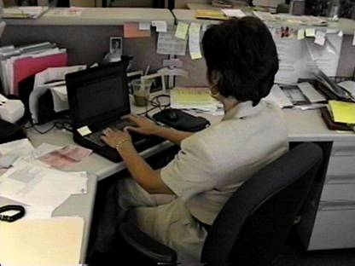
Design of laptops violates a basic ergonomic requirement for a computer, namely that the keyboard and screen are separated. The reason is simple - with a fixed design, if the keyboard is in an n optimal position for the user, the screen isn't and if the screen is optimal the keyboard isn't.
This means that you need to pay special attention to how you use your laptop because it can cause you problems.
Laptop User Type
Are you an occasional user who works on your laptop for short periods of time or are you a full-time user with the laptop as your main computer?
Occasional users will have less risk of problems than full-time users.
All users should pay some attention to how they use their laptop, but full-time users may have more problems.

Occasional Users
Because large muscles control the neck/head position, you are better off sacrificing neck posture rather than wrist posture. For occasional use:
- Find a chair that is comfortable and that you can sit back in.
- Position your laptop in your lap or table for the most neutral wrist posture that you can achieve.
- Angle laptop screen so that you can see this with the least amount of neck deviation.

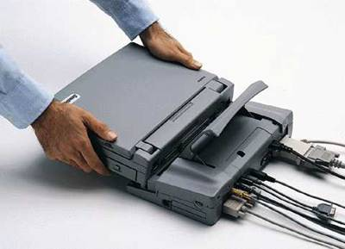
Full-time Users
If you use your laptop at work as your main computer you should:
- Use a separate keyboard and mouse. You should be able e to connect a keyboard and mouse directly to the back of the laptop or to a docking station. A port replicator is used.
- Position this on your desk/worksurface in front of you so that you can see the screen without bending your neck. This may require that you elevate the laptop off the desk surface using a stable support surface, such as a computer monitor pedestal.
- Follow the postural guidelines for working at a computer workstation.

Laptop weight
If you frequently transport your laptop think about the weight of the system. Many lightweight portables can become as heavy as regular laptops when you add the weight of all of the components together. If your laptop and components weigh 10 lbs or more then you should certainly consider using a carry-on bag that you can pull along. If you want a smaller bag and can comfortably carry your laptop consider a good shoulder bag or wheeled case.

Telephone

Frequency and duration
There is no doubt that the telephone is an essential part of our offices. Think for a moment about how much time you spend on the telephone and how important is it for you to have a proper telephone set up? If you make only a few calls a day, it really doesn’t have much of an impact.
On the other hand, if you spend hours on the phone every day or if you make frequent short calls here are some things to consider. The position of your head/shoulder/hand can be an issue with telephone use. If you use a telephone handset how do you hold it? Do you hold the handset between your ear and shoulder forcing you to crane your neck?

Headsets
To improve head/shoulder/hand position, more and more people who use a telephone on a frequent and regular basis are switching to headsets. This frees up both your neck and your hands and allows a good neutral position.
Several different types of headsets are available and you’ll want to find one that works the best for you. Over-the-head and over-the- ear versions are available either in wired or wireless formats.
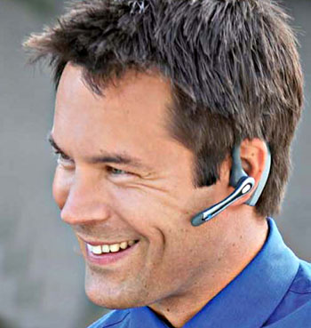
It does take a little while to get used to headsets, so give it some time.
Think about where you want to store your headset when you’re not using it. Sometimes a small hook on the wall or on your computer monitor for example, can be a good storage place. This keeps it off your worksurface and also keeps it in ready reach.

Cradle
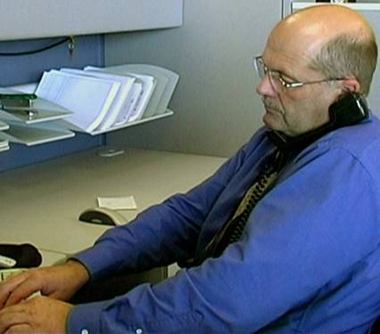
You could add a phone cradle onto your telephone handset. This does help to put your head and neck in a better position but it still requires you to maintain tension in your neck and shoulder to position the telephone handset. Our recommendation is to not use phone cradles on a regular basis. A headset is a much better solution in most cases.

Sound quality
Poor sound quality and low-volume are problems in the effective use of your telephone. If you identify either the sound quality or volume as an issue see if there are any adjustments you can make to improve it. If not, you may want to consider replacing or exchanging your telephone handset or headset.
Telephone |  | Issue | Comment | Recommendation
Type | Handset/Headset/ Speaker | No  Yes | Telephone type and location appropriate  Telephone located in awkward position  Awkward head/neck position with handset use  Other (comment) | None  Add headset to allow for hands-free operation  Reposition telephone to left side worksurface  Reposition telephone to right side worksurface  Other (comment)
Location | Left/Right

Handwriting/Reading
Despite the leaps and bounds of technology we still find ourselves using the good old pen and paper as a tool for communication. The way we choose to do the simple task of writing, or even reading, ca n have a huge influence on the condition of our hands and wrists, neck, shoulders and eyes.

Inclined
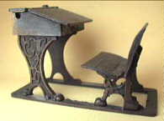
To correct working on a horizontal surface think about the old-style school desk. It actually had a tilted worksurface to position the writing and reading materials that encouraged the student to stay in a more upright position.
Think about how you might put your material in a more in a tilted position.
You might use a document stand or podium. Think about where you need to place the stand or podium.
If you’re using it when at your computer you might place it either in front of you between the keyboard and monitor if there is enough room, or you might position it slightly off to the side.

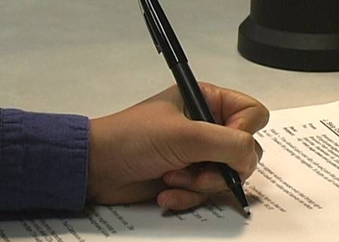
Gripping
Is it really true, that the harder you squeeze the more ink or lead will come out? Lighten up your grip/use a soft grip that slides onto your pen/pencil or use one of the newer “ergonomic” grips designed to fit your hand. The larger the grip the more you can use the larger muscles of your hands. The smaller the grip the more we tend to use the smaller muscles which fatigue more rapidly.
We all have our favorite pen. However, it makes sense to have a variety of different types and sizes of pens and pencils sleeping trade-off throughout the day and give your hand a break.
Remember that whenever you try something new, it takes a while to get used to it; our bodies sometimes have a difficult time with good changes. So, if it makes sense but feels strange give it a little time.

Office equipment
Make use of the principles we have discussed to place the office equipment.
Includes:
- Calculator  - Printer  - Fax | - Writing utensils  - Scissors  - Paper clips | - Stapler  - Storage  - Etc.
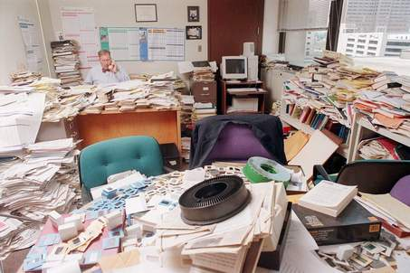
It’s amazing sometimes how much stuff we can accumulate in our offices. So, what we store on our desktops, some would put in our file cabinets and sometimes on shelves and in overhead cabinets.
The old adage, “a place for everything and everything in its place” makes good sense.
On a regular basis make sure that you can easily place and remove any of your office equipment and materials from their storage locations in file cabinets, drawers, shelves and cabinets.
Understand and make use of the reach zones.

Storage
Primary- desktop, shelf, file  - Commonly/frequently accessed from seating system  - Within easy reach  - Within accepted reach zone | 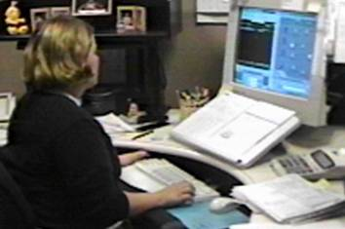
Secondary - desktop, shelf, file  - Occasionally accessed  - Located in the “gray” or danger zone (able to reach to the location by over-extending)  - Require light weight and low frequency of access to limit stress  - Best bet: move into primary or tertiary | 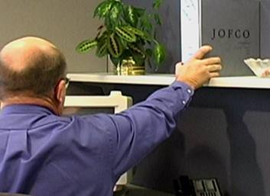
Tertiary – shelf, file  - Occasionally accessed  - Requires getting out of chair to reach | 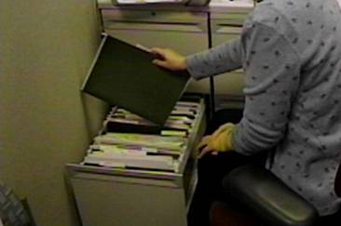

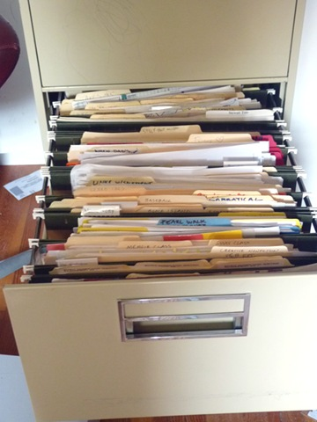
File cabinet types
If you try to put 50 files in a file cabinet that holds 30, you’re going to have problems trying to get them in and out. This creates a great deal of unnecessary additional work as well as the potential for musculoskeletal disorders. (And not to mention the frustration that goes along with.)
Make good use of the different types available:
- Vertical
- Lateral
- Rolling
Storage |  | Issue | Comment | Recommendation
Desktop | OK No/Yes | No  Yes | Adequate desktop and file storage  Limited desktop storage  Limited file storage  Other (comment) | None  Housecleaning to provide additional desktop storage  Housecleaning to provide additional file storage  Add additional file storage  Other (comment)
File | OK No/Yes

Conference rooms
We need to take into account not only the information that is being delivered but is our audience capable of receiving and using the information in an effective way? One issue of meetings is the lack of physical movement: Long meetings without adequate movement can lead to fatigue, discomfort and a non-productive meeting. Ineffective workstation setup (often just a conference table with poor chairs) is an issue with meetings.
For example, meetings held at a standard conference table could make you perform your work outside of the neutral postures. It is tough to be in one position for long periods of time. Look for as many opportunities as possible to move as part of your meeting.
You probably have heard that people think better on their feet. It has to do with improving oxygen flow. If your company wants people to think better during a meeting, consider doing a bit of standing mixed in with sitting.
If you get uncomfortable in long meetings bring in a small footrest or back cushion if you can’t adjust the chair or worksurface.

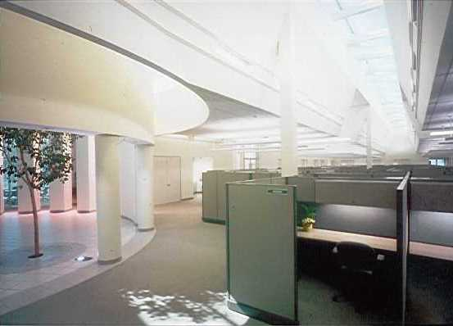
Light
Lighting is a big issue. When you think about light in the office, think about two things: general light that allows you to see e in the office and task light that is specifically focused on the work itself.
General light in the office may be an issue: either too much or not enough.

Too much
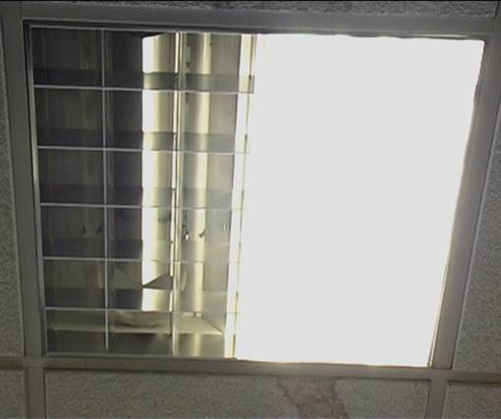
For general light that may be too much, one option may be to turn out some of the overhead fluorescent lights. Before you do this on your own, contact your building facilities staff to make sure how to do it safely.
Also, in some cases, turning out one fluorescent bulb in a set may cause the other bulbs to flicker

Too little
If you simply don’t have enough general light for safety purposes, additional overhead lights may be added or another effective way is to add indirect lights, which bounce the light off of the ceiling and walls. Again, contact your building facilities staff for the best solution.
Task lights are a great way to add additional light where you need it. They come in a variety of configurations and wattage. For example, you may use a desktop lamp to provide additional light on your document holder. You may have a bulletin board where you post information; a task light can be attached to a wall panel or other surface and be pointed at the bulletin board to provide proper illumination.
Remember that how you position the task light is important, for example don’t point it directly at your computer screen because you will create glare. Also make sure it is not in your direct line of vision and pointed at you because this also this will create a problem.

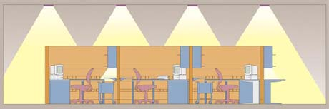
Lighting design
Lighting design within an office setting can get quite complicated and detailed. The recommendation is to work with lighting designers to tackle large jobs.

Illumination |  | Issue | Comment | Recommendation
Overhead | OK No/Yes | No  Yes | Ambient and task lighting appropriate  Ambient light level too high  Ambient light level too low  Task lighting too high.  Task lighting too low  Other (comment) | None  Lower ambient light level  Raise ambient light level  Add desktop task light  Decrease desktop task light  Other (comment)
Task | OK No/Yes

Recommended Specifications
Slide 142
Once the assessment has been performed generate the Recommended Specifications. Refer to the notes below for details needed to take the measurements.
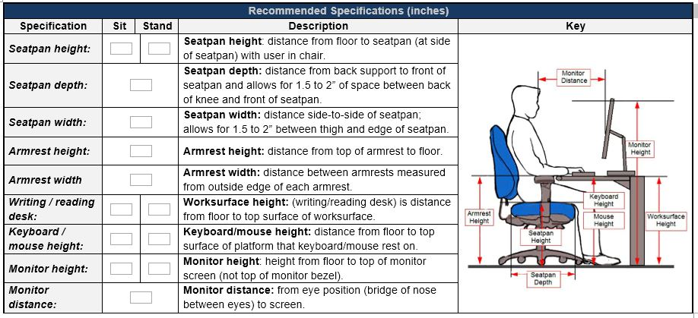
NOTES
Seatpan height is measured as the distance from the floor to the seatpan (at the side of the seatpan) with the user in the chair. Seatpan height is Seatpan depth is measured as the distance from the back support to the front of the seatpan and allows for 1.5 to 2” of space between the back of the knee and front of the seatpan.
Seatpan width is measured as the distance side-to-side of the seatpan and allows for 1.5 to 2” of space between the thigh and side of the seatpan.
Armrest height is measured as the distance from the top of the armrest to the floor.
Armrest width is measured as the distance between the outside edges of the armrest.
Worksurface height (writing/reading desk) is measured as the distance from the floor to the top surface of the worksurface.
Keyboard height is the distance from the floor to the top surface of the platform that the keyboard rests on. (It is not to the top of the keyboard.)
Mouse height is the distance from the floor to the top surface of the platform that the mouse rests on. (It is not to the top of the mouse.)
Monitor height is height from the floor to the top of the monitor screen (not the top of the monitor bezel.)
Monitor distance is from the eye position (bridge of the nose between the eyes) to the screen.

Follow-up
Date: ( / / )
Date: ( / / )
Date: ( / / )

Office Ergonomics Assessment Guidelines

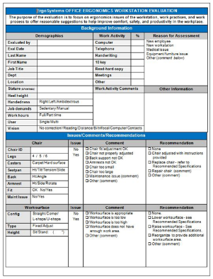
Assessment Steps
- Background Information
- Job Tasks
- Chair
- Worksurface
- Computer and Office Equipment
- Environmental Factors
- Recommended Workstation Setup and Specifications
- Summarize Issues and Recommendations
- Follow-up

Ergonomics – A Potent Tool!
Great number of factors enter into the office ergonomics workplace.
Use the principles and ergonomics analysis process to offer solutions that are practical and effective!

Selected References

Office Ergonomics
Human Factors and Ergonomics Society. (2007). ANSI/HFES 100-2007 Human Factors Engineering of Computer Workstations. Human Factors & Ergonomics Society
Jacko, J.A. (ed) (2012). Human–Computer Interaction Handbook: Fundamentals, Evolving Technologies, and Emerging Applications (3rd Ed.), CRC Press
Kroemer, Anne D., & Kroemer Karl H.E., (2nd ed), (2017), Office Ergonomics: Ease & Efficiency at Work, Taylor & Francis Group
Occupational Safety and Health Administration, (2019) Computer Workstations eTool, https://www.osha.gov/SLTC/etools/computerworkstations/
Pronk NP, Katz AS, Lowry M, Payfer JR. Reducing Occupational Sitting Time and Improving Worker Health: The Take-a-Stand Project, 2011. Prev Chronic Dis 2012;9:110323
Rogers, Y., Sharp, H., & Preece, J. (2011). Interaction Design: Beyond Human Computer Interaction (3rd Ed.). Wiley
Shneiderman, B., Plaisant, C., Cohen, M., & Jacobs, S. (2009). Designing the User Interface: Strategies for Effective Human-Computer Interaction (5th Ed.). Prentice Hall
Washington State Department of Labor and Industries, (2019), Office Ergonomics: Practical solutions for a safer workplace, http://www.lni.wa.gov/IPUB/417-133-000.pdf

Primary Ergonomics References
Bridger, R. S. (2008). Introduction to Ergonomics (3rd Ed.). CRC Press
Chaffin, D.B., Andersson, G.B.J., & Martin, B.J. (2006). Occupational Biomechanics (4th Ed.). Wiley Interscience
Guastello, S. J. (2006). Human factors engineering and ergonomics: A systems approach. CRC Press
Helander, M. (2005). A Guide to Human Factors and Ergonomics (2nd Ed.). CRC Press
Lehto, M. & Landry, S. J. (2012). Introduction to Human Factors and Ergonomics for Engineers (2nd Ed.). CRC Press
Salvendy, G. (Ed.) (2012). Handbook of Human Factors and Ergonomics (4th Ed.). Wiley
Wickens, C. D., Hollands, J. G., Parasuraman, R., & Banbury, S. (2012). Engineering Psychology and Human Performance (4th Ed.). Pearson

Journals (Selected)
Applied Ergonomics, Elsevier Science Ltd.
Ergonomics, Taylor and Francis.
Human Factors, Human Factors and Ergonomics Society.
(Reference www.ergoweb.com for a list of ergonomics related journals)

Professional Organizations
American Industrial Hygiene Association
2700 Prosperity Avenue, #250
Fairfax, VA 22031
(703) 849-8888

American Society of Safety Engineers
1800 E. Oakton St.
Des Plaines, IL 60018-2187
(847) 699-2929

Human Factors and Ergonomics Society
PO Box 1369
Santa Monica, CA 90406-1369
(310) 394-1811

International Ergonomics Association
Secretary General IEA
Pieter Rookmaaker
SEARBO/Ergonomics
PO Box 2286
3500 GG Utrecht
The Netherlands
+31 30 2399455

National Safety Council
444 North Michigan Avenue
Chicago, IL 60611
(800) 621-7619

