ErgoSystems Office Ergonomics Assessment
Last name: | Peterson | Stature: | ft in |  | Work hours:
First name: | Monica | Shoe heel ht: | in |  | Comments:
Date: | 2/6/2012 | Handedness: |  |  | Reports daily low back discomfort with onset over this past summer of 2011.
Job Title: | Merchandise Specialist | Vision:
Department: | Merchandising | Job tasks:
Company: | Simpson Brands, Inc | Job demands:
Location: | 810 Simpson Drive  Eden Prairie, MN 55344 | User:
 |  | Other station:
Assessment performed by Mark Anderson, MA, PT, CPE, ErgoSystems Consulting Group, Inc. 19285 Shady Hills Road, Excelsior, MN 55331 Voice: 952-401-9296 Email: mark.anderson@ergosystemsconsulting.com.  The purpose of the assessment is to focus on ergonomics issues of the workstation, work practices, and work process to provide a set of workstation set-up specifications and to offer reasonable suggestions to help improve comfort, safety, and productivity in the workplace.  The 30/30 rule was encouraged - this promotes physical movement up and out of chair for at least 30 seconds at least every 30 minutes. |  |  |  | 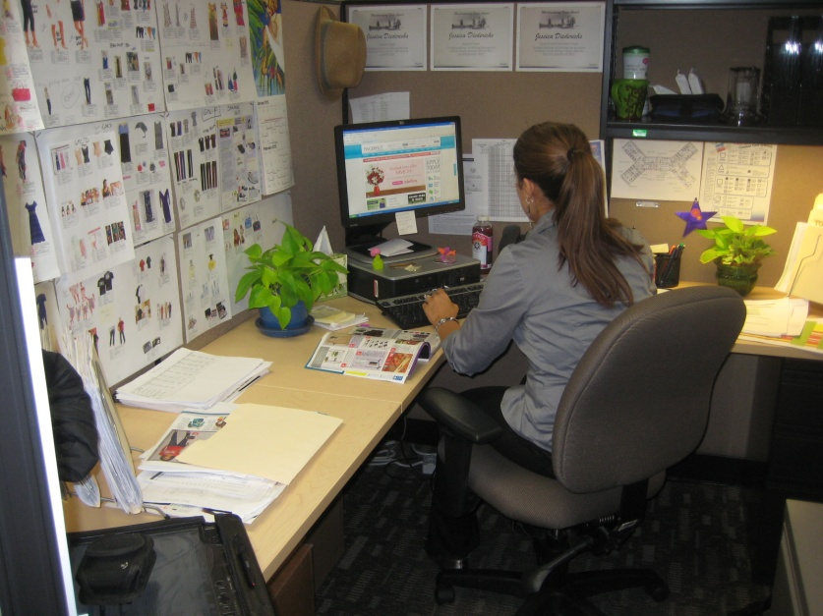
Chair |  | Comment | Recommendation
Type | Standard | Chair, as currently adjusted was not providing adequate back support.  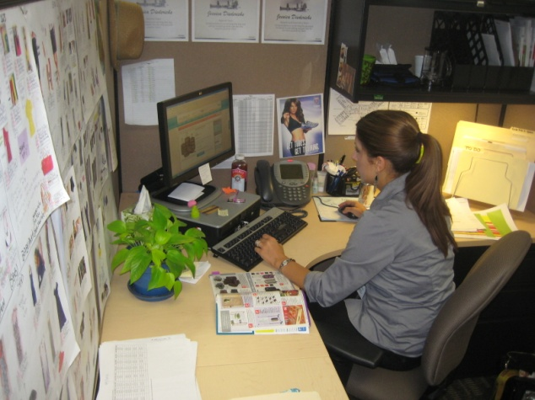 | Instructed in upright “keyboard position” and semi-reclined “conversation position”.  Recommended to alternate between these two seated postures based on job tasks throughout day.  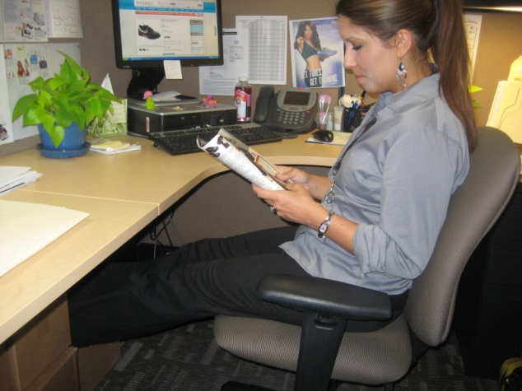
Legs
Casters
Seat
Back
Arms
Foot support/Clearance |  | Comment | Recommendation
Feet  Footrest |  | At a worksurface height of 29 inches a foot rest is needed to provide for adequate foot support; one is not in place.  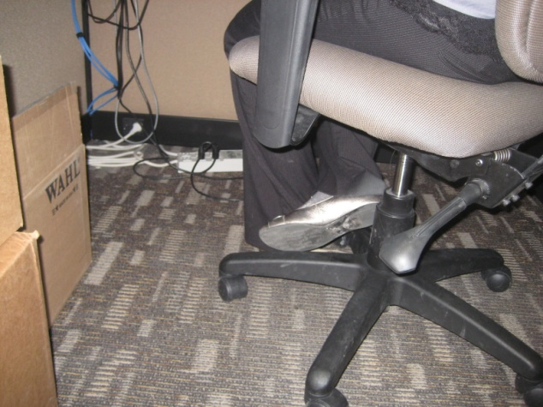 | Add basic foot rest. The following 3M footrest or comparable is recommended.  Foot Rest, Adjustable, Ergonomic, Foot Control, 18"x13"x4", Charcoal MMMFR330
Worksurface |  | Comment | Recommendation
Config |  | With footrest in place 29 inch height worksurfaces appropriate. Ideally the best worksurface height for her is 28 inches.
Type
Keyboard Tray |  | Comment | Recommendation
Used
Adjust
Keyboard |  | Comment | Recommendation
Type
Location
Mouse |  | Comment | Recommendation
Type
Location
CPU |  | Comment | Recommendation
Type |  | Computer is placed under the monitor taking up needed space on the worksurface. | At the time of the assessment we relocated the desktop computer to the left side of the workstation.
Location
Monitor |  | Comment | Recommendation
Type
Number
Telephone |  | Comment | Recommendation
Type
Location
Document holder |  | Comment | Recommendation
Type |  |  | Once the computer was moved out of the way, space is available to place a document holder between the keyboard and monitor. The recommended document holder is the 3M DH630 or comparable..  3M Compact In-line Copy Holder, 150 Sheet Capacity (DH630)  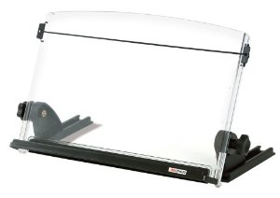
Location
Storage |  | Comment | Recommendation
Desktop
File
Lighting |  | Comment | Recommendation
Ambient
Task

Recommended Specifications (inches)
Seatpan height: |  | Seatpan height is distance from floor to seatpan (at side of seatpan) with user in chair.  Seatpan depth is distance from back support to front of seatpan and allows for 1.5 to 2” of space between back of the knee and front of seatpan.  Seatpan width is distance side-to-side of seatpan and allows for 1.5 to 2” of space between thigh and side of seatpan.  Armrest height is distance from top of armrest to floor.  Worksurface height (writing/reading desk) is distance from floor to top surface of worksurface.  Keyboard/mouse height is distance from floor to top surface of platform that keyboard/mouse rest on.  Monitor height is height from floor to top of monitor screen (not the top of monitor bezel.)  Monitor distance is from eye position (bridge of the nose between the eyes) to screen.
Seatpan depth:
Seatpan width:
Armrest height:
Writing/reading desk
Keyboard/mouse height:
Monitor height
Monitor distance

