Ergonomics

Workstation
Evaluation

Job:
FST at GBS (Reception, Mailroom and Receiving Dock)
Project Number:
SAMPLE
100304
Organization:
Logistics, Inc.
Location:
Logistics, Inc.
3850 Longview Street N
Minneapolis, MN 55126
Date:
July 27, XXXX
Contacts:
Gary Anderson
Ergonomist:
Mark A. Anderson, MA, PT, CPE
ErgoSystems Consulting Group, Inc.

19285 Shady Hills Road
Minneapolis, MN 55331-9156
Voice: (952) 401-9296
Email: Mark.Anderson@ergosystemsconsulting.com

Introduction
FST (Facility Service Team) Reception, Mailroom and Receiving Dock workstations and job tasks at Logistics Global Business Solutions were evaluated by Mark A. Anderson, MA, PT, CPE, Certified Professional Ergonomist on July 27, 2007.
The evaluation was coordinated by Gary Anderson. Appreciation is also extended to those FST employees who provided input during the assessment (Lori Shand, Angie Corey, Terry Lundquist and Tom Forrest).
Specific focus of the assessment was to examine ergonomics issues of the workstations and work processes to offer reasonable suggestions to help improve the comfort, safety and productivity of performance of the job tasks.
Conclusions are offered below and pertinent process steps are outlined in the Issues and Recommendations as noted on the following pages.

Method
The assessment was completed through a data collection process that included direct observation with pictures, personal interview and objective measurements as indicated. Specific workstation components and processes were analyzed including:

- Demographics/Background
- Work/Job Tasks/Concerns
- Workstation Use
- Equipment
- Worksurface – type and configuration
- Storage
- Environmental Issues
- Other – as indicated

Risk Level Index
The following key was used to establish the Risk Level Index in terms of ergonomics issues (health, safety and productivity): NOTE: Ranking may be subject to change based on additional input.  - LOW considered low risk with low priority to change.  - MOD considered moderate risk, recommend modification as feasible.  - HIGH considered high risk, recommend concerted effort to modify.  The Risk Level Index takes into account the Dose (severity/stress level of the ergonomics risk factors) in combination with the Exposure (duration/frequency of the ergonomics risk factors).  See the Matrix to the side; the higher the values for Dose and Exposure the greater the estimated risk. | Dose  E x p o s u r e Low Dose High Exposure High Dose High Exposure  Low Dose Low Exposure High Dose Low Exposure

Conclusions
Please refer to the Issues and Recommendations section on the following pages for specific details.
The main conclusions from the ergonomics assessment of the FST (Facility Service Team) Reception, Mailroom and Receiving Dock workstations and job tasks are:

Reception
- Short-term: Seated workstation set-up (Risk Level Index: HIGH)
Encourage staff to make use of information on the Logistics Ergonomics Website: http://myLogistics/frame.aspx?http://mitintra.corp.Logistics.com/EHS/ and the office ergonomics training offered through Saba.
- Long-term: Seated workstation set-up (Risk Level Index: LOW)
When the workstations are replaced consider use of height adjustable workstations. An example is located at WHQ Education Center Reception.
- Instruction in chair use (Risk Level Index: HIGH)
At the time of the assessment we revisited the use of the Aeron stool. We went through all the adjustment features and determined it should be adequate for use at the reception counter.
- Add monitor privacy screen (Risk Level Index: MOD)
Replace the current monitor glare screen with a monitor privacy strain. The monitor size is 19 inch diagonal.
- Adjust monitor height (Risk Level Index: MOD)
At the time of the assessment instruction was provided regarding the height adjustability feature of the monitor with proper height obtained.
- Add wireless headset (Risk Level Index: HIGH)
Consider adding wireless headset to allow for unencumbered telephone use in the area. Due to a multi-user situation provide separate ear pieces per individual (hygiene issue).

Mailroom
- Modify slot level (Risk Level Index: HIGH)
Consider modifying worksurface/slot level by raising the worksurface to 32 inches. This can be accomplished without raising the higher shelf levels; there is a three-inch space between the worksurface and the first shelf in the sorting rack.
- Investigate other carts (Risk Level Index: MOD)
Investigate the use of other mailroom carts that would be easier to maneuver. Specifically investigate if other wheel styles would be easier to maneuver on the floor surfaces
- Provide alternative worksurface heights: (Risk Level Index: HIGH)
There are three tables in use for the work surfaces. Investigate the feasibility of providing three different heights by elevating two of the tables (one is maintained at 29 inches, one is raised to 32 inches and the third is raised to 36 inches.)
- Provide alternative storage locations: (Risk Level Index: HIGH)
Investigate alternative storage locations for these materials. Options include a rack or shelf that would place the heavier materials on shelves at approximately hip/waist level (30 inches).
- Seated workstation set-up (Risk Level Index: MOD)
Continue with use of the computer workstations as setup. Encourage staff to make use of information on the Logistics Ergonomics Website: http://myLogistics/frame.aspx?http://mitintra.corp.Logistics.com/EHS/ and the office ergonomics training offered through Saba.

Receiving
- Work technique (Risk Level Index: HIGH)
Encourage continued use of manual handling equipment (pallet jack, powered pallet jack, four wheel hand truck. etc.) as indicated. Encourage continued use of proper body mechanics during manual material handling activities by anyone who works in the area. Encourage staff to make use of information on the Logistics Ergonomics Website: http://myLogistics/frame.aspx?http://mitintra.corp.Logistics.com/EHS/ and the Manual Material Handling training offered through Saba.
- Modify handling of plates (Risk Level Index: HIGH)
Investigate if an overhead lift system (or some other method) could be installed that would provide a powered means to remove the heavy plates.
- Continue with powered snow removal equipment, investigate ergonomic shovels (Risk Level Index: MOD)
Continue to make use of the powered snow blower and snow brush as indicated to clear the walks. Ergonomically designed shovels and attachments are available to reduce the stress into the low back when removing snow. For example the Motus D-Grip handle can be attached to an existing straight handle shovel. Source: http://www.storesonline.com/site/1492981/product/729312
- Investigate other chair racks (Risk Level Index: HIGH)
Investigate if other chair racks are available from the vendor that are easier to stack and maneuver.
- Proper technique and two person lift to handle heavy tables (Risk Level Index: HIGH)
Insure proper technique and two person lift policy when handling these heavy tables. Refer to additional details as noted above in the manual handling section.

Thank you for the opportunity to conduct the evaluation and submit the report. Please contact me directly with any questions and if I can assist further. Contact information: (952) 401-9296, email: Mark.Anderson@ergosystemsconsulting.com
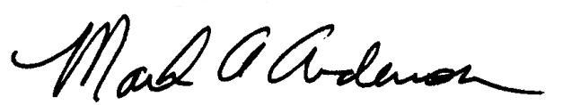
Mark A. Anderson, MA, PT, CPE
Certified Professional Ergonomist
Licensed Physical Therapist
ErgoSystems Consulting Group, Inc.
Issues and Recommendations

Reception
Overview:
Reception workstations are multi-user in nature, indicating the need for the workstation to be able to accommodate for differing stature and morphology of the staff. The workstations are configured with a standing height counter (height about 40”) and worksurfaces (height about 32”.)
The seating system is a stool with height adjustable seatpan, armrests and back support (old chair has some maintenance issues-a new Aeron stool is available). A foot-ring is in place for foot support (but was not adjusted). Computer equipment is placed on the worksurface. A closed-circuit security monitor is placed to the left of the computers monitor.
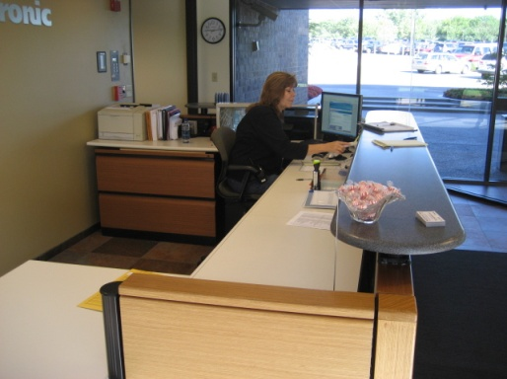 | 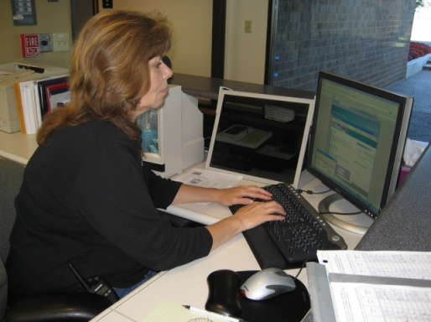
Reception station overview | Computer set up | Height adjustable monitor
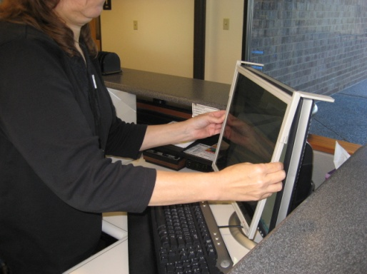 | 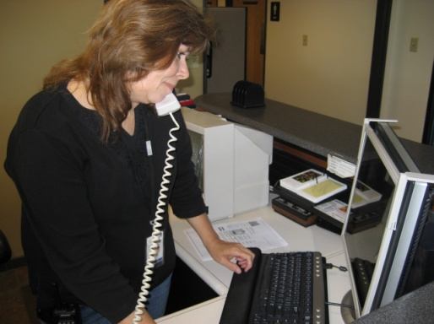 | 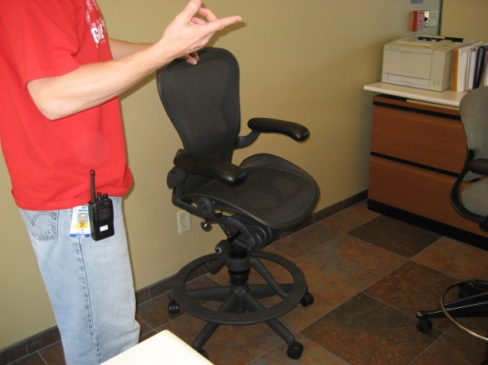
Monitor glare screen | Cradling handset | New Aeron stool
Job tasks include:
- Greeting employees and the visiting public
- Telephone use (making and receiving calls, taking message, etc.)
- Information look-up via hardcopy and computer
- Miscellaneous office tasks

Issue | Recommendation
Seated workstation set-up  The objective is a computer workstation set-up that provides body weight support in a neutral body and arm position when seated at the workstation while using the computer or performing other activities.  Two factors are important:  - Adequate equipment/furniture that can be adjusted to meet the user’s needs.  - Adequate user knowledge in how to adjust the equipment/furniture.  The reception counter is fixed worksurface height. Keyboard/mouse are placed on the worksurface and stool height is adjusted to place hands at the neutral level. This necessitates need for foot support on the foot-ring or foot rest.  Chair Issue: the chair observed in use is an Equa 2 stool that mechanically is no longer sound. A Herman Miller Aeron stool had been purchased but due to lack of instruction in adjustment it was not being used.  Monitor glare screen: a monitor glare screen is in place; however it does not provide for privacy.  Monitor height and distance: distance is appropriate; monitor is height adjustable and this feature was not being used.  Handset telephone: a handset telephone is in use for frequent phone use; result is cradling the phone between the ear and shoulder with out of neutral head and neck positions. | Short-term: Seated workstation set-up (Risk Level Index: HIGH)  Encourage staff to make use of information on the Logistics Ergonomics Website:  http://myLogistics/frame.aspx?http://mitintra.corp.Logistics.com/EHS/  and the office ergonomics training offered through Saba.  Long-term: Seated workstation set-up (Risk Level Index: LOW)  When the workstations are replaced consider use of height adjustable workstations. An example is located at WHQ Education Center Reception.  Instruction in chair use (Risk Level Index: HIGH)  At the time of the assessment we revisited the use of the Aeron stool. We went through all the adjustment features and determined it should be adequate for use at the reception counter.  Add monitor privacy screen (Risk Level Index: MOD)  Replace the current monitor glare screen with a monitor privacy strain. The monitor size is 19 inch diagonal.  Adjust monitor height (Risk Level Index: MOD)  At the time of the assessment instruction was provided regarding the height adjustability feature of the monitor with proper height obtained.  Add wireless headset (Risk Level Index: HIGH)  Consider adding wireless headset to allow for unencumbered telephone use in the area. Due to a multi-user situation provide separate ear pieces per individual (hygiene issue).

Mailroom
Mailroom workstations are multi-user in nature, indicating the need for the workstation to be able to accommodate for differing stature and morphology of the staff. Workstations include: sorting workstations, use of carts to transport materials, computer workstations and office equipment.
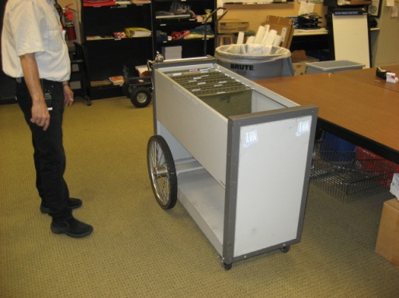 | 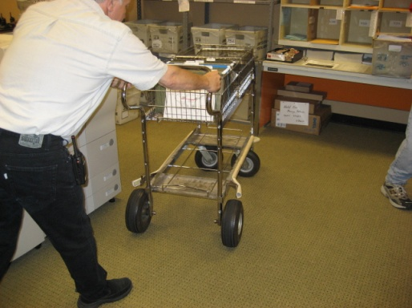 | 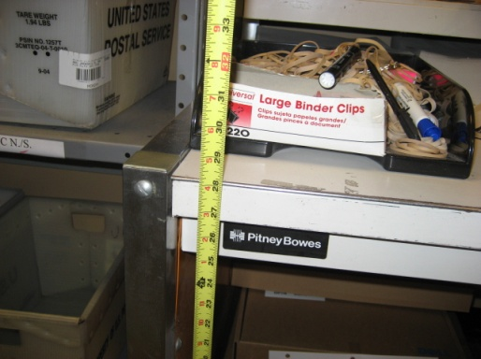
Mailroom cart | Cart hard to maneuver | 29 inch high worksurface
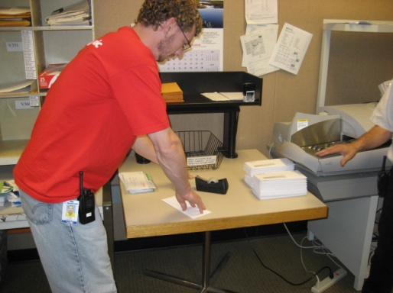 | 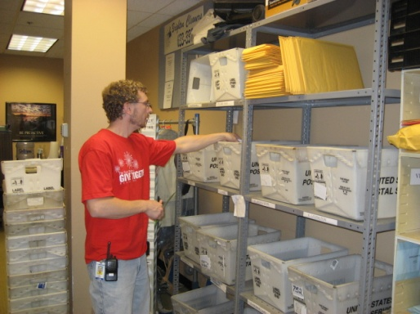 | 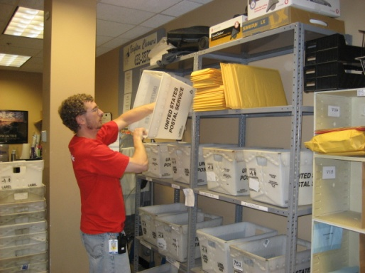
Worksurface too low | Shelving | Reach to upper shelf level
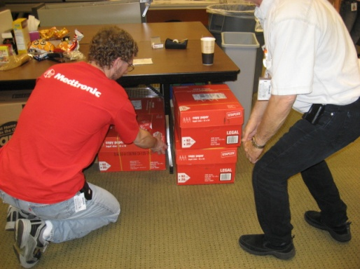 | 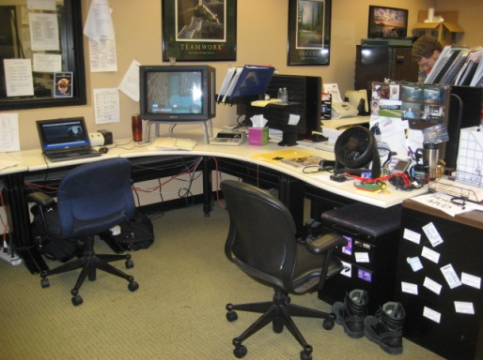 | 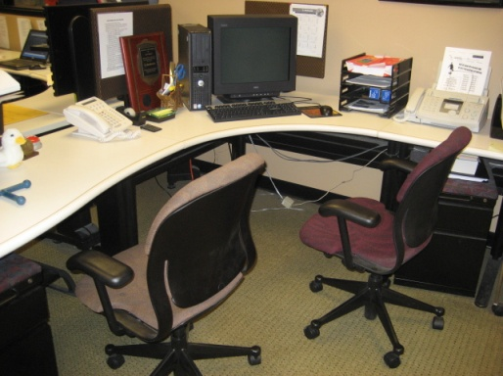
Boxes stored on the floor | Office workstations | Office workstations

Issue | Recommendation
Mail sorting stations  Mail items are brought into the Mailroom via carts and are sorted into slots. The slots range in height from 29” to about 65”. The lower worksurface/slot height results in a forward bend for taller individuals. | Modify slot level (Risk Level Index: HIGH)  Consider modifying worksurface/slot level by raising the worksurface to 32 inches.  This can be accomplished without raising the higher shelf levels; there is a three-inch space between the worksurface and the first shelf in the sorting rack.
Carts  A couple different styles of carts are in use. In general the carts provide acceptable access to place materials into the car and the handles are placed appropriately.  However the carts were noted to be difficult to maneuver. | Investigate other carts (Risk Level Index: MOD)  Investigate the use of other mailroom carts that would be easier to maneuver. Specifically investigate if other wheel styles would be easier to maneuver on the floor surfaces
General collating workstations  The worktables are at 29 inches height. Many times people stand to perform work at these workstations. As a result they end up with a forward bend posture due to the low worksurface height. | Provide alternative worksurface heights: (Risk Level Index: HIGH)  There are three tables in use for the work surfaces. Investigate the feasibility of providing three different heights by elevating two of the tables (one is maintained at 29 inches, one is raised to 32 inches and the third is raised to 36 inches.)
Material stored on the floor  Boxes of paper and other materials were observed to be stored on the floor below work tables. This results in awkward positioning while manually handling these materials. | Provide alternative storage locations: (Risk Level Index: HIGH)  Investigate alternative storage locations for these materials. Options include a rack or shelf that would place the heavier materials on shelves at approximately hip/waist level (30 inches).
Computer workstations  The objective is a computer workstation set-up that provides body weight support in a neutral body and arm position when seated at the workstation while using the computer or performing other activities.  Two issues are indicated:  - Adequate equipment/furniture that can be adjusted to meet the user’s needs.  - Adequate user knowledge in how to adjust the equipment/furniture.  A fixed worksurface height computer workstations setup was observed. Keyboard/mouse placed on the worksurface and chair height adjusted to place hands at the neutral level. This may necessitate need for foot support on a foot rest. | Seated workstation set-up (Risk Level Index: MOD)  Continue with use of the computer workstations as setup.  Encourage staff to make use of information on the Logistics Ergonomics Website:  http://myLogistics/frame.aspx?http://mitintra.corp.Logistics.com/EHS/  and the office ergonomics training offered through Saba.

Receiving Dock and Miscellaneous
Tasks in the Receiving Dock include receiving materials onto the receiving dock, processing them for entry into the system and delivering them as needed via cart within the building. Also meeting room set up (handling tables and chairs) and clearing sidewalks of snow was discussed
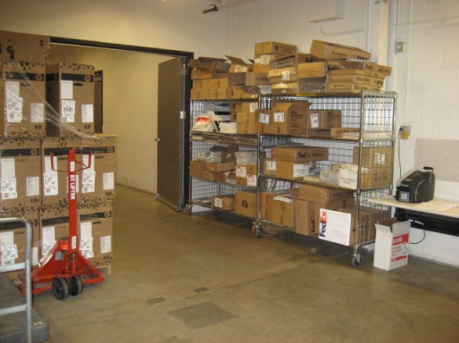 | 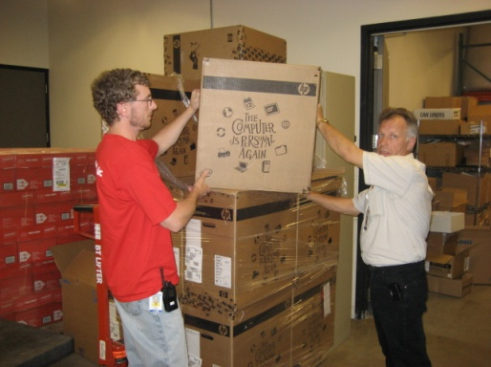 |  | 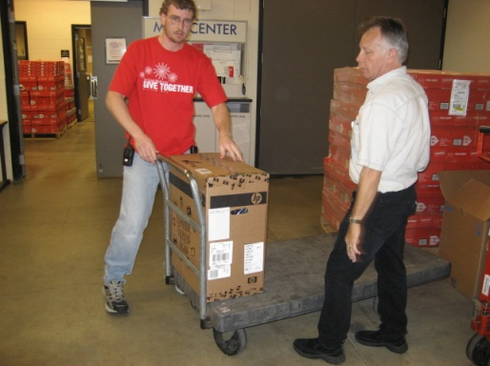
Receiving dock overview | Two person lift heavy materials |  | Four wheel hand truck
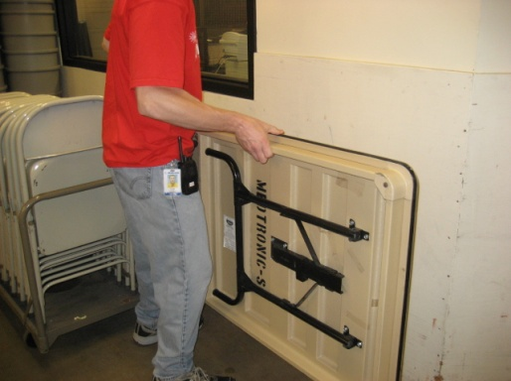 | 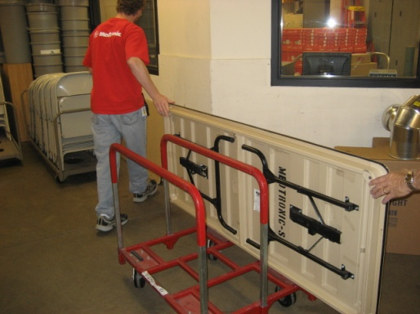 |  | 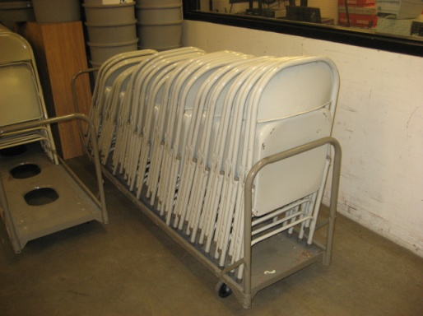
Handling fold up tables | Cart for fold up tables |  | Card for fold up chairs
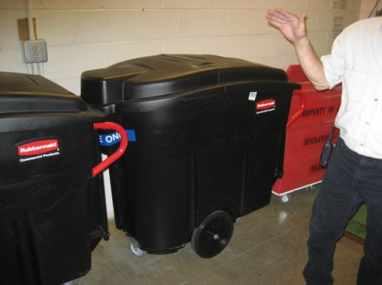 | 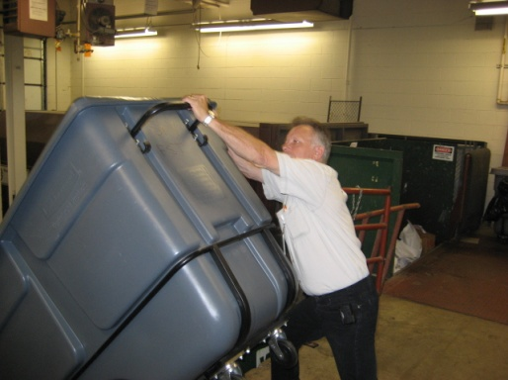 |  | 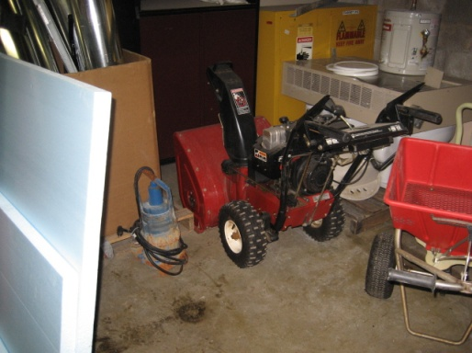
Cart | Tipping cart into dumpster |  | Snow blower
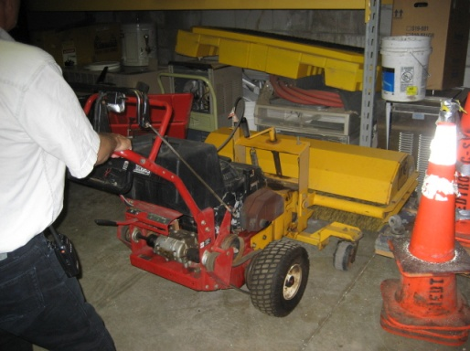 | 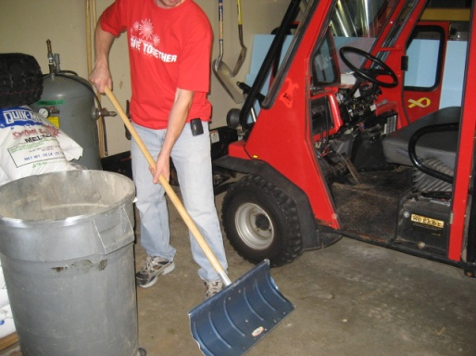 |  | 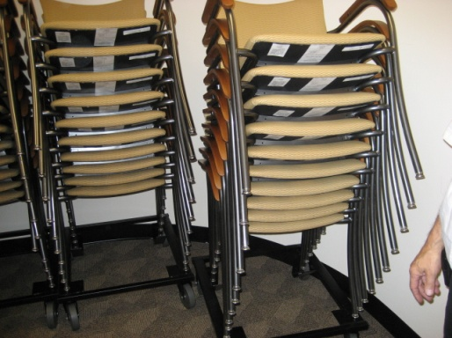
Snow brush | Straight handled shovel |  | Stackable chair cards
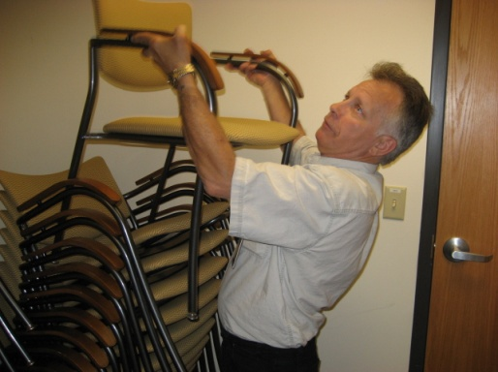 | 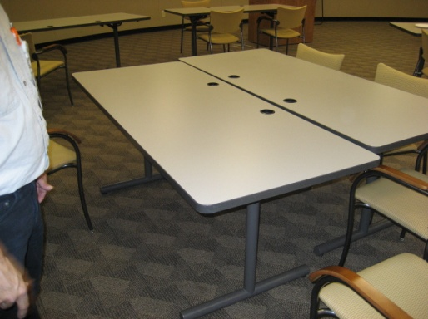 |  | 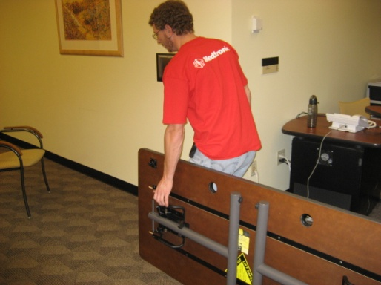
Placing top chair on cart | Heavy fold up tables |  | Handling fold up tables
Issue |  | Recommendation
Handling of boxes/materials in receiving area  We discussed handling of boxes/materials in the receiving area.  Two person lifting techniques are used as required for manual material handling.  Mechanical handling equipment is available for use in the area (this includes hand pallet jacks, a powered pallet jack and various two wheel and four wheel hand trucks.)  We also discussed tipping the gray carts into the dumpster. This can be difficult to accomplish and is improved by using proper technique.  Note: we discussed the use of a powered work positioner to reduce any manual material handling. It was determined that the frequency is not significant enough to warrant recommendation for a powered work positioner. |  | Work technique (Risk Level Index: HIGH)  Encourage continued use of manual handling equipment (pallet jack, powered pallet jack, four wheel hand truck. etc.) as indicated.  Encourage continued use of proper body mechanics during manual material handling activities by anyone who works in the area.  Encourage staff to make use of information on the Logistics Ergonomics Website:  http://myLogistics/frame.aspx?http://mitintra.corp.Logistics.com/EHS/  and the Manual Material Handling training offered through Saba.
Trash compactor maintenance  Twice annually maintenance is performed on the trash compactor. Heavy plates have to be removed to gain access to perform maintenance. |  | Modify handling of plates (Risk Level Index: HIGH)  Investigate if an overhead lift system (or some other method) could be installed that would provide a powered means to remove the heavy plates.
Clearing snow  It was noted that the new heated sidewalk for the Main entrance has been a significant improvement.  Also a two-stage snow blower and snow brush are available for use. Hand shovels are used as needed for those areas where the blower and brush are not accessible. |  | Continue with powered snow removal equipment, investigate ergonomic shovels (Risk Level Index: MOD)  Continue to make use of the powered snow blower and snow brush as indicated to clear the walks.  Ergonomically designed shovels and attachments are available to reduce the stress into the low back when removing snow.  For example the Motus D-Grip handle can be attached to an existing straight handle shovel.  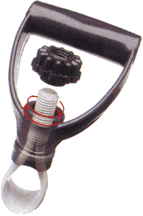  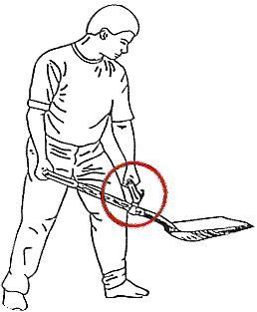  Source: http://www.storesonline.com/site/1492981/product/729312
New conference room/training room chairs and tables  It was noted that the new conference room/training room chairs and tables are very heavy and difficult to handle during setup and takedown.  Particularly it was noted difficult to stack the chairs on the chair rack. |  | Investigate other chair racks (Risk Level Index: HIGH)  Investigate if other chair racks are available from the vendor that are easier to stack and maneuver.  Proper technique and two person lift to handle heavy tables (Risk Level Index: HIGH)  Insure proper technique and two person lift policy when handling these heavy tables. Refer to additional details as noted above in the manual handling section.

