Workstation Case Study: Workbench

ErgoSystems Workstation Design Worksheet
Job/Task: Assembly M3057 Unit | Date: 12-19-08 | Time: 1:00 PM | Analyzed by: Mark Anderson
Area/Dept/Location: 70445 | Project Number: 100345 |  | Employee Name: Jane Smith
Supervisor: Marge Jones | Workstation: M3057 Unit |  | Job Title: Equipment Builder

Define Design Question
Define Design Question with necessary detail to accurately develop Design Specifications.
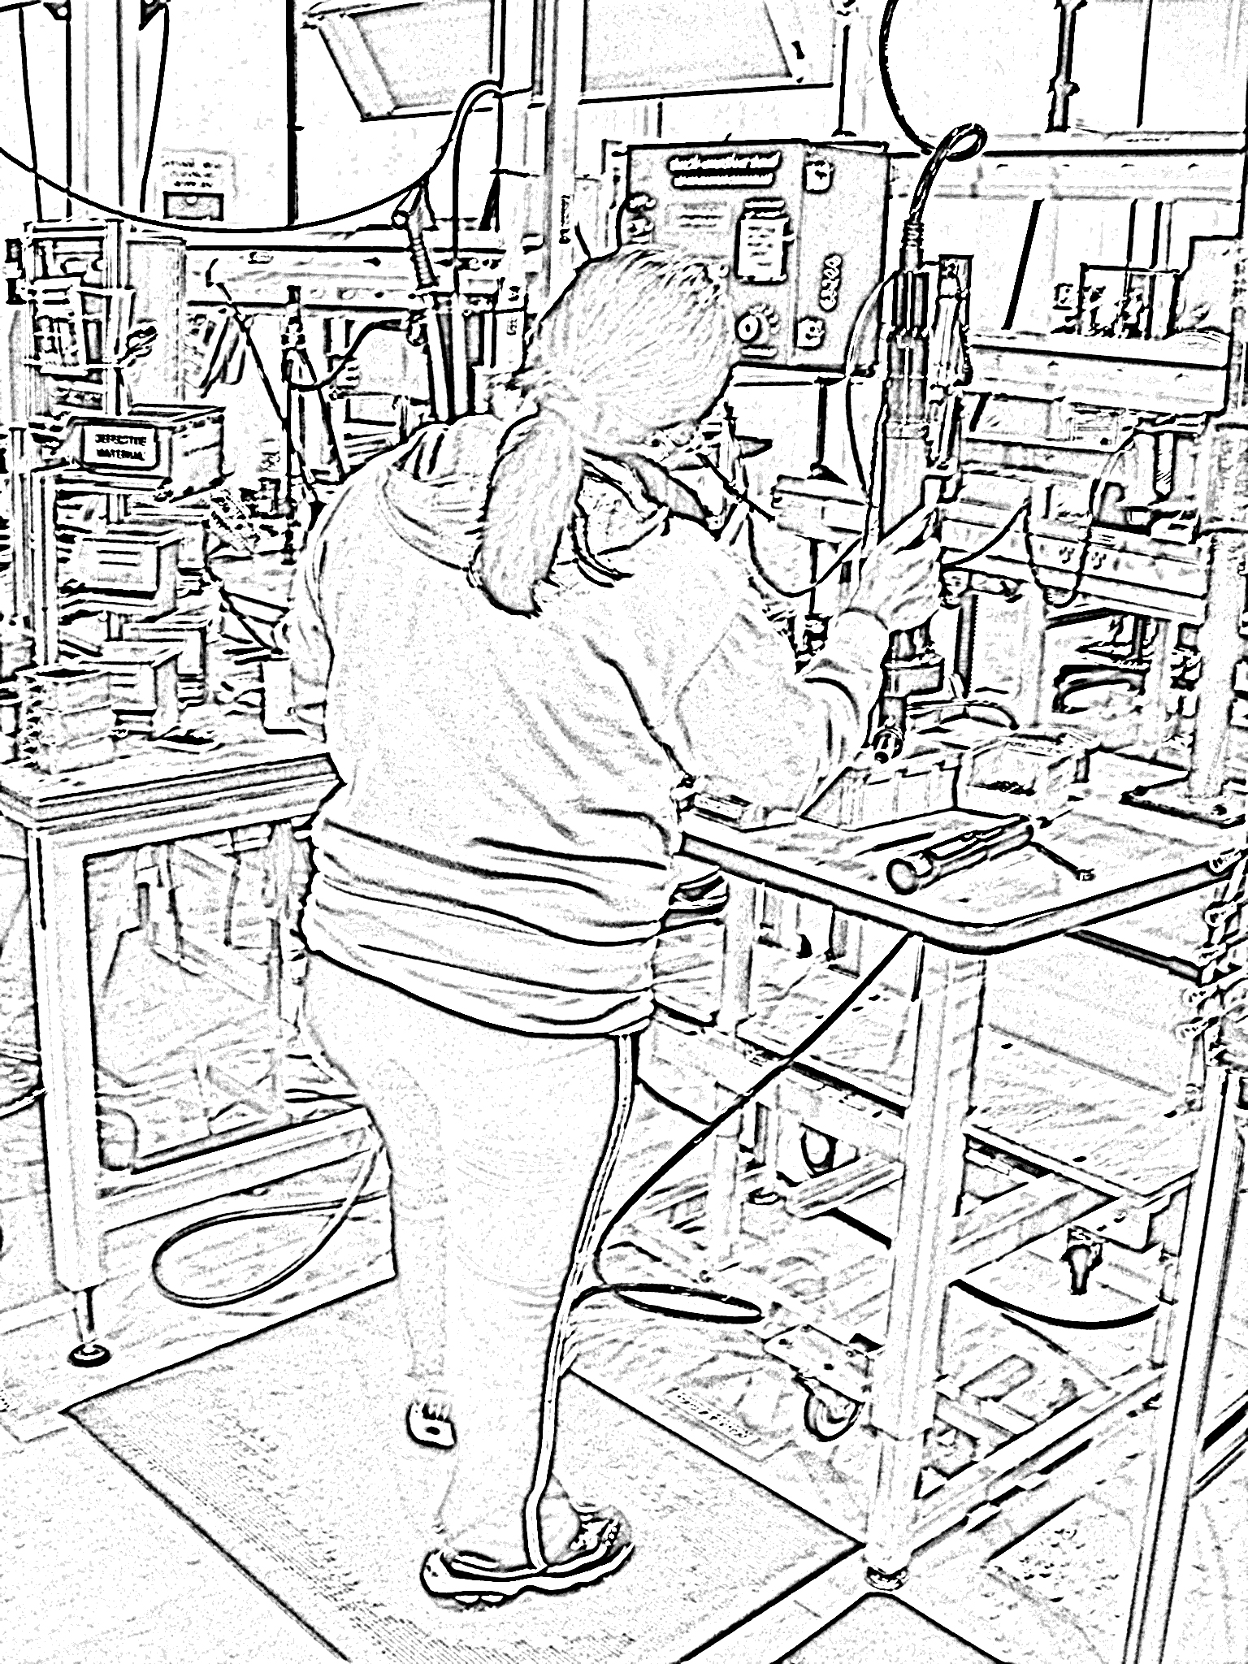
Workbench
Define the Design Specifications for a height adjustable workbench.
Specifications to include:
- Workbench height: Low/High adjustment range as measured from top of the worksurface to the floor.
- Workbench dimensions: Worksurface depth, width and thickness.
- Workbench foot/leg clearance: Specifications to allow for adequate foot/leg clearance under the worksurface.
- Footrest platform: Size and location for footrest (if needed).
- Method of height adjustment: Powered (type) or manual crank.
- Storage bin location: Height and reach to bins (in needed).
- Workbench weight capacity: Load capacity requirement for workbench.

Develop Design Criteria
Develop the Design Criteria using the W5H Approach (Who, What, When, Where, Why and How).
W5H | Questions | Outcome
Why  Why will the workbench be used? | Validate rationale for workbench:  - Is the workbench the best approach?  - Modify process to eliminate need for the workbench?  - Incorporate process at another location?  - Use other type of workstation? (e.g. cart) | Use of workbench validated:  - Use of the workbench determined to be value added and integral to the process
Who  Who will work at the workbench? | Define user population:  • Description of the user population? (size, stature, age, experience, handedness, etc.) | Diverse user population:  - Small female to large male  - Need to include 5th percentile female (5’0”) to 95th percentile male (6’2”)  - Age range from 18 to 75  - Wide range of experience  - 90% right handed, 10% left handed
What  What will be worked on at the workbench? | Define/describe parts, materials, tools, etc.:  • Size, shape, weight, quantity?  • How staged or stored?  • Influence appropriate workbench height? | Parts:  - Parts staged on the bench- Work in Progress (WIP) of 3  - Small parts stored in bins at workbench  - Need to include 5th percentile female reach zone  - Parts up to 35# in weight  - Parts up to 5” in height  - Parts handled from bottom of part  - Parts up to 12” in depth  - Parts up to 36” in length  Tools:  - Hand tools (screwdriver)  - Counterbalanced overhead inline driver (air powered)
How  How will the workbench be used? | Describe how workbench will be used:  • Standing or seated worker position?  • Describe job task (precision, light assembly, forceful assembly/manual handling).  • Task will influence appropriate workbench height. | Position:  - Standing worker position  Job Task:  - Moderate forceful assembly with manual handling  - Indicates work level/hand position at 2 to 6” below elbow level
When  When will the workbench be used? | Determine timeframe of use of workbench:  • Intermittent or continuous use?  • Indication of exposure of user to the workbench | Continuous use:  - Three shifts  - High workforce exposure to workbench
Where  Where will the workbench be used? | Determine location of workbench:  • Stand-alone bench or integrated into a line?  • If integrated, how will it fit with other workbenches?  • How will parts be conveyed from workbench to workbench?  • Adequate access to workbench – ingress/egress? | Stand alone workbench:  - Small parts in bins at bench  - Large parts conveyed to workbench via cart

Generate Design Specifications
Generate the Design Specifications making use of the appropriate databases (ANSUR Database and\or other databases as indicated).
Summarize Design Criteria
Validation | Use of workbench is validated.
Diverse user population | Population includes 5th percentile female to 95th percentile male.
Parts | Parts weigh up to 35# and sizes up to 5” by 12” by 36”, small parts stored in bins at workbench.
Tools | Hand tools and overhead counterbalanced inline driver.
Work position | Standing work position.
Job Task | Moderate forceful assembly with manual handling. (Indicates work level/hand position at 2” to 6” below elbow level)  Bin storage within reach of 5th percentile female
Determine required data point(s) and results
Standing | Elbow Height (5th%tile Female=37.6”, 95th%tile Male=47.1”)
Standing | Forward Functional Reach- Acromial Process to Functional Pinch (5th%tile Female=22.0)
Standing | Shoulder Height (5th%tile Female=46.5”, 95th%tile Male=61.4”)
Standing | Eye Height (5th%tile Female=55.2”, 95th%tile Male=69.5”)
Footrest Location | Location - Height from floor with toe clearance (6” footrest height, 5” in from workbench edge)
Knee Clearance | Clearance (5” from edge of workbench)
State Design Specifications
Workbench height: Measured from top of the worksurface to the floor. Calculated by subtracting 4” from min/max values. |  | 34” to 44” (Low/High adjustment range)
Method of height adjustment: Powered (type) or manual crank. |  | Powered (Electric-pneumatic height adjustment)
Storage bin location: Height and reach to bins. Note: attached to workbench and will move up/down in sync with bench. |  | 10” to 20” (Above workbench surface, allows reach to head level)  22” (Maximum reach to back of bin from front edge of workbench)
Workbench dimensions: Worksurface depth, width and thickness. |  | Depth: 30”  Width: at least 48”  Thickness: max of 2”
Workbench foot/leg clearance: Specifications to allow for adequate foot/leg clearance under the worksurface. |  | 5” (From edge of workbench)
Footrest platform: Size and location for footrest (if needed). |  | 4” to 6” (Height from foot support surface and depth from front of any obstruction.)
Workbench weight capacity: Weight capacity based on parts, tools and table top weight (stainless steel). |  | 500#

Test Design Specifications
Test Design Specifications by applying to appropriate cases in the workplace. Modify design as indicated.
Mock-up design as needed to allow testing.  Identify individuals who represent Design Specification boundaries.  Perform test and modify design as indicated. | Accomplished: workbench mocked up and tested. Design criteria were met.

Implement Design Specifications
Implement the Design Specifications and follow-up once in place.
Implement the Design Specifications. | Accomplished: workbench in place and operational.
Follow-up to ensure adequate user acceptance. | On-going.

Comments

