Discomfort Survey
Based on your average workday, please complete the Discomfort Survey. Fill in all of the boxes below. Please respond honestly and thoughtfully. Your responses are anonymous.  THANK YOU! | Date: | / /
 | Handedness: | Right | Left | Ambidextrous
 | Line/Work Unit:
 | Operation/Task:
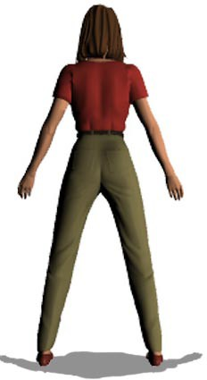
Rate discomfort for each region by writing the number (0 to 3 in the box.)
0=NONE/MINIMAL: No discomfort at all. Some discomfort, able to reasonable cope with discomfort while performing general tasks
1=MODERATE: Moderate discomfort, some difficulty in performing general activities
2=SEVERE: Significant difficulty in performing general activities
3=MAX: Maximum discomfort (unable to function, admitted to the hospital)

BODY PART |  | Left | Right
A | Head/Neck/Eyes
B | Shoulder/Upper Back
C | Low Back (Mid/Low)
D | Arms/Elbows
E | Hands/Wrists/Fingers
F | Legs/Feet
TOTAL SCORE
Please respond to questions below (circle response):

How physically hard do you rate your work? | Easy | Moderate
 | Hard | Very Hard
How much energy do you have left at the end of your shift? | Lots | Some
 | Little | None

OVER FOR ADDITIONAL COMMENTS

Please list suggestions to make your work more comfortable, safe and productive.

1.

2.

3.

4.

5.

