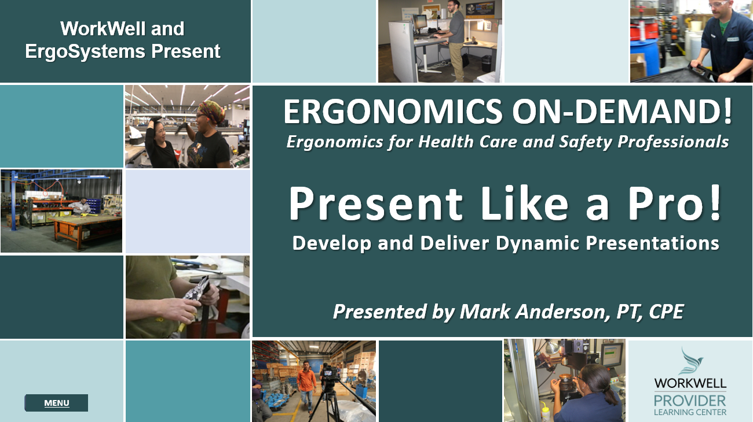
Developed by:
Mark A. Anderson, MA, PT, CPE
Certified Professional Ergonomist
Physical Therapist
ErgoSystems Consulting, LLC.
10205 28th Avenue North
Plymouth, MN 55441
Voice: 952-401-9296
Mark.Anderson@ergosystemsconsulting.com
www.ergosystemsconsulting.com

The information contained in this training workbook has been developed in good faith and is believed to present good ergonomics principles and practices. ErgoSystems Consulting, LLC and all other participating organizations make no representations or warranties as to the completeness or accuracy of the materials thereof. Persons using this information must make their own determination as to its suitability for their purposes. ErgoSystems Consulting, LLC and all other participating organizations are in no way responsible for damages of any nature resulting from the use of this information.
Copyright 2024 ErgoSystems Consulting, LLC, All Rights Reserved, Version 1.0_03132024

Present Like a Pro!
Develop and Deliver Dynamic Presentations

Table of Contents
Table of Contents 3
Have you had this question yet? 7
Step-by Step Development Process 7
Preparation 8
‘House Building’ 8
Presentation Skills 8
Instructional Design Worksheet 8
Generic or Custom Presentations 8
Generic Presentation 8
Custom Presentation 8
Financial Perspective 9
What are the employee costs? 9
What is the cost per attendee? 9
Tree Trunks, Branches and Leaves 9
Presentation Development Case Study 9
Understand your Audience 10
Presentation Format 10
File Formats 11
Distribution Channels 11
Version Control 11
Accessibility 11
Case Study Format 11
‘Take Aways' 11
Go to the End to get to the Beginning 11
Case Study ‘Take Aways’ 12
Mind Mapping 12
Mind Mapping Basic Tutorial 12
Tree Trunk, Branches and Leaves 13
Title 13
General Guidelines 13
Five Basic Presentation Guidelines 13
Open Big 14
Maximize Audience Involvement 14
Emphasize in Unusual Ways 14
Build in Redundancy 15
Close Big with a Call to Action 15
Case Study Mind Map 16
Outlining in Word 16
Main Topic 17
Bodies and Basketballs 18
Major Components 19
Expand the Major Components 20
‘Build the House’ 20
Storytelling 20
Asset Inventory 20
Onsite 20
Graphics 21
Generic 21
Asset Acquisition 21
Onsite 22
Personal Protective Equipment 22
Measurement Devices 22
Effective Interview Tips and Techniques 23
Setups 24
Designing Visuals and Graphics 24
Contrast 24
Balance 25
Emphasis. 25
Movement 25
White Space 25
Proportion 25
Hierarchy 25
Repetition 25
Rhythm 26
Pattern 26
Interactive Activities and Assessments 26
Hands-On Exercises 26
Formative Assessments 26
Summative Assessments 26
Case Study 26
Video, Image and Graphics Editing 27
Video Camera 27
Video and Image Editing Software 27
Still images from Video 28
Generic Graphics and Images 28
PowerPoint Outline 28
Import into PowerPoint 30
Slide Masters 30
PowerPoint Template 30
Review and Revision 32
Second Set of Eyes 32
Self Video 32
Client Preview 32
Practice . . .Practice . . . Practice! 32
Presentation Skills 33
Prepping the Room 33
Set up equipment 33
Choose an appropriate room layout 33
Room for micro-breaks 33
Optimize lighting 33
Optimize acoustics 33
Laptop or flash drive 34
Props and teaching aides 34
Public Speaking Anxiety 34
Practice regularly 34
Know your material 34
Visualize success 34
Use controlled breathing exercises 35
Crowd Control 35
Invade their space 35
Practice Emotional Intelligence 35
Acknowledge without encouragement 36
Use humor to defuse 36
Redirect focus 36
Seek assistance 36
Analyze Real Time Audience Feedback 36
Observe body language and facial expressions 36
Monitor engagement levels 36
Gauge verbal feedback 37
Enhancing Delivery and Impact 37
Using PowerPoint as an aide 37
Avoiding Slide-Reading 37
Filler words 37
Tips to reduce filler word use 37
PowerPoint Presenter View 38
Practice Mode 39
Voice Control 40
Vary your pitch, pace, and volume 40
Speak clearly and at an appropriate volume 40
Control your breathing 41
Body Language 41
Non-verbal cues 41
Posture and Movement 41
Eye Contact 41
General Logistics 42
Incorporate the Lessons Learned for the Next Presentation 42
Follow up with key stakeholders 42
Analyze post-presentation evaluations 42
Effective Instructional Design 43
References 43

Have you had this question yet?
Have you had this question yet?
“We really like what you’ve been doing for our Return to Work employees. We would like to train all of our employees in ergonomics. Do you have any training you can provide to our employees?”
Joe Morgan, Route Manager
I'm Mark Anderson, a Certified Professional Ergonomist and Physical Therapist. I vividly remember when I was first asked this question. I was working in an Industrial Rehabilitation program with Worker’s Compensation patients. One of our clients was a beverage bottler and distributor.
Talking with the Route Manager, he was interested in preventing further injuries and asked if I could provide ergonomics and injury prevention training for all of the route delivery employees.
I had done some one-on-one training on basic ergonomics principles and body mechanics but nothing like a formal training session. But I figured I could probably put some information together.
Interestingly enough, during summer breaks in my undergraduate college days I worked for a beverage distributor as a route delivery person. I was very familiar with the physical job demands and equipment used. In fact, I found out later from the Route Manager that one of the reasons I was hired for the training was I knew you had to pull a loaded two-wheeler up a flight of stairs and not push it!
At any rate, I put together what I thought was a dynamite 45 minute presentation. I had just finished a graduate degree in Physical Therapy and was in kind of an academic mindset. In other words, I was kind of full of it! I included all this great theoretical information about anatomy, physiology and biomechanics.
I previewed it for the Route Manager and to put it frankly, he tore it to shreds. He said it was boring, wasn’t information his route delivery guys would relate to and overall would not be effective.
Thankfully that wasn’t the end of the story. He offered to help me with it and collaboratively we developed a dynamic, engaging and effective presentation!
And that kicked off my journey into instructional design. Now, whether you're a seasoned pro or just getting started, I'm here to share my insights and tools that can empower you to create impactful content and deliver it with confidence.

Step-by Step Development Process
My plan is to take you behind the scenes to show you the step-by-step development process I have developed over the years. Here is my development process:

Preparation
- Determine if it is a custom or generic presentation
- Understand the audience
- Determine the presentation format
- Develop the ‘take aways’

‘House Building’
- Develop the Asset Inventory
- Acquire the Presentation Assets
- Prepare the Presentation
- Review the Presentation

Presentation Skills
- Practice, Practice, Practice
- Deliver the Presentation and obtain Feedback

Instructional Design Worksheet
To guide the development process we are going to use the Presentation Instructional Design Worksheet. I’ve developed it from my years of experience in Instructional Design. Please take a moment and access it through the Resources Tab so you can refer to it as we go along.

Generic or Custom Presentations
At this point in my career, just about 99.9% of the presentations I do are customized for the particular client I am working with. I recognize you may be asked to do generic presentations rather than customized ones, so let’s talk about generic versus custom presentations.

Generic Presentation
Have you had the situation where you had to sit through a generic presentation?
- How engaging was it?
- How much did it pull you in?
- How much did you get out of it?
More than likely the answer is, ‘Not Much!’. I suspect you are picking on my feelings about generic presentations!

Custom Presentation
From my very first experience in instructional design I learned the value of customizing presentation content. Your audience is much more engaged if they ‘see people they know, doing things they actually do’.
In my mind the effectiveness of a customized presentation is huge. They are much more likely to recall and make use of the ‘take aways’. We’ll define what I mean by ‘take aways’ a little later in our discussion.
When I am initially talking with clients about training, we discuss generic versus customized options. Honestly, from your fee perspective, customized will cost more than generic. It takes time and effort to customize. Is it worth it?

Financial Perspective
Here is how I approach the generic versus customized conversation from the financial standpoint. Let’s say the employer wants to put 300 employees through a 60 minute live presentation. They have a conference room large enough to accommodate 50 employees at one time, so I am going to do 6 sessions. My current presentation fee is $350/session, so $350 times 6 is $2100. Now to customize this will typically involve 3 hours onsite to get the content I want and another 3 hours to customize it. My office fee is $200/hour. So I have 6 hours times $200 for $1200.
Total for the 300 employees is $3300 for the customized version and if I do a generic version, it is $2100. So the difference is $1200.

What are the employee costs?
- Depending on the industry and location, average labor cost per hour might be about $28.
- 300 employees times $28/hour is $8400.

What is the cost per attendee?
- For the generic version the cost is $7.00 per person.
- For the customized version the cost is $11.00 per person.
- For an additional $4.00 per person they get a customized version.
In my experience the labor cost far outweighs your presentation fees. Customized training is phenomenally more impactful than generic training. For generic training they probably should just show them a generic video!
In my experience, once they see how much more a customized presentation brings to the table, most employers recognize the value of customized training and are willing to pay the additional fee.

Tree Trunks, Branches and Leaves
Now one more point about customized training. As you develop more and more customized training, you will start to see common elements in the content. I use the analogy of a tree. The ‘Tree Trunk’ becomes the constant from client to client. You will develop a solid foundation of content that you can use time and time again.
This will also include a number of ‘Branches’ that you can add based on your ‘take aways’. As you develop presentations you will have ‘Branches’ you can swap for other ‘Branches’ as you need to. You graft whatever you need to the ‘Tree Trunk’.
Then as you work to customize the presentation for a particular client, you are attaching ‘Leaves’ that are unique to that client’s particular situation. We’ll discuss a little later exactly how to get the ‘Leaves’ you need.

Presentation Development Case Study
As we explore the development steps, we are going to develop a Case Study presentation. Our client is the Safety Specialist for the City of Minneapolis Public Works Department. He has asked for a 45 minute presentation on Ergonomics and Back Care to be presented to Public Works employees during their annual Safety Days. The presentation will be repeated four times over the course of two days.

Understand your Audience
Before diving into content creation, it's crucial we understand the audience demographics, learn their preferences and their existing knowledge levels. How can we do this?
Well, maybe you have already been working with company employees and you have a good sense of their demographics. This is the situation for our Case Study. Our Audience consists of:
- Employees who work in Fleet Services, including mechanics and general labor
- We have a gender mix of about 80% male and 20% female
- Age range is in the early 20’s to late 60’s
- Most have been in physically active jobs in their careers
- Many have had musculoskeletal issues over the years
- Each session will have about 30 to 40 attendees
What if you are not familiar with your audience? In this case, I request a ‘walk through’ of the workplace to observe firsthand the job demands and have a chance to talk with future presentation attendees. You also can interview managers and supervisors to get their perspective. Another option is to administer a specific needs assessment to identify specific learning goals and any knowledge gaps that need to be addressed.
When you don’t have a good understanding of your Audience, my experience is that things don’t go well. Spend the time and effort upfront, you will find it is a critical component to a successful presentation or one that falls flat on its face. And that is not good for anyone!
A little later, we’ll discuss the value and mechanics of customizing presentations to greatly enhance effectiveness. As we’ll discuss, I do this by obtaining video and stills of examples of pertinent job tasks that include employee interviews, before and after examples and other information. This gives me an excellent understanding of the audience and their needs. It also provides the custom content I incorporate into the presentation.

Presentation Format
At this point, working with your client, you need to determine the presentation format.
- Will it be a live standup presentation.
- Will it be a self-directed on-demand format?
- Or some other format?
Well, that of course will depend on the needs of the client and also your development skills.
For example I have developed presentations that range all the way from live 10 minute ‘tool box talks’ to ‘self-directed, on-demand’ training programs that are day long. Depending on the level of training material development you also may have to consider and understand formatting and distribution.

File Formats
Think about choosing appropriate file formats for different types of materials, such as PDFs for printable documents, PowerPoint presentations for live sessions and SCORM packages for e-learning modules.

Distribution Channels
Determine the best distribution channels for delivering training content and materials. This could be live stand-up presentations, online learning management systems (LMS), email, cloud storage or printed handouts.

Version Control
Presentations will go through changes as you work with them. Version control measures to track changes and ensure that learners have access to the most current version of the materials can be important.

Accessibility
You want to ensure the training materials are accessible to all learners, including those with disabilities. Use of clear fonts, appropriate color contrast, alt text for images and captioning for videos will be needed.

Case Study Format
I suspect most of you will be involved in live standup presentations using PowerPoint or perhaps some other presentation software. For our Case Study we are going to focus on developing a live standup presentation using PowerPoint.
As an interesting note another level of your involvement in training development may be as a Subject Matter Expert. I have done this a number of times working with Instructional Design and Production professionals.

‘Take Aways'
Now that we know whether the presentation is generic or customized, the format required and we understand our audience, we have to focus on the objectives of the training. What content do we need to meet the training objectives?
This, of course, is a collaborative effort between yourself and your client. What specifically does the client want to achieve? I call these, ‘Take Aways’.

Go to the End to get to the Beginning
What are ‘Take Aways’? When I develop content, I go to the end to get to the beginning. What do I mean? Imagine your presentation is over, participants are leaving. If asked, what would be the three to five things you want them to be able to repeat back to you that they recall from your presentation.
These become your training objectives and your presentation needs to be developed, formatted and presented to accomplish them. One thing I have learned is, It’s not what you know that is important, it is what the audience ‘takes away’.

Case Study ‘Take Aways’
Let’s work on the ‘take aways’ for our Public Works Department presentation. The general topic from the Safety Specialist is a presentation on Ergonomics and Back Care. That is quite broad and we could go in many different directions. How do we focus it? I use a process called Mind Mapping.

Mind Mapping
You might have heard of Mind Mapping. I first discovered it early in my instructional training development; I came across a book by Michael J Gelb called Present Yourself: The Simple Way to Give Powerful and Effective Presentations. I found it quite helpful in terms of five basic presentation guidelines that we will go through shortly. It is still in print and I would encourage you to pick up a copy. Gelb’s book also included information about Mind Mapping.
Mind Mapping has roots in the works of ancient philosophers and educators who used diagrams to visualize knowledge. However, the modern mind mapping technique that I discovered was popularized by British psychologist Tony Buzan in the 1970’s.
Buzan argued that traditional note-taking methods were linear and restrictive and he proposed Mind Mapping as a way to harness the brain's capacity for imaging and association in a way that is more natural and effective. I tend to be a visual and spatial learner and this made a lot of sense to me.

Mind Mapping Basic Tutorial
To create a mind map, you would follow these basic steps:

Start with a central idea
- Place the main concept or subject matter at the center of the page. This could be a word or an image representing the theme you're exploring.

Draw branches for major categories
- From the central idea, draw branches outwards to represent major categories or themes related to your central idea. Use keywords or short phrases on these branches.

Add sub-branches for details
- For each major category, draw sub-branches to break down the ideas into more specific details or subcategories. Continue branching out as needed to explore deeper levels of detail.

Use colors and images
- To make your mind map more engaging and distinct, use different colors for different branches or themes. Incorporating images or symbols can also enhance the visual impact and effectiveness of your mind map.

Connect ideas
- As you identify connections between different branches or ideas, draw lines or arrows to link them. This helps in understanding the relationships and dependencies between concepts.
To generate Mind Maps you can start with a piece of paper and colored pens. You probably have some software you can already use. For instance you can use Smart Art in PowerPoint. Also other apps are available for free or subscription. Search on “Mind Map apps for free” for an idea of what is available. For our case study I will show you the method I currently use.

Tree Trunk, Branches and Leaves
For your first presentations you will put together your ‘tree trunk’. Based on your ‘take aways’.
For example, for a short presentation, 15 to 30 minutes, I might have three ‘take aways’. As the presentations get longer and include more information, you will identify more ‘take aways’. I have developed presentations that are day-long and even longer; for these you certainly will have considerably more ‘take aways’. I have to make sure the presentation has the content and structure that facilitates audience understanding, remembering and applying these ‘take aways’.

Title
At some point you will need to come up with a title for your presentation. Typically I have a working title I’ll use during the development period. Then when I am done, I’ll come up with an engaging title.

General Guidelines
Here are some general guidelines to help you come up with a compelling title for your presentation:
Be clear and descriptive: Ensure your title clearly reflects the topic and purpose of your presentation.
Engage curiosity: Use language that sparks interest and curiosity in your audience. Pose questions or tease intriguing points.
Promise benefits: Highlight the benefits or outcomes your audience will gain from attending your presentation .
Tell a story: Craft a title that suggests a narrative or story to captivate your audience.
Keep it concise: Aim for a concise title that is easy to remember and communicate. This can include a main title with a subtitle for more details. The examples below use this strategy.
- "Empowering Employees Through Ergonomics: Strategies for a Healthier, More Productive Workforce"
- "Investing in Health: Implementing Effective Ergonomic Practices to Reduce Workplace Injuries"
- "Achieving Optimal Performance: The Role of Ergonomics in Employee Safety and Productivity"
- "Lift Smart, Stay Strong: Proper Body Mechanics for Safe and Effective Lifting"

Five Basic Presentation Guidelines
Expanding on Gelb’s book, ‘Present Yourself’, I use five basic guidelines when I develop any presentation:
- Open Big!
- Maximize Audience Involvement!
- Emphasize in Unusual Ways!
- Build in Redundancy!
- Close Big with a Call to Action!

Open Big
Start your presentation with something memorable to grab your audience's attention from the get-go. Here are some ideas.
- Use a short, engaging story or anecdote that relates directly to your main message.
- Begin with a striking visual or video clip that directly relates to your topic, setting a vivid scene.
- Present a challenging question that provokes thought and directly involves the audience in the subject matter.
- Use a relevant, surprising fact or statistic that frames the significance of your topic in a new light.
- Start with a dynamic, interactive activity that directly involves the audience, making the experience immersive from the outset.

Maximize Audience Involvement
How long is a person’s typical attention span? Two hours, an hour, 30 minutes? How about 10 to 15 minutes! That is what research tells us. My goal is to actively involve the audience about every 15 minutes to keep their attention and make the message more memorable. Here are some ideas.
- Conduct a live poll on a topic related to your presentation to see where the audience stands and tailor your content accordingly.
- Ask for volunteers for a demonstration that illustrates one of your points.
- Use thought-provoking questions to encourage audience reflection and discussion, making the presentation more of a two-way conversation.
- Implement a real-time Q&A session, encouraging the audience to submit questions throughout the presentation.
- Break the audience into small groups for a brief discussion on a relevant question, sharing summaries afterward.
- Invite the audience to share their experiences related to your topic, creating a shared learning environment.
- Incorporate elements like quizzes or interactive games that reinforce your key points.

Emphasize in Unusual Ways
If nothing else, your goal is to make the presentation interesting to your audience. Now hopefully you are also imparting valuable information, but if they are not tuned in it won’t matter anyway!
Highlight your key points in creative and unexpected ways to ensure they stick with your audience. Here are some ideas.
- Use a striking visual metaphor in your slides to represent a complex idea, making it easier for the audience to understand and remember.
- Incorporate a physical prop that symbolizes a major point in your presentation.
- Share a personal or historical story that parallels the main theme of your presentation, creating a vivid, emotional connection to the material.
- Use a live demonstration or experiment that visually represents a concept or problem.
- Incorporate music or sound effects that enhance and underscore key points or transitions.
- Create a role-play scenario that illustrates a point vividly.

Build in Redundancy
Recall we are looking to have our audience be able to recite back the ‘take aways’. Hearing something once will not do this. Build in redundancy to reinforce your message through repetition. Make sure you do this in varied and engaging ways. Here are some ideas.
- Summarize your key points at the end of each section of your presentation, but with different wording or perspectives each time.
- Use a recurring visual theme in your slides that ties back to your main message, subtly reinforcing it throughout the presentation.
- Revisit a critical point through audience interaction, such as asking them to share how they might apply what they've learned in their context.
- Integrate a catchy phrase or slogan that encapsulates your key message, repeating it throughout.
- Use a series of related images or icons throughout your presentation that symbolize your main points.
- Create a recurring Q&A moment after each section to recap and reinforce the information shared.
- Use parallel structures in your storytelling to reinforce the narrative arc of your presentation.

Close Big with a Call to Action
End your presentation with a powerful conclusion and a clear directive for your audience. Please do not say, “That’s all I have. Any Questions?” Here are some better ideas.
- Challenge your audience to take a specific action that relates to your presentation topic, making it time-bound and measurable.
- Inspire your audience by sharing a vision of what could be achieved if the ideas presented are implemented, encouraging them to be part of that change.
- Provide a simple, straightforward step they can take immediately after the presentation.
- Showcase a success story of someone who implemented the advice or strategy you're advocating, illustrating the potential impact.
- Offer a resource, like a toolkit or guide, that supports the audience in taking the next steps, providing immediate value.
By diversifying your approach within these five steps, you can create a presentation that not only captures and retains attention but also motivates your audience to act, ensuring your message has a lasting impact.

Case Study Mind Map
Let’s work on the Mind Map for our case study. When I first started using Mind Maps, I actually did them on a large pad of paper with different color pens. It worked pretty well, but the problem was it was analog. From there I would need to create an outline in Word that I would import into PowerPoint to complete the presentation slide deck.
What I have evolved to is to skip the paper pad and go directly to the power of Outlining in Word. With proper formatting this outline can be imported directly into PowerPoint so you can work on the actual presentation. For many of my presentations, I also create manuals that complement the PowerPoint slide deck. Once you have the outline completed you can readily expand it to a narrative format for the manual. This is the process I used to develop all of the content for Ergonomics On-Demand.
By no means am I saying this is the only way to do this, I appreciate there are many development strategies available. Quite honestly, I also believe Artificial Intelligence applications like ChatGPT and others will revolutionize this whole process.

Outlining in Word
My intent here is not to go in-depth into showing you how to use Outlining. Other resources are available to you. With that said, here is a quick overview of how I am using it. The Outline function allows you to create levels of an outline; Level 1, Level 2, Level 3, Level 4 and so on. You can format the font style of the heading levels. Here is a sample of what it looks like.
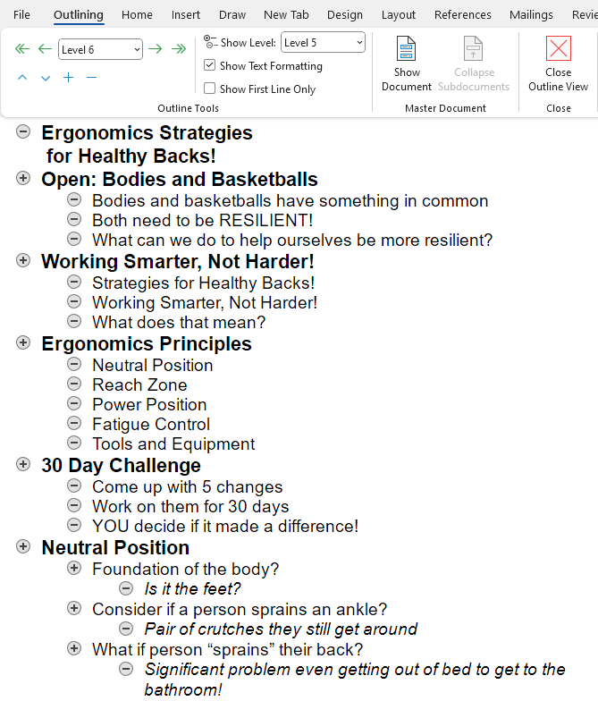
Here is why I use it, when you import the properly formatted outline into PowerPoint, the outline levels are used to generate the slides. Each Level 1 heading becomes the title of the slide and the remaining levels are the headings and subheadings on the slide.
When we get to PowerPoint, I will also show you how I use Master Slides to very quickly design the slide format. But I am getting ahead of myself.
At any rate for right now let’s use the Mind Mapping strategy to pull together our thoughts for our case study presentation. I have included two Outlines as part of your training materials, the Mind Map Outline for Mind Mapping and the PowerPoint Outline for importing into PowerPoint. Please locate them in the Resources Tab to reference them and follow along.

Main Topic
Our main topic is Ergonomics and Back Care. The presentation title we are going with is, ‘Ergonomics Strategies for Healthy Backs’.
So in the Outline our first Level 1 heading is Ergonomics Strategies for Healthy Backs.
What topics do you think we could include that would support the main topic? Note: Remember we also want to address the Five Basic Presentation Guidelines as we work on the ‘Take Aways’.
Let’s brainstorm on the major components of the presentation. These will become our ‘Take Aways’. Based on your experience, list a number of objectives you could have.
- ____________________________________________________________________
- ____________________________________________________________________
- ____________________________________________________________________
- ____________________________________________________________________
- ____________________________________________________________________
- ____________________________________________________________________
- ____________________________________________________________________
- ____________________________________________________________________
- ____________________________________________________________________

Bodies and Basketballs
I am going to jump ahead and show you how the actual Open Big slide looks. The completed PowerPoint presentation is found at the Resource Tab. I encourage you to review it to get an overall perspective of the finished product.
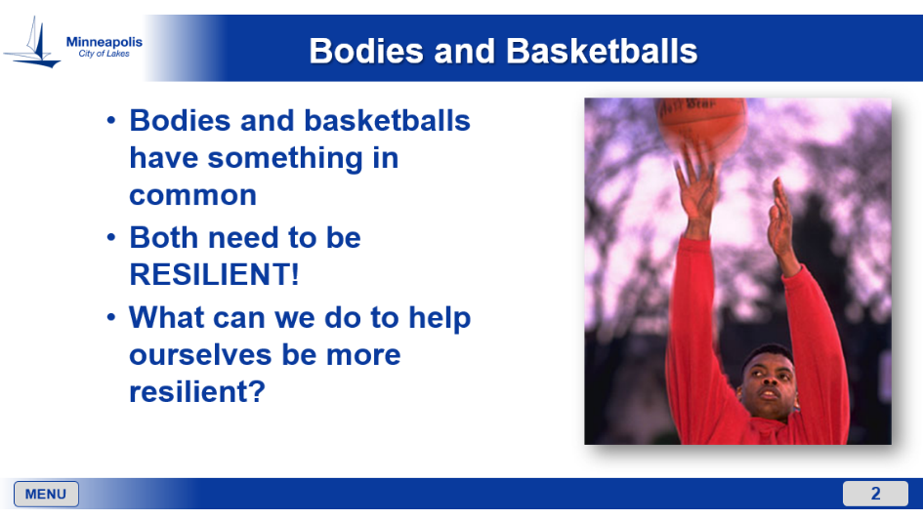
Here is how I would open with this slide.
Bodies and Basketballs
We want to ‘Open Big’. For this opening I hold up my model of the spine and a basketball. I ask the audience . . .
“What do Bodies and Basketballs have in common?”
“Aside from it being round what is the most important characteristic of the basketball?”
I then drop the underinflated basketball on the floor and of course it doesn’t bounce! I then say.
“Well, I guess this is going to go real well!”
“If this is the tool we are using to play the game, we need a basketball that has enough air in it to bounce!”
“It needs to be resilient!”
“Now think about what we ask our bodies to do day in and day out. We need bodies that are resilient as well. I am not saying you should see how well you can bounce, but what I am saying is we are going to talk about a number of strategies you can use to help your body be more resilient!’
Here is the Mind Map Outline in Word for this slide (please reference it via the Reference Tab to look at it in the Word document). You will see that Show Level: Level 2 is selected. So we are seeing both Level 1 and 2.
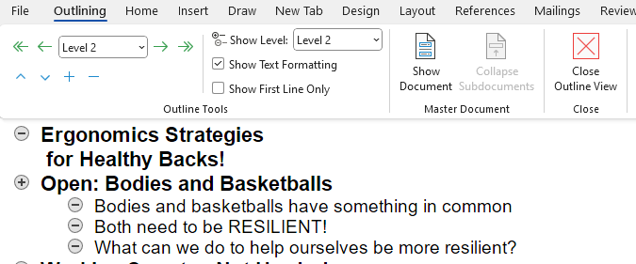

Major Components
Here are the major components (Level 1 of the Outline) of the presentation I included. More than likely your list will have some common elements with mine and some others that are not in common. And that is fine; you can certainly use these elements but what is most important is for you to make your presentations yours!
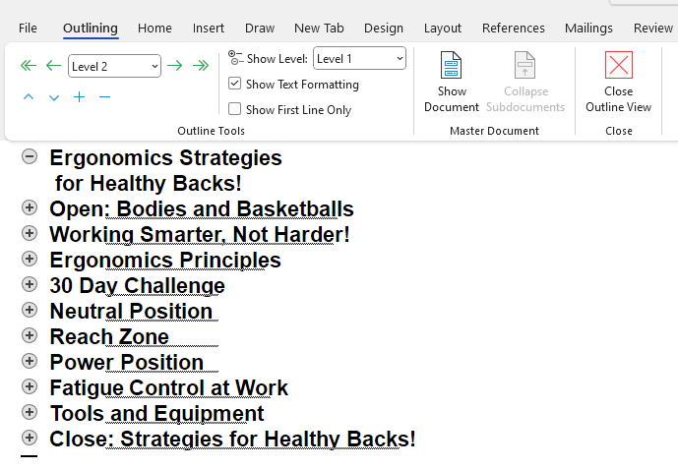
As you will see we are going to define ergonomics as ‘Working Harder, Not Smarter!’, we will preview the ergonomics principles, we will offer the 30 Day Challenge to make use of the principles over the next 30 days, we will expand on the basic ergonomics principles of Neutral Position, Reach Zone, Power Position, Fatigue Control at Work and Tools and Equipment. We will close with a Call for Action on the strategies.

Expand the Major Components
At this point please take the opportunity to closely look at the Word Outline. You will see I have expanded each major component to add detail. We will need to do some more formatting to allow it to be imported into PowerPoint. Each separate slide needs to have a Level 1 heading and then the other lower level headings. I have included a second Word document (PowerPoint Outline) that does just this.
Now that we have the ‘Take Aways’ in a conceptual format, the next step is to make it a reality.

‘Build the House’
We have compiled the ‘blueprint’ for the presentation, next we get to ‘build the house’. That is the analogy I use; we are going to build the house, the presentation. Let’s go through some overview concepts of ‘house building’.

Storytelling
As long as there have been humans, humans have been storytellers. Before the development of written language, storytelling was how we passed information to the next generation. And even to this day, storytelling remains a powerful mode of communication!
We want to use storytelling techniques to make the presentation relatable and memorable to our audience. We want to capture our audience's attention with dynamic and interactive content. We want to incorporate multimedia elements such as videos, images and graphics to enhance comprehension and retention.
Use your experience to add your stories to the presentation. As appropriate, bring in examples from your personal and professional life. Make the stories topical based on what is going on in your world!

Asset Inventory
As I develop the presentation content, I work with my client and other sources to develop what I call an Asset Inventory. This is a list of the assets I need for the presentation. This will be based on the Mind Map we developed within the context of the five basic presentation guidelines. Also some of the assets may come from other sources. I will provide more details in the Assets Acquisition section. This includes three categories:
- Onsite – Examples: video of specific jobs and tasks, interviews with employees, specific video that I can pull stills from and so on.
- Graphics – Graphics that I either need to produce or source already produced.
- Generic – Assets that are not unique to the client site.
Here is the Asset Inventory for our case study presentation. Refer to the Instructional Design Worksheet Case Study to see them added to the Worksheet.

Onsite
- Cover shots of various employees doing typical tasks (I get these by pulling still frames from the video, I will talk more about this in the Assets Acquisition section.)
  - Head shots – pulled from video
  - Workbench/workstation
  - Tool and equipment use
  - Work processes
  - Etc.
- Video of employee talking about concept of “Working Smarter, Not Harder”
- Video of me talking with an employee
- Video of before and after examples of using Neutral Position
- Video of employee holding an item at arm’s length and close to the body
- Video of employee demonstrating the Operating Range
- Video of employee doing a task within their operating range
- Video of employee performing a task using the power position
- Video of employee talking about importance of “Planning” as part of material handling
- Video of me demonstrating and teaching the Power Lifting technique to employees
- Video of employee demonstrating Power Lift technique
- Video of employees stretching at work
- Videos of employees using tools and equipment ( 3 or 4 examples)
- Video of employees using mechanical handling equipment
- Video of employee talking about problem solving

Graphics
- Graphic of “Working Harder, Not Smarter”
- Ergonomics principles graphic
- Graphic of side view of the spine
- Graphic of a spring
- Power Position, Power Zone (Green, Yellow and Red)
- Graphic of three stretches (Back Bend, Power Squat, Large Arm Circles)
- Menu graphic

Generic
- Picture of a basketball
- Employee standing, close up of feet/legs
- Person using crutches
- Person experiencing back pain
- “Ready Position” with sports
- Person using water fountain; 1. Back bent/straight leg and 2. Using Power Position
- Weight lifter using power lift technique
- Person sleeping in bed

Asset Acquisition
So, at this point we understand our audience, decided on the presentation format, determined our ‘take aways’ and developed our Asset Inventory. The next step is to acquire the assets to customize the presentation. These are the ‘Leaves’ we talked about that you add to your ‘Tree Trunk’ and ‘Branches’. Here is the process I use to obtain the assets.

Onsite
Put together your Asset Tool Box; it will have several trays.

Personal Protective Equipment
Ensure that YOU have the proper personal protective equipment and attire. At a minimum, YOU may need eye, foot, clothing, head, and hearing protection. Don’t take it for granted; communicate with your client contact to understand what the company requirements are. Dress at the proper level based on the worker's level of attire. For example, do not show up in a suit on an assembly production floor, just as jeans, steel toe boots and a work shirt may not be appropriate for a boardroom.

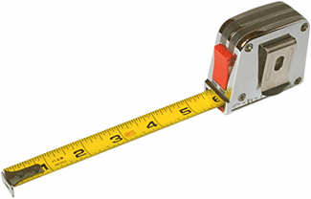
Measurement Devices
To take measurements of the workplace, you'll need:
- Tape measure – I suggest you have at least a 12 foot/3 meter tape measure that is robust enough so you can extend it out a fair distance without it collapsing.
- Photographic equipment – I strongly encourage you to use video rather than still cameras, you will pull freeze frames off the video to get the images you want.
A word about video and cameras in general. Typically, you must get approval for the video and/or pictures from the appropriate individuals, including employees, supervisors, managers, etc. In a few cases a written release may be needed.

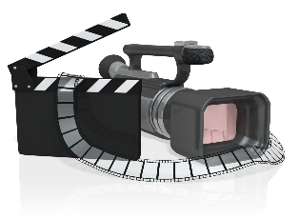
Why use Video?
I have been using video ever since I first started instructional design development. My thought is if a picture is worth 1,000 words, a moving picture (video) must be worth at least 5,000 words. With the Prosumer video cameras (prosumer camcorders combine professional-level features with ease of use for fast and discreet 4K and full HD filmmaking on the go) available you can get reasonable quality video and pull decent resolution stills from the video.

Video “Secrets”
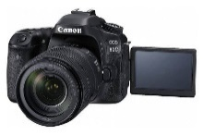
Don’t be accused of making home videos, follow these guidelines.
- I am not going to make any specific recommendations for the brand and model of a video camera. I use a camera that is at the Prosumer level.
- Use a camera with a flip-out view finder. This allows you to position the camera to get the shot and still see the view finder.
- Use enough light; low light causes grainy video that is hard to analyze. If you know you will be in a low light area, see if you can obtain more light in the area.
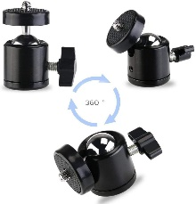
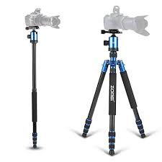
- Use a tripod or monopod as much as you can. You will get much better quality video.
- A monopod works very well to get overhead shots.
- A swivel ballhead mounted between the camera and the monopod works well to position the camera and still see the view finder.
- A wide angle lens will allow you to work in close quarters.
- If you have to use a handheld technique, build a bridge with your arm against your body for stability.
- Always have a backup power supply; either additional battery packs or able to run off of wall current with the AC adapter.
Plan your video sequence. Use your Asset Inventory to know what shots you want.
- Use the zoom sparingly. Zooming in and out and in and out will drive your audience crazy.
- Use manual focus (if available) to stop the auto focus from searching.
- Pan (move from side to side) the camera about three times more slowly than what your eyes can track.
- After videoing a few seconds, check to make sure the camcorder is working correctly. I have learned this the hard way!
- In a loud environment, use a separate microphone to pick up audio from interviews.
- Be aware of your surroundings; don’t walk into equipment, people, etc. I always try to have someone watching ‘my back’ to keep me out of trouble.

Effective Interview Tips and Techniques
An important aspect of the customization process is to obtain video clips that are concise and on point. Follow these tips:

Establish a conducive environment
- Try to limit background noise.
- Use an area that provides some privacy, so the person feels comfortable.
- Set up the camera at about head level within 2 or 3 feet of the person and close to you, that way the person can talk to you not the camera (it will still look like they are talking to the camera and not that weird looking off to the side look).
- Some people are just naturally more comfortable being on camera, if you have someone who is not, that is fine and just move on to someone else.
- I always tell them my intent is never to embarrass them, I will always put them in a ‘good light’ for their interview.

Prepare structured questions
- Have your questions in mind so you have a plan.
- Review the questions with them in advance to give them some time to think about answers and practice.
- I have learned to video the practice sessions, sometimes their first response is the most natural.

Practice active listening
- Pay full attention to the interviewee's responses, demonstrating engagement and understanding, I often nod at them as they are speaking to give them affirmation.
- I ask them to imagine I am a new employee and they are helping me learn my job, people do well when they talk about things in which they are expert..
- Do not speak over them. when they finish a thought, let it ‘breath’ a little before you speak, otherwise it will be difficult to edit later.
- I always let them know we can do as many takes as we need to get what we want.

Ask probing questions
- Avoid asking only Yes/No questions, ask open-ended questions.
- Encourage them to elaborate on their experiences and provide specific examples.
- Provide clear and specific feedback to help them give an answer.
- Sometimes I will give them an idea of how they could answer the question to see if that helps them formulate an answer.

Some typical questions
- “Please tell me your name, what your job is and where we are.”
- “Please take me step-by-step through the process you are showing me.”
- “Based on your experience what three tips and techniques would you want a new employee to know?”
- “What three things do you wish you knew when you started that you know now?”
- “Anything else you want to add?”

Reflect on your own performance
Identify areas where you can improve your interviewing skills. We all get better with practice.

Setups
To make it as realistic as we can, I try to video actual job tasks. Sometimes this will not work. Let’s say you have found out what you really want on video is not currently in operation. Here are a couple of options.
- First see if they can set up a reasonable simulation to make the points you want. This can work quite well to get content you can use.
- If this is not possible, have them verbally tell you what the situation is; this gives you something you can use to bring up the point in the training.

Designing Visuals and Graphics
While this is not a course on graphics design it makes sense to consider some basic graphics design principles as we build the PowerPoint presentation.

Contrast
Use contrasting colors, sizes, and shapes to draw attention to important elements.
- Use dark text on a light background for easy readability.
- Use bright colors for headings and key statistics.
- Use contrasting shapes to distinguish different types of data.

Balance
Distribute visual elements evenly to create a stable and harmonious design.
- Use symmetrical layouts for formal presentations.
- Use asymmetrical layouts for dynamic and informal presentations.
- Use empty space to balance heavy text or graphics.

Emphasis.
Highlight key information or sections to draw attention.
- Use larger fonts for headings.
- Use bold or italic fonts for important words.
- Place key elements in focal areas of the slide.

Movement
Guide the viewer's eye across the slide in a logical sequence.
- Use directional arrows or lines.
- Use animation to highlight transitions.
- Use a consistent flow of information from one slide to the next.

White Space
Leave ample space around slide elements to prevent overcrowding and improve clarity.
- Use margins around text and images.
- Use empty space to create focal points.
- Use white space to create a sense of calm and sophistication.

Proportion
Adjust the size and scale of elements in relation to each other to create a visually appealing design.
- Use larger fonts for headings and smaller fonts for body text.
- Use larger images for important visuals and smaller images for supporting information.
- Use consistent spacing between elements.

Hierarchy
Organize elements to reflect their relative importance.
- Use larger fonts for more important information.
- Use different colors for different levels of information.
- Use indentation or white space to visually separate different levels of information.

Repetition
Repeat visual elements throughout the presentation to create unity and consistency.
- Use a consistent color scheme throughout the presentation.
- Use similar fonts and typefaces for all text elements.
- Use repeating patterns or graphics to create visual interest.

Rhythm
Use repeated patterns or sequences to create a visual flow.
- Use alternating colors for rows of data.
- Use a consistent grid layout for multiple images or text boxes.
- Use repeated shapes or patterns to create a sense of movement.

Pattern
Use patterns to add visual interest or to unify different parts of the presentation.
- Use a subtle background texture to add interest to the presentation.
- Use patterned borders or frames to highlight different sections of the presentation.
- Use patterns to create a brand identity for the presentation.

Interactive Activities and Assessments
We know the more interactive we can make the presentation the more informative it becomes. Here are some methods to accomplish this.

Hands-On Exercises
Include interactive activities, case studies, simulations, and role-playing exercises to reinforce learning and promote active engagement.

Formative Assessments
Incorporate quizzes, self-assessments and knowledge checks throughout the training to gauge learners' understanding and provide feedback.

Summative Assessments
Evaluate learners' comprehension and skill mastery through final assessments, such as tests, projects, or presentations.

Case Study
Let’s work on our Case Study. So far, we have determined our audience background and training needs. Our presentation is a customized, live stand-up format using PowerPoint as the media. Using a Mind Map process we determined our ‘take aways’ and developed the Mind Map Outline in Word to document it. We identified the assets we needed by generating the Asset Inventory.
We have been onsite at the client and obtained the raw footage of the video and other information we needed. As we work on the presentation, we have some technical questions to answer.
- How to take the raw video footage and turn it into finished video clips?
- How to create the stills needed from the video?
- How to obtain the generic images?
- How to create the graphics?
I am going to share with you the process I have developed over the years. It has worked well for me, but I also recognize there are many other methods available. You may very use a different process; use what works for you.

Video, Image and Graphics Editing
Let’s start with acquiring and editing the video. When I started with video as part of my presentations, VHS video tape was the format. I had a VHS camera and with two VHS machines I would copy video from one to the other. Then digital video tape was the next evolution and now everything is HD video recorded onto cards.

Video Camera
You can spend thousands of dollars on a professional camera, but you don’t need to. Many prosumer level cameras are available for between $500 and $1000. Prosumer camcorders combine professional-level features with ease of use for fast and discreet 4K and full HD filmmaking on the go.
Review my recommendations for camera features in the Assets Acquisition section. I am not going to make a specific recommendation for a brand and model. Everyone will have different needs. Some of you may have video production services available through your employer. Here is a list of prosumer level cameras under $1000.
- Panasonic Lumix G7
- Nikon D5600
- Sony a6400
- FUJIFILM X-T30 II
- Sony 7 II
- Canon EOS RP
- Canon EOS 5D Mark III

Video and Image Editing Software
If you don’t have any experience editing videos and images, I would encourage you to acquire some basic editing software and learn the basics yourself. Honestly, you are not going to be making videos that will win an Oscar and you don’t need to.
My experience is you need to be able to take raw video and edit it into clips that you insert into the PowerPoint presentation. This is essentially a cut and paste process and you export the edited version.
Do a search on ‘basic video editing software’ to see what is available. I use Adobe Elements. Adobe Elements 2024 is the most recent version. It includes two main applications: Photoshop Elements and Premiere Elements.
I have both Photoshop Elements and Premiere Elements and have found it pretty straightforward to edit video and photos for use in PowerPoint and other applications. Looking at the Adobe website you can get both for about $170. It is not a subscription; you own it outright. I am not affiliated with Adobe. You may have other resources you can use if you decide to incorporate custom video and images into your presentation. I would encourage you to explore your options as you need to.

Still images from Video
I use the media player from VLC to pull still images from video. VLC is a free and open source cross-platform multimedia player and framework that plays most multimedia files.
https://www.videolan.org/
You can take ‘Snap Shots’ directly from the player.
https://www.howtogeek.com/831597/how-to-take-snapshots-in-vlc/
I have found it a very fast and efficient method to get still images.

Generic Graphics and Images
You will certainly be using generic graphics and images in your presentations. I suspect you have already done Google image searches. Please be aware that while you are able to acquire images and graphics this way, they may be subject to copyright. I am aware of situations where copyrighted images were used without permission and this created legal issues.
Here are a several options I have used to make sure I am not in violation of any copyright laws.
- Take your own – I have developed my own library of generic images that I have personally taken and can use at my discretion.
- Permission from clients – Occasionally I am able to gain permission from clients to use images used in their presentations for other presentations.
- PresenterMedia – A subscription service for $50/year. You can create custom graphics, have access to PowerPoint templates and animation, clipart and more. I am not affiliated with PresenterMedia.
https://www.presentermedia.com/dashboard
- Purchase images – Many resources are available on-line, where you can purchase rights to images. Do a search on ‘purchase stock images’. I am not affiliated with any of them.
- Free access images – Free to use images are available on-line.
  - Adobe Stock (https://stock.adobe.com/free)
  - Pexels (https://www.pexels.com/)
  - Conduct a search for others

PowerPoint Outline
Recall we used Outlining in Word as a Mind Map to develop our ‘take aways’ and from that we created the Asset Inventory. Now we have one more step to go through to turn the Mind Map Outline into a document we can import into PowerPoint. We call this the PowerPoint Outline. You will find it in the Resources Tab.
Always remember to view the documents in Outlining View in Word so you will see the document properly formatted in the Outline view.
When you import the properly formatted outline into PowerPoint, the outline levels are used to generate the slides. Each Level 1 heading becomes the title of the slide and the remaining levels are the headings and subheadings on the slide. To create the PowerPoint Outline, for every individual slide I wanted, I used the Level 1 format for the slide title and then Level 2 and 3 for the Headings and Subheadings. Here is what it looks like.
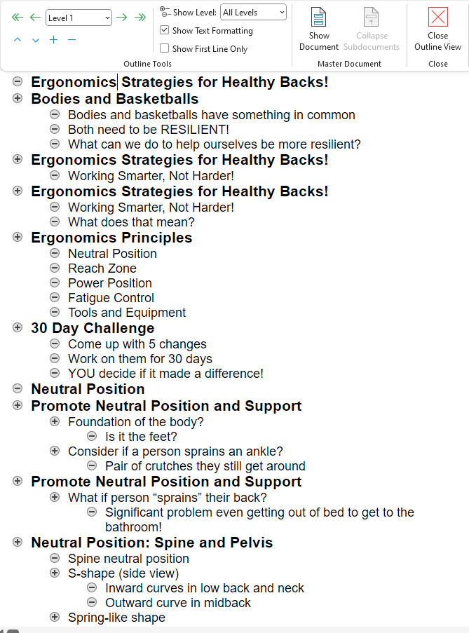

Import into PowerPoint

Slide Masters
Now that we have the PowerPoint Outline formatted properly, we can import it into PowerPoint. When we import it into a new blank PowerPoint document you will see each Heading 1 has its own slide. However, we would have a lot of work ahead of us to make it look the way we want it to.
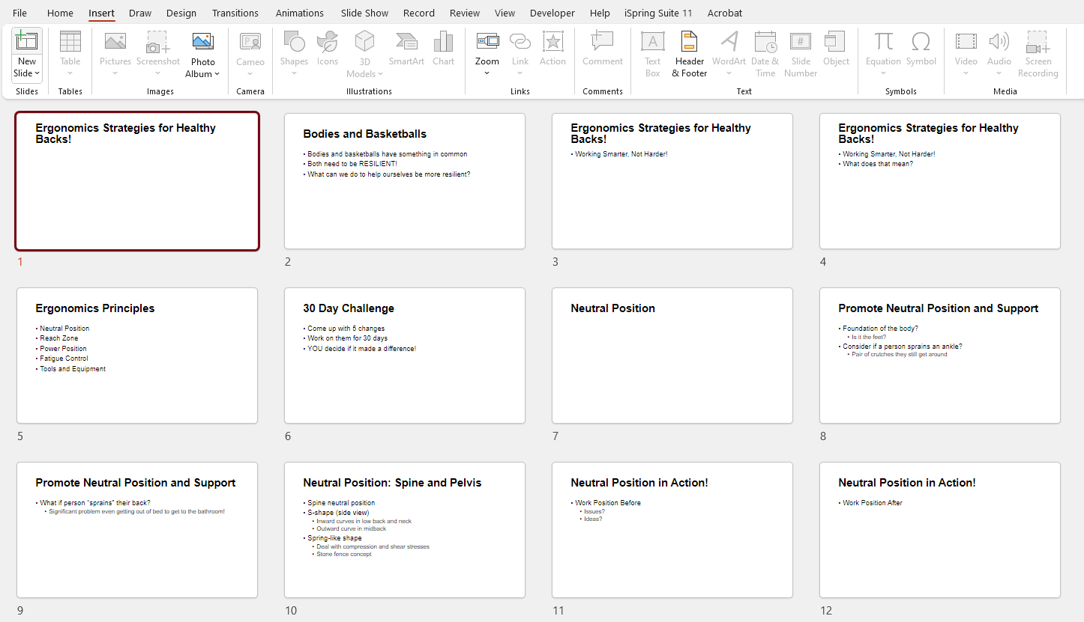

PowerPoint Template
It would be great if we could use a PowerPoint template so we can get the look and feel we want for the presentation! I created a template that I used for the ‘Ergonomics Strategies for Healthy Backs’ presentation that we will use. The PowerPoint template with the Slide Master and associated Layout Masters are located in the Resources Tab.
The template uses Slide Masters. If you are not familiar with using Slide Masters and Layout Masters, I encourage you to learn more about them. They will save you incredible amounts of development time. Look for tutorials on line.
Slide Masters in PowerPoint are a powerful feature designed to help users create consistent formatting across all slides in a presentation. They control the overall appearance of your presentation, including the default layout, fonts, colors, and bullet styles.
By editing the Slide Master, changes are automatically applied to all slides, saving time and ensuring uniformity.
- Define Slide Look: The Slide Master controls fonts, colors, bullets, and more for the entire presentation.
- Consistency Across Slides: Ensures a consistent look and feel across all slides by making global style change​​.
- Efficiency in Editing: Allows for efficient modifications to slide layouts and design elements, affecting all slides at once.
- Focus on Content: Encourages the use of brief points and visual cues, enhancing the presentation's effectiveness without the need for extensive text or detailed sentence​.
I have used the template to format the Outline we created. Here is what it looks like.
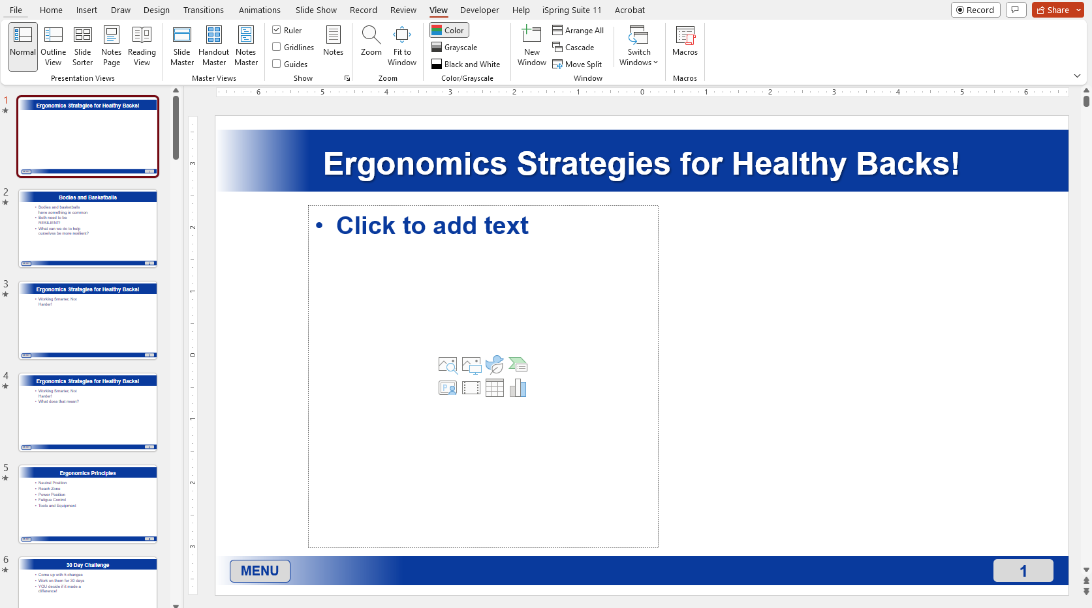
Now when add the assets we have the finished product.
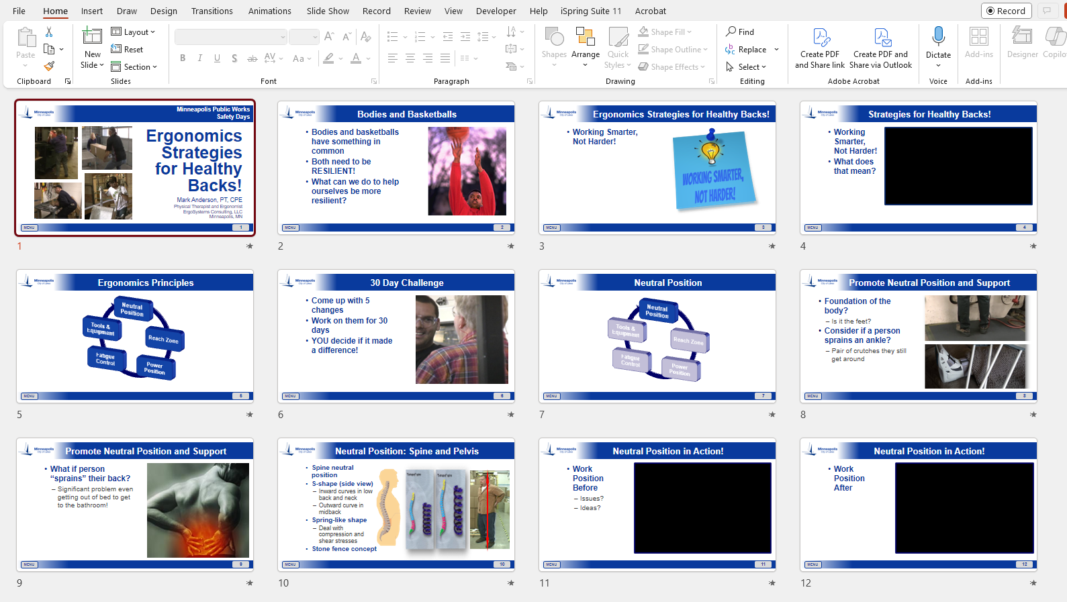
Please review the included Case Study PowerPoint in Slide Show view to see the slide transitions and animations. See if you can identify use of the five Presentation Guidelines.
- Open Impactfully: Start with compelling hook, create emotional connection.
- Maximize Audience Participation: Foster a collaborative atmosphere. Make use of demonstrations, props, polls and quizzes. Really whatever you can think of.
- Emphasize in Unusual Ways: Use real-world anecdotes to clarify complex ideas. Put a different twist on the topic. Have them think you are going in one direction and then turn it on its head.
- Incorporate Redundancy: Recap key points; appeal to different learning styles. Remember we need repetition for the concepts to soak in.
- Close with a Call to Action: Motivate participants to apply the concepts. Use the 30 Day Challenge; try it for 30 days and then they decide if it’s worth their time and energy. The main motivator of behavior change is self-benefit.

Review and Revision

Second Set of Eyes
Now that we have finished the draft presentation, before we preview it for our client, we might want some of our colleagues to review it for accuracy, clarity, and effectiveness. I have learned a second set of eyes can be quite valuable.
The presentation content makes good sense to me, because, well, I wrote it! Someone else may have a different take on it. Embrace constructive criticism, it will make for a better product in the long run. For your first presentations I would encourage you to do a Pilot Test with a small group of learners to identify any issues or areas for improvement.

Self Video
I also encourage you to video yourself presenting. I appreciate most of us are not thrilled to see ourselves on video! However it is a fantastic feedback tool that will help you better understand how your presentation is viewed by the audience. You will identify changes you can make to improve your presentation skills. Refer to the Presentation Skills section for specific details about what to look for.

Client Preview
Once you are ready, preview it for your client. Get ready to make some changes, because more than likely they will ask for them.
My experience is, as you get more experience with your clients you will better understand their concerns and anticipate their needs. At this point, with my long time clients, they don’t ask for previews. They know what the product will be and how I will present it.

Practice . . .Practice . . . Practice!
I really can’t emphasize enough the need to Practice, Practice, Practice!
With practice comes real familiarity with the content and that directly builds your confidence. Next let’s focus on the delivering the presentation.

Presentation Skills
Well the day is here; you are soon to deliver your first presentation for real. With your professional knowledge and your preparation using the strategies we have covered; you will do well! With that said, let’s cover a few more topics about the logistics of the presentation, some pertinent presentation tips, some audience control strategies and how to get feedback.

Prepping the Room
Work to create a welcoming and inviting environment to put the audience at ease and foster a positive learning experience. If it makes sense, the client may provide water, coffee or refreshments.
Work to ensure the room temperature is generally comfortable. Everyone has a different internal thermostat and you will never get a group to all agree. My preference is a room that tends to be on the cooler side. A warm room particularly after lunch can be a tough room.

Set up equipment
Arrive early to set up and troubleshoot any issues. My general policy is to arrive at least 30 minutes before start time. Test all the equipment beforehand to avoid disruptions and ensure a seamless presentation. Hopefully the projector or screen is in a central location for optimal visibility. More than likely you will not control over this. Most modern training rooms have quite sophisticated AV set ups.
I recommend you have a remote wireless mouse to control the slides. This frees you up from having to stand at the computer. The remote allows you to go forward and backward and many also have a laser pointer built in. Have backup batteries for the remote.

Choose an appropriate room layout
Optimize visibility and facilitate audience interaction by selecting the appropriate seating arrangement and stage position. Work with your client to set up a seating arrangement such as a U-shape or theater-style setup. If you are going to have small group activities, one technique is to set it up with tables and chairs so the groups can see each other and interact.

Room for micro-breaks
I always like to ‘practice what I preach’; one of our basic principles of ergonomics is to promote regular and active physical movement. I use the micro-break concept. About every 20 to 30 minutes we do short, perhaps 30 to 60 seconds, of standup stretching. Make sure you have ample space for movement and any other planned activities.

Optimize lighting
With PowerPoint as your media format you will be using a projector or monitor. Test the lighting controls in the room to adjust lighting to avoid glare on the screen or monitor.

Optimize acoustics
Depending on the room size you may be using a microphone and sound system for audio. If I need amplification, I prefer to have a lavalier microphone so I can move around the room. Test the acoustics to ensure speech is clear and audible.

Laptop or flash drive
Depending on the set up, you may be using your laptop plugged into the client’s projector or monitor. In some other situations you may need to bring your presentation on a flash drive and use the client’s AV equipment. Always have a backup of your presentation available. Believe me, at some point something will go wrong and you will be very glad to have it.

Props and teaching aides
Check to make sure you have all the props and other teaching aides you need. You may want to create a checklist so you won’t forget something. I know it seems like you won’t but believe me I have been there and had to improvise a few times. A checklist can help to control your stress levels as you get ready.

Public Speaking Anxiety
Did you know that some sources claim that the fear of public speaking is more common than the fear of death? My thought is, if push comes to shove, I think just about everyone will choose speaking in public over dying. Now, that doesn’t mean that many people have substantial anxiety speaking in a public setting. Here are strategies to consider so public speaking is less anxiety producing.

Practice regularly
The more you practice, the more confident you will become. I relish the opportunity to practice. I have discovered it is much more rewarding the more often I give a presentation. New ideas and presentation techniques come to me as I am presenting. I have the opportunity to immediately try them out to see what works and does not work with the audience.

Know your material
Solid knowledge of your material will give you a sense of confidence and authority. You are the expert! But here is a caveat with what I call, ‘What I know versus what they know’. What am I talking about? At the end of the day it is not what you know that is important; it is what your audience learns and can actually make use of.
I learned if the audience doesn’t walk away with the ‘take aways’, I have, in some way, failed at my job. I want to make sure that I am doing the very best I can for them.

Visualize success
Before I start a presentation, I always picture myself driving away after the presentation is done. I Imagine that I have given a successful presentation, it went well, I dealt with any issues that popped up and I feel good about the experience. This strategy helps me build positive expectations for the upcoming presentation.
I also use this same strategy when I know I have a very busy day coming up where I might be doing the same presentation 3 or 4 times. This is tiring and it takes a lot of focus and energy. Before I start the day, I just picture the day is over and I am on my home. And then it seems, before I know it, I am on my way home after a successful day. If you have not tried this, I would encourage you to do this exercise to see if it works for you.
Just as a postscript, the most presentations I have ever repeated in one day is eleven. They were 30 minutes long and covered a couple of shifts. I did learn not to ever do this again! My brain and body were fried; I got to the point where I lost track of what I had told the groups. It all melded together. Make sure you take care of your energy and focus needs.

Use controlled breathing exercises
Deep breathing is beneficial for controlling stress and anxiety, especially before public speaking, due to its impact on both emotional and physical health. It works by activating the body's relaxation response, helping to decrease feelings of stress or anxiety. Engaging in controlled breathing before and during a speech can provide a quick, discreet method to manage nerves and maintain composure.

Crowd Control
Let’s talk about crowd control. Your goal is to facilitate the presentation and part of that is dealing with the audience if they throw up some distractions. Hopefully because your presentation was prepared with care and you incorporated the five basic presentation guidelines, this rarely occurs.
I have learned, however, that some people will like you no matter what you do and unfortunately some people will not like you no matter what you do. If I have an individual who does not want to pay attention and they are not disruptive, I basically ignore them.
But what about the more active examples? What about those in the audience that won’t stop talking over you or want to keep talking to their buddies or are just generally being disruptive? Here are strategies to handle these situations.

Invade their space
The most effective strategy I employ for crowd control is what I call, ‘Space Invasion’. No it is not some sci-fi movie.
Let’s say I have attendees at a table that want to keep chatting once I start speaking. All I do is to approach their space and keep talking. I may have a prop in my hand that I am showing to the audience. I may be asking a question of the audience. Any number of interactive opportunities. The noisy group immediately recognizes the expectation I have, which is to pay attention. And they respond positively. They and the rest of the audience know exactly what I have just done and we are good to go.
My experience is that the true heckler is very rarely if ever an issue. But I have learned to never say ‘never’ just like you never say ‘always’! If you truly run into a single heckler here are some options.

Practice Emotional Intelligence
Understanding the potential motivations behind heckling can help you respond effectively. Some hecklers may seek attention, while others may have genuine concerns. Adjust your approach based on the individual's intentions.
- Observe body language and verbal cues
- Respond with empathy and understanding

Acknowledge without encouragement
You can politely acknowledge the heckler's comment, without giving it undue attention. This can help diffuse the situation and prevent them from gaining momentum.
- Avoid engaging in debates or confrontations
- Use brief and respectful language

Use humor to defuse
If appropriate, employ wit to turn the heckler's comments into a humorous moment. This can disarm the situation and bring the audience to your side.
- Keep your humor respectful and avoid sarcasm
- If the humor is not well-received, move on quickly

Redirect focus
After addressing the heckler, redirect your focus back to your presentation and the rest of the audience. This helps minimize the interruption and maintain the flow of your talk.
- Use transitional phrases or questions to smoothly shift attention
- Remind the audience of the presentation's purpose or key points

Seek assistance
If a heckler becomes persistently disruptive and refuses to respect boundaries, it may be necessary to involve additional help. This ensures the comfort and safety of all attendees.
In more than 30 years as a professional presenter and thousands of presentations, I have only had one instance when the individual was asked to leave. The supervisor was in the audience, recognized the situation and dealt with it appropriately.
- Inform the heckler that the situation will be handled by staff
- Remain composed and focus on your presentation

Analyze Real Time Audience Feedback
To optimize presentation delivery, analyze the audience feedback. Your audience has energy, it has a group dynamic that can help you do a dynamite job. You are there to share something valuable with them. Pay attention to what non-verbal cues signs they are giving you during the presentation that indicate engagement and understanding.

Observe body language and facial expressions
Observe the audience's posture, gestures, and facial expressions to understand their engagement and comprehension. Attentive listeners with positive body language indicate interest, while restlessness or disinterest may require adjustments.

Monitor engagement levels
Track audience participation through Q&A sessions, polls, or interactive activities. High engagement indicates the presentation is resonating, while low engagement may necessitate changes to make it more engaging or relevant.

Gauge verbal feedback
Seek verbal feedback through questions, discussions, or surveys. Positive feedback reinforces the effectiveness of the presentation, while negative feedback provides valuable insights for improvement.

Enhancing Delivery and Impact
How you deliver the content is just as important and dare I say, perhaps even more important than the content itself. I have sat through presentations that had really good content but the presentation delivery really got in the way.

Using PowerPoint as an aide

Avoiding Slide-Reading
I believe the best advice I can provide about using PowerPoint is, do not just read your slides. Your audience will wonder why you are there? They could just get the PowerPoint and read it themselves. When you avoid just reading the slides you preserve and enhance audience engagement.

Slides as cues
Slides should serve as visual aids for you and your audience. You use them to help you stay on track during your presentation and facilitate your flow of information. The slides should add to your narrative by being visually appealing both in terms of the aesthetic and the content. They allow the audience to see your verbal comments to reinforce the concepts.

Subject matter mastery
How to avoid just reading your slides? This comes through adequate preparation and practice so you will present confidently and knowledgeably. Remember you are the subject matter expert. Let that come through.

Audience interaction
When you are not focused on reading your slides you can better maintain eye contact, move around the space and invite questions or comments.
You create a more interactive and engaging experience, fostering a stronger connection with your audience.

Filler words
I recall listening to a presentation once and all I remember about it is counting the number of times the presenter used the word ‘like’ as a filler word. I believe in about a 20 minute presentation the count was over one hundred uses. To say the least it was very distracting!

Tips to reduce filler word use
To effectively minimize the use of filler words such as "you know," "like," "um," and others, it's crucial to first become aware of your speech patterns and the specific filler words you frequently use.
Practice speaking slowly and deliberately, allow yourself time to think and choose words carefully, which can significantly reduce reliance on fillers. I sometimes imagine I am speaking to an audience where English is not their primary language; this helps me slow down and concentrate on my speaking cadence and word choice.
Recording and reviewing your speech will help you identify when and why you use filler words, so you can target your improvement. Work on practice exercises that focus on eliminating these words, such as speaking on a topic without using filler words or pausing instead of filling silence. Understand that occasional use of fillers is natural in conversational speech. Aim for improvement, not necessarily perfection.
Changing your speaking habits requires mindfulness and continuous practice, but with dedication, you can enhance your clarity and effectiveness as a speaker, making your communication more impactful and professional.

PowerPoint Presenter View
PowerPoint's Presenter View is a powerful feature that provides a more controlled and professional presentation experience. It's especially useful in settings where you're presenting to an audience using a projector or a second screen. Presenter View offers you a private view of your presentation, including your notes, a preview of the next slide, and a timer, while the audience only sees the current slide.
If you are not familiar with Presenter View in PowerPoint, check it out. It will enhance your presentation by providing a dual-screen setup.
Here's how to use Presenter View:

Setting Up Presenter View
Connect to a Secondary Display: First, make sure your computer is connected to a projector or a second monitor.
Enable Presenter View:
  - Open your PowerPoint presentation
  - Go to the "Slide Show" tab in the ribbon
  - In the "Monitors" group, check the box for "Use Presenter View".
  - Choose the monitor you wish to display the presentation on from the "Monitor" dropdown if your setup involves multiple displays.

Navigating Presenter View
Once you start your slideshow with Presenter View enabled, you will see your presentation through a special interface that includes several key features:
- Current Slide: The large area on the left shows the slide currently being displayed to your audience.
- Next Slide: On the right, you'll see a preview of the next slide, so you know what's coming up. This area may also show upcoming animations or multimedia that you've included in your presentation.
- Speaker Notes: Below the next slide preview, you will find a resizable area where your speaker notes for the current slide are displayed. This allows you to refer to your notes discreetly during your presentation.
- Timer/Elapsed Time: At the top, there's a timer that shows the elapsed time since you started the presentation. This is helpful for keeping track of time without needing an external clock.
- Tools and Navigation: Across the bottom, you'll find tools for drawing or pointing on your slides, a magnifying glass for zooming in on details, and slide navigation controls to move forward or backward through your presentation.

Tips for Using Presenter View
- Practice: Before your actual presentation, practice using Presenter View to familiarize yourself with its layout and features. This will help you navigate smoothly during your presentation.
- Adjust Your Notes: Make sure your speaker notes are concise and readable at a glance. Presenter View allows you to scroll through them, but it's best if you can mostly avoid having to scroll during your presentation.
- Use Tools: The pen, laser pointer, and highlighter tools can be particularly useful for drawing your audience's attention to specific parts of your slides. Practice using these tools as well.

Troubleshooting
If Presenter View does not activate automatically when you start your slideshow, it could be due to your display settings. Ensure your computer recognizes the projector or second monitor as an extended display, not a mirrored one. In Windows, you can adjust these settings in the Display section of your Control Panel or Settings app. On a Mac, use the Displays preference pane in System Preferences to arrange your displays and check the "Mirror Displays" option is not selected.

Practice Mode
PowerPoint's Rehearse with Coach and Rehearse Timings are two powerful features designed to help presenters prepare their presentations more effectively. These features aim at improving your delivery by practicing the timing and delivery of your presentation. Here’s how you can use them.

Rehearse with Coach
Rehearse with Coach is an AI-powered tool available in PowerPoint for the web, Microsoft 365 versions of PowerPoint for Windows and Mac, and PowerPoint for Android and iOS. It offers real-time feedback on your pacing, use of filler words, culturally insensitive phrases, and more. Here's how to use it:
- Open Your Presentation: Launch PowerPoint and open the presentation you wish to rehearse.
- Start Rehearse with Coach:
  - For PowerPoint for the Web, navigate to the "Slide Show" tab and select "Rehearse with Coach".
  - For desktop versions, you might find it under the "Slide Show" tab or similar.
- Begin Rehearsing: Once you start, the feature will listen to your presentation as you speak. Ensure your microphone is on and working.
- Receive Feedback: As you present, Rehearse with Coach will provide on-screen guidance on your pacing, suggest avoiding filler words, and give feedback on readability and other verbal and non-verbal cues.
- Review Summary: After you finish your rehearsal, a summary of the feedback will be presented, allowing you to review areas for improvement.

Rehearse Timings
Rehearse Timings allows you to practice the timing of your slides, ensuring that your presentation fits within a specific timeframe. This feature is available across various versions of PowerPoint. Here’s how to use it:
- Open Your Presentation: Open the PowerPoint presentation you wish to practice.
- Access Rehearse Timings:
  - Go to the Slide Show tab.
  - Click on Rehearse Timings.
- Start Rehearsing: The presentation will start in full-screen mode, and a timer will begin counting the time spent on the current slide.
- Navigate Through Slides: Use the arrow keys, mouse, or any presentation remote to move to the next slide. The timer will automatically record how long you spend on each slide.
- Adjust Timings as Necessary: If you need more or less time on a specific slide, simply stay on that slide for the desired duration during rehearsal. PowerPoint will remember these timings.
- Save Timings: Once you've gone through all slides, PowerPoint will ask if you want to save the timings. If you save them, these timings will be used to automatically advance slides when you present in Slide Show mode.
Using these tools can significantly enhance the quality of your presentation, ensuring that your delivery is polished and your timing is on point. Remember to rehearse several times to get comfortable with the content and the flow of your presentation.

Voice Control
Your voice is a very large part of your presentation.

Vary your pitch, pace, and volume
I suspect you have attended presentation where the speaker spoke in a monotone voice. Really hard to stay tuned in, isn’t it; it seems to put you to sleep. Something we are definitely trying to avoid! Use different pitch and pacing to emphasize key points, maintain interest and convey emotions.

Speak clearly and at an appropriate volume
Enunciate clearly, don’t mumble. Ensure everyone can hear you without straining or shouting. Use amplification if that is needed in large rooms. Don’t be afraid to speak loudly at times but also drop your volume to emphasize a particular point. You want to give your audience something to pay attention to.

Control your breathing
Work on your breath control to maintain a steady vocal tone and avoid shortness of breath. Consider voice coaching if you think that would benefit you.

Body Language
If your voice is a large part of your presentation persona, your body language is a huge part. A great deal of communication is nonverbal as demonstrated through your body language.
Effective body language is a crucial aspect of successful presentations, as it enhances message clarity, engages the audience and establishes rapport and confidence.

Non-verbal cues
Non-verbal cues, such as gestures, facial expressions, and posture, can emphasize key points, make information more memorable and help build a connection with the audience. By using effective body language, you can capture and hold attention, reducing the chances of the audience becoming disinterested or distracted.
Use appropriate facial expressions to convey emotions and engage your audience. Smile, nod, or raise eyebrows to emphasize points. Specific gestures can greatly enhance the impact of presentations.
- Enumerating Gestures: Using fingers to count points helps the audience track and remember information.
- Descriptive Gestures: Movements that illustrate shapes, directions, or motions make abstract concepts easier to understand.
- Emphatic Gestures: Deliberate hand gestures (fists, open palms, pointed fingers) emphasize important points.
- Comparative Gestures: Hand movements used for comparisons (e.g., high vs. low, close vs. far) make differences clear.
- Invitational Gestures: Open gestures (arms slightly spread, palms up) signal openness and encourage audience engagement.
When used appropriately, these gestures complement verbal messages, making presentations more dynamic and memorable.

Posture and Movement
Maintain an upright and confident posture. An upright posture signals confidence and purposeful movement around the stage maintains engagement. Adopt an open stance with your arms uncrossed and legs uncrossed or slightly apart. Stand or sit with your shoulders relaxed, chest out, and back straight. Avoid slouching or fidgeting.
Move around the stage or presentation area. This helps engage different parts of the audience and adds dynamism to your presentation. Make sure you control your movement; Move with purpose and avoid pacing or fidgeting. Understanding cultural norms is crucial, as non-verbal cues may vary across cultures.

Eye Contact
Establish and maintain eye contact with your audience. This conveys confidence and engages them actively. I rotate eye contact from audience member to audience member. This method helps that person feel the presentation is directed to them and will pull them into the presentation.
By being mindful of your body language and practicing non-verbal communication skills, you can ensure your body language complements and reinforces your verbal messages, enhancing the overall effectiveness of your presentations.

General Logistics
As part of your presentation, consider what you need to do in terms of general logistics like:
- Review the schedule
- Refreshments (if provided)
- How to access participant materials if there are some
- I use Participant name tags or tents them for longer presentations; I like to be able to address them by name when I talk with them
- Make sure they and you know the locations of Restroom and Fire Exits
Determine if you are going to do group introductions or not. Typically for shorter presentations, I will not do a formal group introduction. As I am in the room before the presentation starts, I will chat with people in the crowd. This helps to break the ice and you may find out some anecdote you can incorporate into your presentation.
For longer sessions, particularly if I am are going to use small group sessions and I want to facilitate comments, questions, thoughts and opinions from them, I will do formal group introductions. I ask them to introduce themselves, tell us what area they work in, a bit about their background and experience and how that experience relates to the session.
For example let’s say the session is on Ergonomics Analysis and Workstation Design, I ask them to share their level of experience with the topic. This helps me understand how I might need to adapt my content how best to structure it. It also is a good ‘ice breaker’ to get the audience more comfortable to speak up to ask questions and add comments.

Incorporate the Lessons Learned for the Next Presentation

Follow up with key stakeholders
Reach out to key stakeholders to gather their specific feedback and perspectives. Their insights can provide valuable guidance for refining future presentations and addressing specific audience needs.

Analyze post-presentation evaluations
Distribute surveys or request feedback after the presentation to gather detailed insights into the audience's experience. This feedback can help identify areas for enhancement and measure the overall impact of the presentation.

Feedback Form
I have included a Feedback Form in the Resources Tab. Please feel to modify and use it for your purposes.

Effective Instructional Design
Developing effective training materials requires careful planning, thoughtful design, and continuous refinement. By following the steps outlined in this guide and incorporating best practices, you can create engaging and impactful training materials that empower learners to achieve their learning goals with confidence.
Thanks for your time and attention!

References
These references cover various aspects of instructional design, content development, and training delivery, providing a solid foundation for developing effective training materials.
1. Understanding the Audience:
Clark, R. C., & Mayer, R. E. (2016). e-Learning and the Science of Instruction: Proven Guidelines for Consumers and Designers of Multimedia Learning. John Wiley & Sons.
Dick, W., Carey, L., & Carey, J. O. (2015). The Systematic Design of Instruction. Pearson.
2. Setting Learning Objectives:
Morrison, G. R., Ross, S. M., & Kemp, J. E. (2013). Designing Effective Instruction. John Wiley & Sons.
Mager, R. F. (1997). Preparing Instructional Objectives: A Critical Tool in the Development of Effective Instruction. Center for Effective Performance.
3. Content Development:
Smith, P. L., & Ragan, T. J. (2005). Instructional Design. John Wiley & Sons.
Merrill, M. D. (2013). First Principles of Instruction. Routledge.
4. Designing Visuals and Graphics:
Tufte, E. R. (2001). The Visual Display of Quantitative Information. Graphics Press.
Lohr, L. L. (2008). Creating Graphics for Learning and Performance: Lessons in Visual Literacy. Pearson.
5. Interactive Activities and Assessments:
Branch, R. M. (2009). Instructional Design: The ADDIE Approach. Springer.
Piskurich, G. M. (2006). Rapid Instructional Design: Learning ID Fast and Right. John Wiley & Sons.
6. Review and Revision:
Allen, M. W. (2012). Michael Allen's Guide to e-Learning: Building Interactive, Fun, and Effective Learning Programs for Any Company. John Wiley & Sons.
Reiser, R. A., & Dempsey, J. V. (2012). Trends and Issues in Instructional Design and Technology. Pearson.
7. Formatting and Distribution:
Smith, P. L., & Ragan, T. J. (2005). Instructional Design. John Wiley & Sons.
Rosenberg, M. J. (2015). Beyond e-Learning: Approaches and Technologies to Enhance Organizational Knowledge, Learning, and Performance. John Wiley & Sons.

