Temporary Laptop Use at Home
Working at home on your laptop? You aren’t alone! Many people who normally work primarily at their desk at work are now working at home.
For many people this may mean sitting on the couch with the laptop on their laps. They are called laptops after all! However, in terms of your comfort and productivity, as well as decreasing the potential for sore wrists, elbows, shoulders, neck and back here are some basic guidelines for temporary laptop use at home.
NOTE: Please note the Guidelines are for primarily temporary laptop use at home. If you work at home on a permanent basis, our recommendation for you is to set-up your home office workstation with all the ergonomics components of a typical ‘at work’ workstation.
Image Credit: "Man Working at his Laptop on the Couch Cartoon Vector.svg from Wikimedia Commons by Videoplasty.com
- Ergonomics
- Ergonomics is all about the physical relationship between you and your office equipment, in this case your laptop.
- Your goal is to obtain a comfortable, well supported position that keeps your head balanced on your neck with your arms, back and feet well supported.
- 30/30 Movement Guideline
- Move and change positions on a regular basis through-out the day.
- Don’t lock into one position!
- About every 30 to 45 minutes take at least a 30 to 45 second physically active micro-break. Get up, stretch, take a walk. Remember to MOVE . . . MOVE . . . MOVE!
- Adjustable Height Table/Desk and Adjustable Height Chair
- If both your table/desk and chair are height adjustable, first adjust the chair height to place your feet directly on the floor.
- Adjust the table/desk height so your wrists are straight when you place your hands on the laptop keyboard.
- Angle the laptop monitor so you can see it with the least amount of forward head position.
- Fixed Height Table/Desk and Adjustable Height Chair
- If your desk or table is at a fixed height, place your laptop on the desk/table.
- If your chair height is adjustable, adjust the chair height so your wrists are straight when you place your hands on the laptop keyboard when you sit all the way back in the chair. (you can add a back cushion if needed)
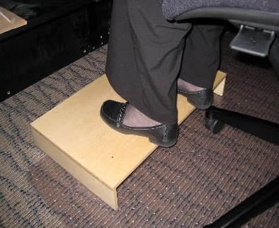
- If this caused your feet to come off the floor, find a box or stool so your feet are not dangling.
- Angle the laptop monitor so you can see it with the least amount of forward head position.
- Fixed Height Table/Desk and Fixed Height Chair
- Place the laptop on the table/desk. If your wrists are straight when you place your hands on the laptop, you are good to go!
- If your wrists are not straight you need to adjust your seated height. Look for a different height chair or put a seat cushion in the chair if the chair is not high enough.
- If this caused your feet to come off the floor, find a box or stool so your feet are not dangling.
- If you are a taller individual and the table/desk to low you may be able to put blocks under the legs to raise it up.
- Angle the laptop monitor so you can see it with the least amount of forward head position.
- Couch
- Are we saying never sit on your couch or easy chair and use your laptop?
- The answer is no.
- You can certainly some of the time use your couch.
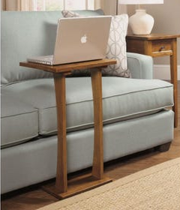
- The same guidelines apply to obtain a comfortable, well supported position that keeps your head balanced on your neck with your arms, back and feet well supported.
- Use pillows under your forearms to provide support for your arms and shoulders.
- Some will also find it helpful to place a pillow under the laptop to ensure your wrists are straight when your hands are on the laptop keyboard. Also, there are sofa servers that may work to position your laptop when seated on the couch.
- Make sure your feet and legs are well supported.
- Just remember the 30/30 Movement Guideline and MOVE, MOVE, MOVE!
- Standing Counter
- Mix in some standing when using your laptop.
- Look for a counter top that allows you to stand comfortable tall with your elbows about 90⁰ with your wrists straight when you use the laptop keyboard.
- Angle the laptop monitor so you can see it with the least amount of forward head position.
- Good shoes are important for standing. If they are good walking shoes, they will be good for standing.
- Use a foot rest so you can alternate one foot up on the foot to provide for alternate foot placement and vary your body position.
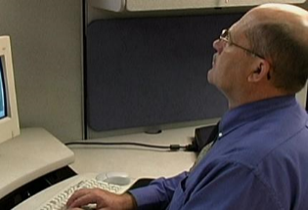
- Other Considerations
  - Eye glasses
- Make sure your eye glasses, for example use of bifocals or trifocals don’t result in out-of-neutral head and neck positions.
  - Telephone
- If possible, use a headset or speaker phone for hands-free operation when using your laptop.
  - Lighting
- Make sure you have adequate light to read documents wherever you use your laptop.

Mark Anderson, PT, CPE, ErgoSystems
7421 W Shoreline Dr, Waconia, MN 55387
mark.anderson@ergosystemsconsulting.com 952-401-9296

