Tips to Reduce Computer Vision Issues
Eyes tired after a day of staring at your laptop screen?  You aren’t alone! Many people who normally work primarily at their desk at work are now working at home.  For many of us that means looking at our laptop screen rather than the large monitor or monitors we may have had in our office.  While we understand there is no evidence that computer use causes any long-term damage to the eyes; tired, dry, itchy eyes by the end of the day can sometimes be the result for some people.  What can you do to have more comfortable eyes?  Try out the tips below, your eyes will thank you! | 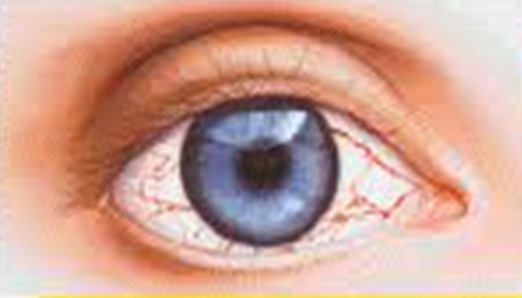
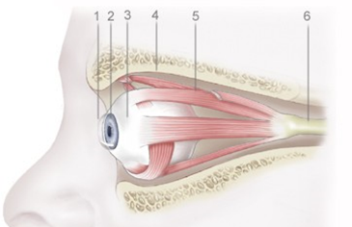
- To Infinity and Beyond!
- Just like the muscles in our arms, shoulders, neck and other parts of our body can get fatigued, the small muscles that control our eye position and focus the lens in our eyes get tired from constant use.
- Get in the habit every 20 minutes of looking away from your screen for 20 seconds to something at least 20 feet away. Take a break!
- Laptop Screen Position
- Because the laptop screen is directly attached to the keyboard it can present a bit of an issue to position the screen.
- With laptop use, position the keyboard so your wrists are reasonably straight and then angle the laptop screen to minimize forward head tip.
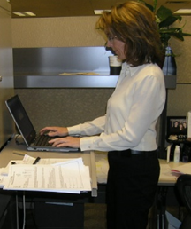
- Proper Lighting
- Wherever you are using your laptop make sure you have adequate and comfortable lighting so you can comfortably see the laptop keyboard and any reading materials.
- Avoid any glare either from lights directly into your eyes or from any glare coming off the laptop screen.
- Remember to Blink
- Our eyes are bathed in a protective film to moisturize the surface of the eyeball. Frequent and regular blinking (10 to 15 blinks/minute) helps to distribute the fluid and minimize dry, itchy eyes.
- Some people may also benefit from using artificial tears.
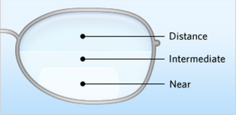
- Eye Glasses
- If you wear eye glasses, particularly bifocals or trifocals, make sure you are able to see the laptop screen clearly and in focus.
- For users of over-the-counter readers who may be having a difficult time viewing the screen, try out a lower magnification reader. This often works as a short-term substitute for prescription computer glasses.
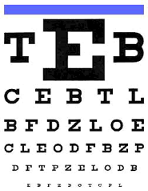
- Comprehensive Eye Exam
- If it has been several years since your last eye examination, you may want to consider getting one. Obviously, right now we need to be aware of not overloading our health care system.
- However, if you are experiencing significant vision issues, please at least consider talking with eye care health professional to determine the extent of your need.

Mark Anderson, PT, CPE, ErgoSystems
7421 W Shoreline Dr, Waconia, MN 55387
mark.anderson@ergosystemsconsulting.com 952-401-9296

