Functional Job Description: Stock

Company: | Bluestem Brands, Inc.
Job Title: | Stock
Date: | 11-13-17
Dept/Facility: | DC, Irvine, PA
Product Section: | Outbound
Electronic Doc. # | FJD Stock FINAL 11-13-17

Work Hours | Overtime: | Voluntary and/or mandatory per production requirements. | Breaks: | (2) 15 minute & (1) 30 minute lunch break
 | Shift: | Days of week: | Time:
 | First | Monday – Friday | 6:00 AM to 2:30 PM or 8:00 AM to 4:30 PM
 | Second | Sunday – Thursday | 9:30 PM to 6:00 AM

Job Rotation | Yes

Job Training or Credentials Required at Hire | Education/ training: | None required; high school diploma or GED preferred.
 | Knowledge/ cognitive skills: | Basic math, reading, writing and oral communication skills preferred. Ability to organize work tasks and work independently or as part of a team.

Machines, Tools and/or Equipment Used | Wearable scanner, freight elevator, 20’ hi-lift, 40’ hi-lift, reach truck, stock cart, pallet jack – hand, safety knife, case labels, shopping cart.

Job Purpose/ Objectives | Replenish merchandise into active locations where items are picked.

Safety and Personal Protective Equipment Required  *Available | Hard Hat | Steel Toe Footwear | Safety Glasses | Gloves:
 | Face Shield  Battery change | Protective Clothing | Safety Glasses/Side Shields | Leather
 | Dust Mask | Safety Vest  Fall Protection Harness | Safety Goggles  Hearing Protection*  Compensatory methods to mitigate heat | Rubberized/cloth*  Chemical  Cut proof glove

Safety/ Equipment Training/ Certification Required | Daily Meeting and Stretch Breaks (includes:) | Industrial Truck Training | OSHA Training (Rules and Regulations)
 | - Safety Topics | EZ-Go | New Hire Safety Orientation
 | - Safety Policies | Walkie-Rider | Right to Know
 | - Questions & Answers | Pallet Jack | Lockout/Tag Out
 | - Review Safety Committee Minutes | Forklift (sit down) | Regulated Materials Training (ORM-D)  Supervisor Safety Updates
 |  | Stand-up Reach Truck
 |  | Order Picker
 |  | Transpositioner
 |  | Pivot Pro Vacuum Lift

Functional Job Elements |  |  | % of Shift
- Replenishment  - Loads cart with boxes.  - Transports cart to racking.  - Cut open box.  - Remove empty box if needed.  - Manually place box on shelf (6” to 72” heights)  - Maximum weight of 40#, average of 30#. If more than 40# will obtain assistance.  - Uses wearable scanner. | 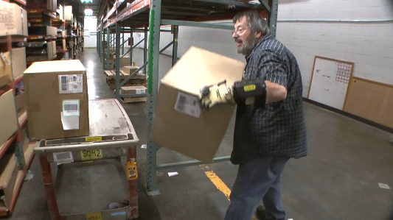 |  | 40
 | 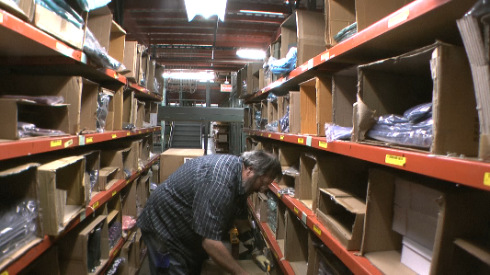
- Dynamic Cleanout  - Preps for dynamic cleanout – obtains labels and cart.  - Transports cart to racking.  - Pulls stock from shelf (6” to 72”). Maximum weight of 40#, average of 30#. If more than 40# will obtain assistance.  - Transports cart to staging area and manually places boxes on pallet.  - Uses wearable scanner.  . | 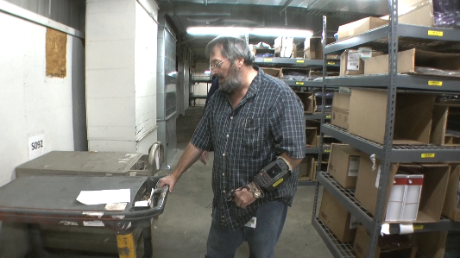 |  | 5
 |  | 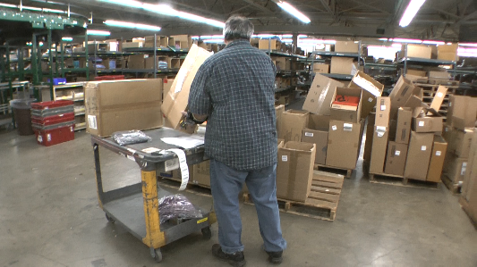
- Stock Return Mixed  - For products that have been returned, return to the pick racks.  - Place totes on cart.  - Transport cart to area.  - Return item to picking location.  - Uses wearable scanner. | 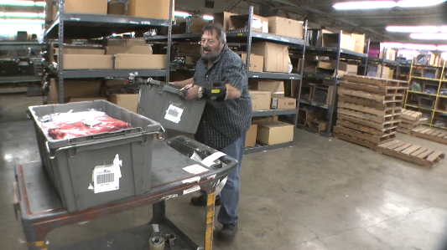 | 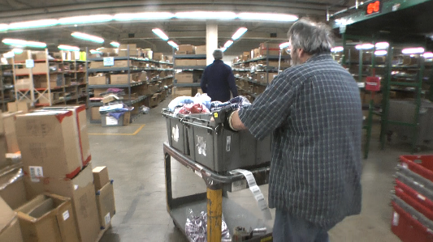 | 10
- Cycle Count  - Walks to area where cycle count will be performed.  - Accesses the merchandise and performs count of the merchandise. |  |  | 5
- Stock – No Location  - Puts product that has no current location into a new location.  - Places products into shopping cart from bin.  - Goes to the new location, creates the location in the systems and puts the product into the location. | 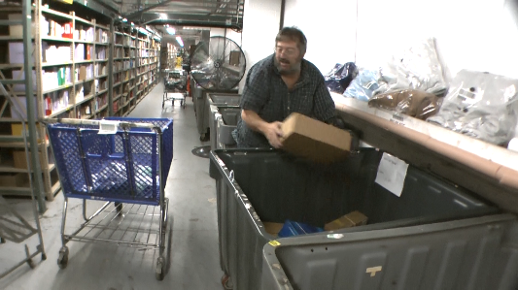 |  | 5
- Use Hi-lifts (20’ and 40’)  - Manually positions boxes on the pallet of the lift.  - Uses mechanical equipment to obtain access to the racking.  - Manually places stock in the racking. | 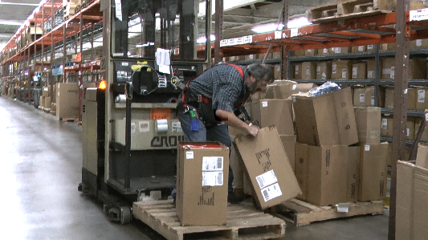 | 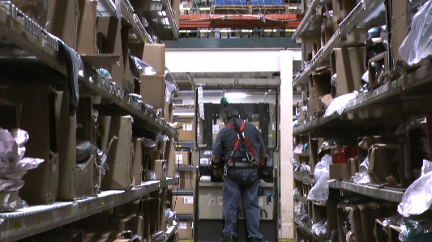 | 5
 | 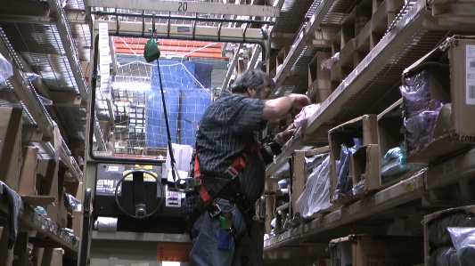 | 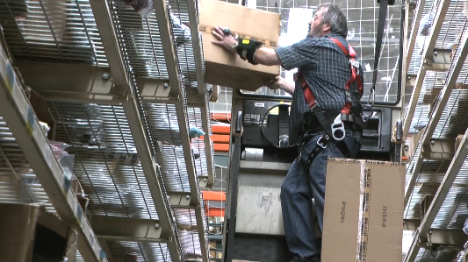
- Carts on Freight Elevator  - Manually pushes carts onto elevator.  - Operates elevator controls.  - Removes cart from elevator.  - About 20 to 30# force to maneuverer cart. | 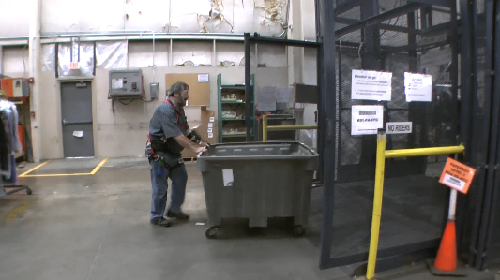 | 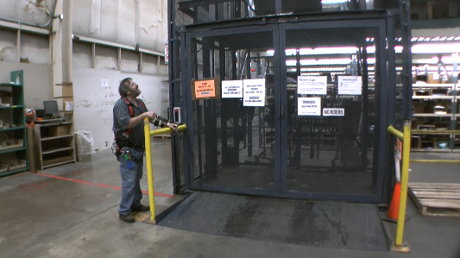 | 5
- Hanging garments  - Uses pole or platform ladder to hang garments. | 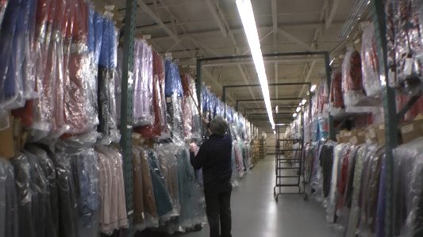 |  | 5
- Lifting stock with reach truck  - Manually places boxes onto the pallet.  - Uses reach truck to lift stock on pallet to the second level.  - Once on the second level, a pallet jack is used to move the pallet to the desired location. | 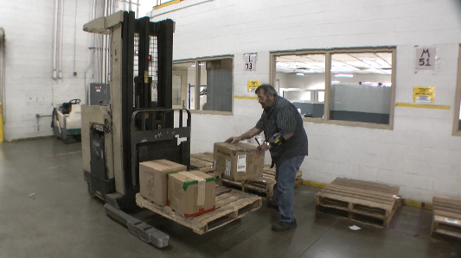 | 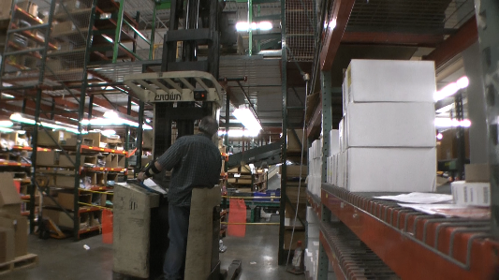 | 5
 | 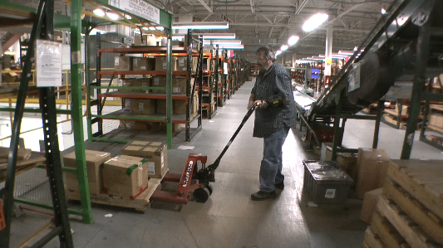 | 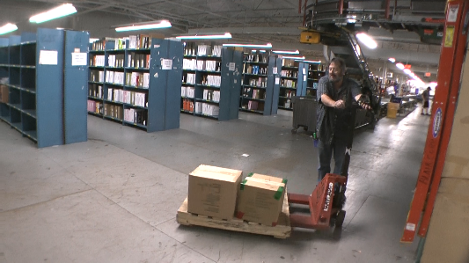
- Empty Tote Dispatch Station  - Apply labels to empty totes. | 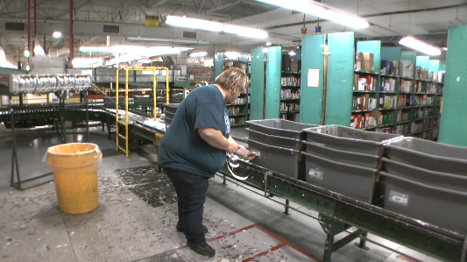 | 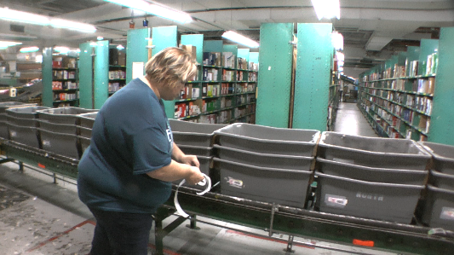 | 0  To 100
- Clear tote jams on conveyor  - Clear jams on the conveyor. | 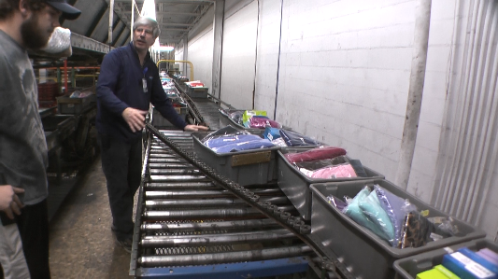 | 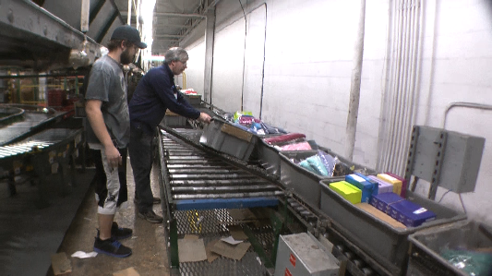 | 0 to 100

Physical Factors
Manual Material Handling
(lbs) | Floor-Knuckle (0” to 30”) |  |  |  |  |  | Knuckle-Chest (30” to 50’) |  |  |  |  |  | Chest-Overhead  ( > 50”) |  |  |  |  |  | Carry - Two Hands; Front |  |  |  |  |  | Carry - One Hand; Side |  |  |  |  |  | Push |  |  |  |  |  | Pull
100
75
40
25
15
10
5
0
Exp | N | R | O | F | C |  | N | R | O | F | C |  | N | R | O | F | C |  | N | R | O | F | C |  | N | R | O | F | C |  | N | R | O | F | C |  | N | R | O | F | C

Postures/Movements |  |  |  |  |  |  |  |  |  |  |  |  |  |  |  | Head/Neck
Exp | Sit | Stand | Walk | Bal | Stairs | Lad-der | Foot contrl | Twist Waist | Bend Waist | Squat | Kneel | Crawl | Reach below 54” | Reach above 54” |  | Flex Static | Ext Static | Rot Static | Flex Dyn | Ext Dyn | Rot Dyn
C
F
O
R
N

Hand Use |  |  |  |  | Sensory |  |  |  |  |  | Communication |  |  |  |  | Key C - Continuous: 67 to 100% of shift  F - Frequent: 34 to 66% of shift  O - Occasional: 6 to 33% of shift  R - Rarely: up to 5% of shift  N - Never: 0% of shift  Abbreviations: Bal=Bal, Exp=Exposure, Contrl=Control, Flex=Flexion, Ext=Extension, Dyn=Dynamic, Manip=Manipulation
Exp | Simple Grasp | Firm Grasp | Fine Manip | Bal | See | Hear | Touch Feel | Taste | Smell |  | Talk | Read | Write | Hand Signal
C
F
O
R
N

Environmental Factors | Exposure Level |  |  |  |  | Key/Comments
 | N | R | O | F | C
Outdoor Work |  |  |  |  |  | Key C - Continuous: 67 to 100% of shift  F - Frequent: 34 to 66% of shift  O - Occasional: 6 to 33% of shift  R - Rarely: up to 5% of shift  N - Never: 0% of shift  Comments:  Indoor Work: Primary work area is a large indoor warehouse complex.  Moving Objects: Be aware of and avoid moving objects including product and equipment.
Indoor Work
Heat
Cold
Wet/ Humid
Hearing Protection
Vibration
Fumes/Gases/Odors
Dust
Moving Objects
Electrical
Chemical
Protected Work Heights
Unprotected Work Heights
Flying Debris
Lighting (Inadequate/Excessive)

Position eligible to be considered for temporary modification in conjunction with a Return to Work transitional duty program agreement: Yes
This Functional Job Description was completed through an on-site job analysis by a certified professional ergonomist/licensed physical therapist. It is for the purpose of identifying and quantifying the physical functional requirements of this job. The Functional Job Description should not be construed as a detailed description of all specific job duties and/or tools, equipment and materials that may be necessary or incidental to the performance of this job. Further consideration may be necessary when applying the standards to the injured population in the medical management process.
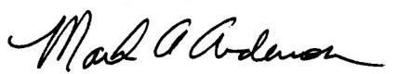 | This Functional Job Description has been reviewed by company representatives and is believed to be an accurate representation of most of the job content.
Mark A Anderson, MA, PT CPE  Certified Professional Economist  Licensed Physical Therapist  ErgoSystems Consulting Group, Inc.  7421 W Shoreline Dr  Waconia, MN 55387  952-401-9296  mark.anderson@ergosystemsconsulting.com  www.ergosystemsconsulting.com | 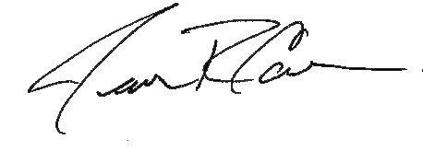  _______________________________________
James Cowan, Production Manager
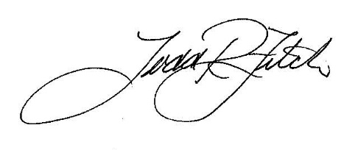
 | _______________________________________
 | Todd Fitch, Facilities Operations Director

