Functional Job Description: Returns Material Handler

Company: | Bluestem Brands, Inc. | 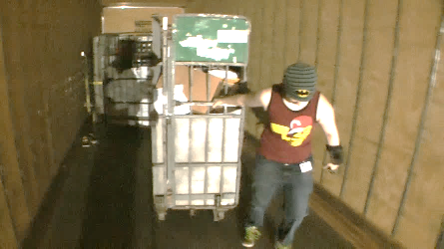 | 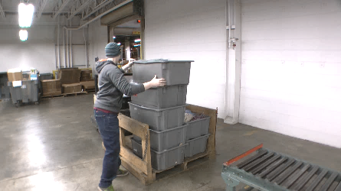
Job Title: | Returns Material Handler
Date: | 11-13-17
Dept/Facility: | DC, Irvine, PA
Product Section: | Inbound
Electronic Doc. # | FJD Returns Material Handler FINAL 11-13-17

Work Hours | Overtime: | Voluntary and/or mandatory per production requirements. | Breaks: | (2) 15 minute & (1) 30 minute lunch break
 | Shift: | Days of week: | Time:
 | First | Monday – Friday | 6:00 AM to 2:30 PM
 | Second | NA | NA

Job Rotation | Yes

Job Training or Credentials Required at Hire | Education/ training: | None required; high school diploma or GED preferred.
 | Knowledge/ cognitive skills: | Basic math, reading, writing and oral communication skills preferred. Ability to organize work tasks and work independently or as part of a team.

Machines, Tools and/or Equipment Used | Box cutter, fork truck, pallet jack – manual, walkie-rider, tape dispenser, stickers, wearable scanner.

Job Purpose/ Objectives | - Unload trucks/trailers with fork truck, manual pallet jack and walkie-rider.  - Upfront - supply Returns Processors with work materials.  - Backline - “good stock” accumulates and is staged for return to inventory.

Safety and Personal Protective Equipment Required  *Available | Hard Hat | Steel Toe Footwear | Safety Glasses | Gloves:
 | Face Shield  Charging walkies | Protective Clothing | Safety Glasses/Side Shields | Leather
 | Dust Mask | Safety Vest  Fall Protection Harness | Safety Goggles  Hearing Protection*  Compensatory methods to mitigate heat | Rubberized/cloth*  Chemical

Safety/ Equipment Training/ Certification Required | Daily Meeting and Stretch Breaks (includes:) | Industrial Truck Training | OSHA Training (Rules and Regulations)
 | - Safety Topics | EZ-Go | New Hire Safety Orientation
 | - Safety Policies | Walkie-Rider | Right to Know
 | - Questions & Answers | Pallet Jack - Powered | Lockout/Tag Out
 | - Review Safety Committee Minutes | Forklift | Regulated Materials Training (ORM-D)  Supervisor Safety Updates
 |  | Stand-up Reach Truck
 |  | Order Picker

Functional Job Elements |  |  | % of Shift
- Unload trucks  Three types of trailers:  - Live load – needs to be done first because driver is waiting for trailer.  - Drop and hook – trailer is dropped off to be picked up at a later time.  - Mail truck – USPS truck.  Typically, about 75% of the shift with remaining 25% filling in Upfront or the Backline. |  |  | 75
Prep trailer for unloading:  - Open dock overhead door (about 5 to 10# force).  - Position dock plate via powered control. | 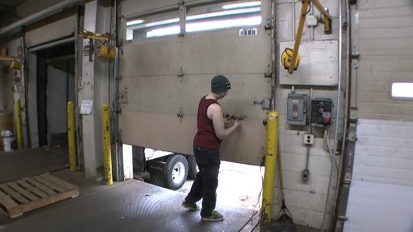 | 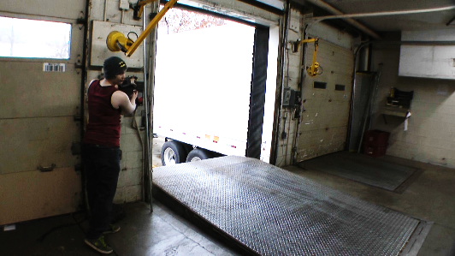
Unload trailer:  - Typically use fork truck/stand-up reach truck to unload pallets from trailer.  - May rarely use manual pallet jack if fork truck not available (about 20 to 40# to initiate movement, 10# to sustain movement). | 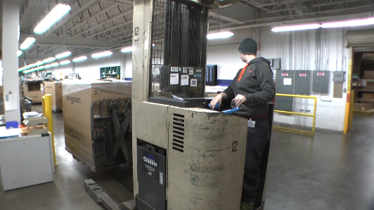 | 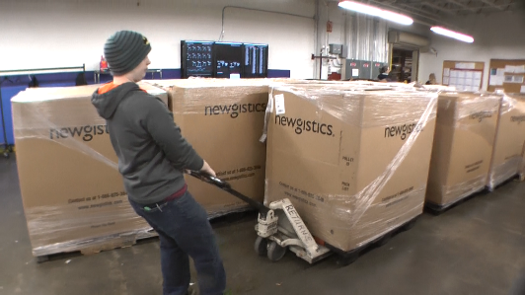
Prep mail truck dock:  - Open dock overhead door.  - Open mail truck overhead door manually (20 to 25# of pull/push to open door).  - Position dock plate via powered control. | 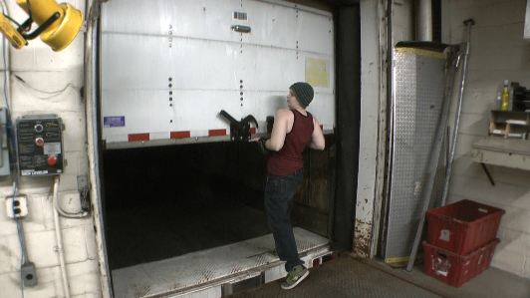 | 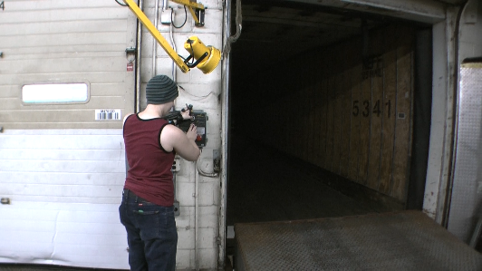
Unload mail truck:  - Release turn buckle straps securing the carts.  - Manually unload carts from mail truck. (about 20# to initiate cart movement on smooth level floor and about 40# on a ramp – inclined surface and 10# to sustain cart movement on smooth level floor).  - Move carts through door to staging area.  - Return empty mail carts to mail truck.  - Depending on day of the week number of carts handled ranges from 2 to 10/day. | 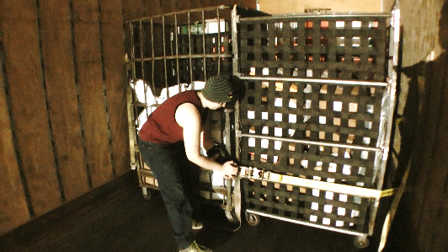 | 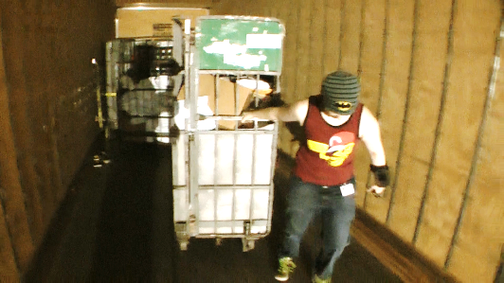
 | 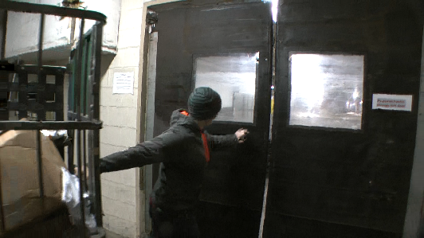 | 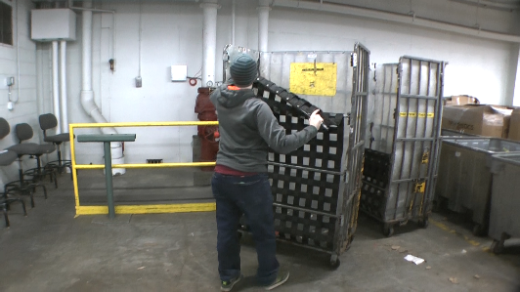

- Upfront  Supply Returns Processors with materials required to process the returned items. Typically, 50% of shift working Upfront and 50% working the Backline. |  |  | 50
- Operate fork truck/stand-up reach truck to move full gaylords from staging area to Returns Processor workstation. | 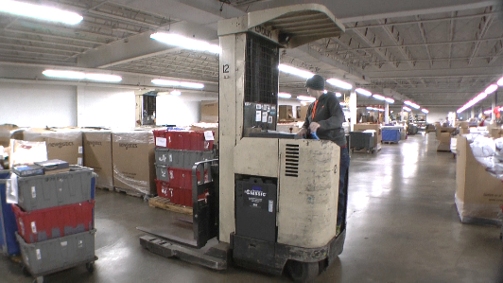 | 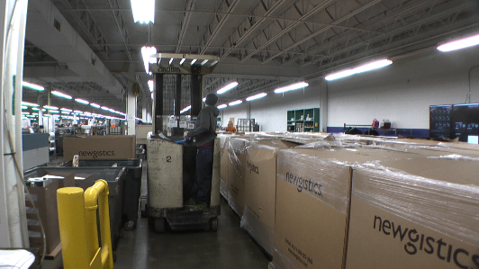
- Prep full gaylord – use safety knife to cut and remove stretch wrap. Cut off flaps and open up side of gaylord. | 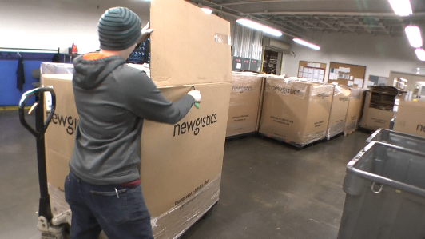 | 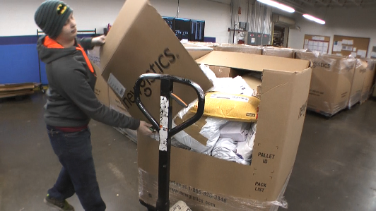
- Operate manual pallet jack to reposition full/empty gaylords at Returns Processor workstation. | 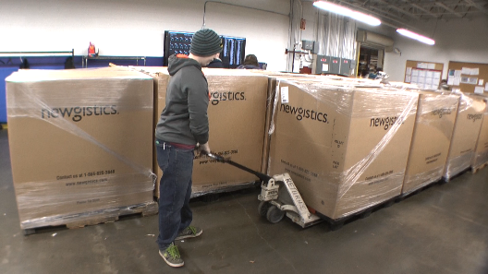 | 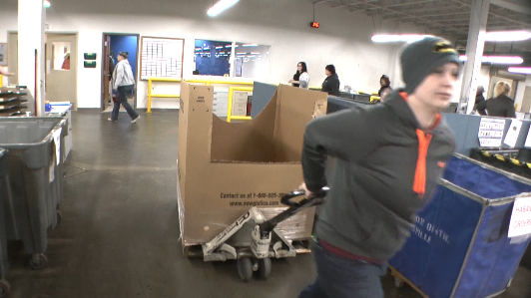
- Use manual pallet jack to move mail carts in the area. | 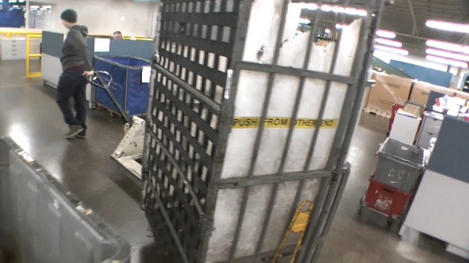
- Remove empty gaylords and breakdown gaylord for recycling. | 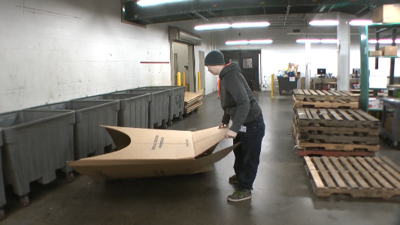 | 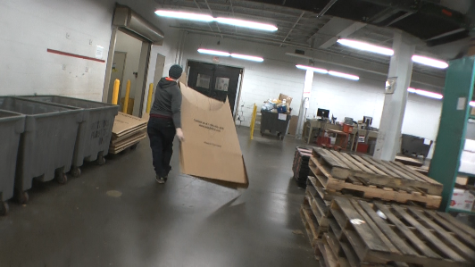
- Stack empty pallets (up to about 12 high), pallet weighs about 25 to 30#. | 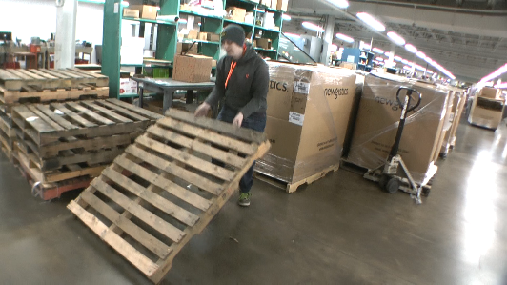 | 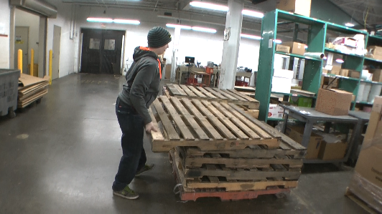
- Handle GOH (goes on hangers) from hanging racks into tubs. Scan one garment (1 to 2#) at a time and place into tub. | 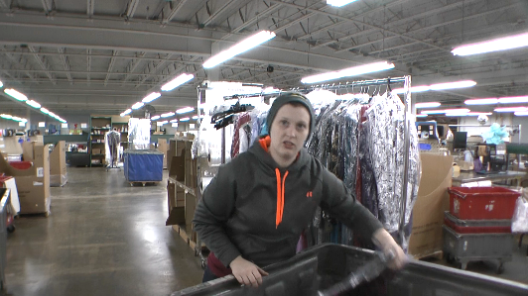
- Handle full tubs – push/pull manually up to 20# force, once materials have been processed by Returns Processors. | 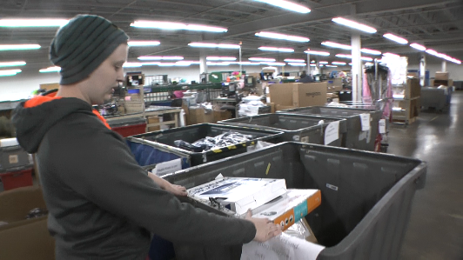
- Bring supplies (tape, boxes) to the Returns Processors workstation. May use a push cart to transport supplies. | 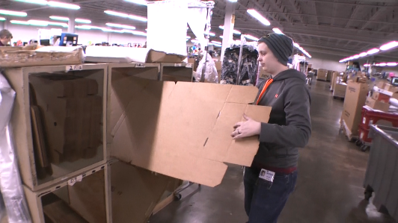 | 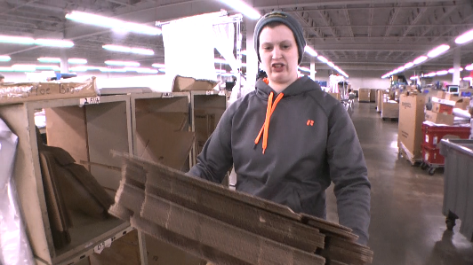
- Will wear a forearm “Wearable” scanner if items need to be scanned. | 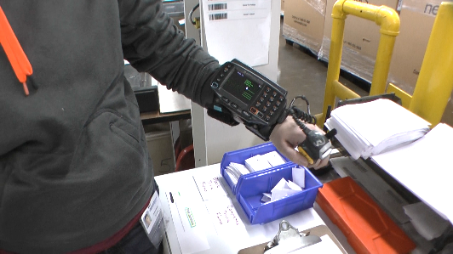
- Backline  “Good stock” accumulates and is staged for return to inventory. Typically, 50% of shift working Upfront and 50% working the Backline. |  |  | 50
- Empty totes (about 2#) are moved from stack on the floor up to roller conveyor (about 20 inches off floor) | 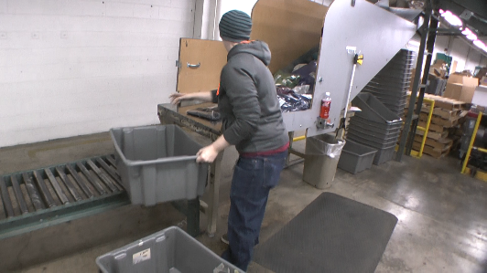
- Items – bagged or boxed, are removed from a dump chute and placed into totes on a roller conveyor. Single items weigh up to a few pounds. | 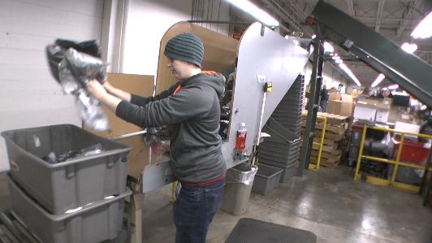 | 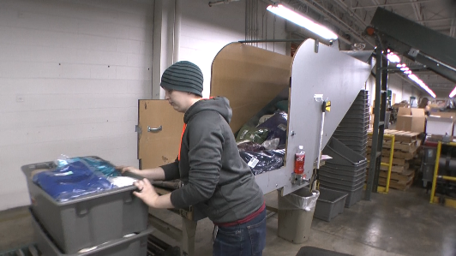
- Full totes (up to 20#) are stacked five totes high onto a box pallet. | 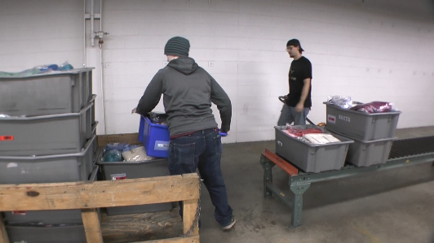 | 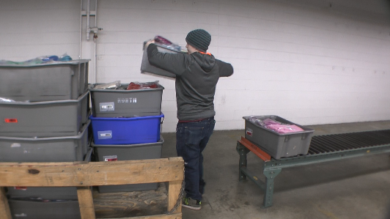
- Operate walkie/rider to move pallet with totes. | 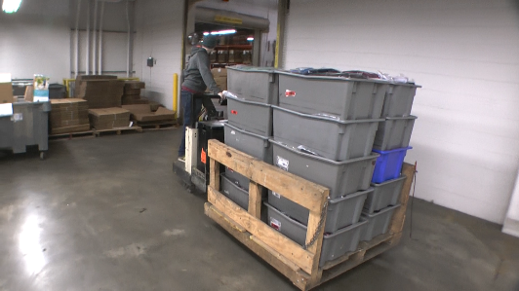
- Uses a pull stick with hook on end to slide stack of totes off of pallet. (up to 20# force needed) and push on floor into position. | 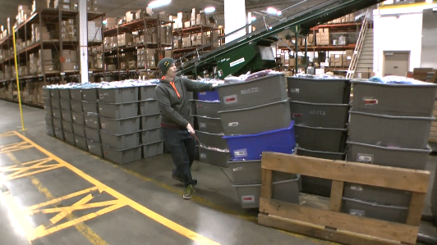 | 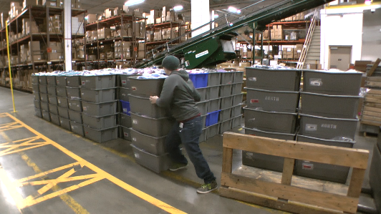

Physical Factors
Manual Material Handling
(lbs) | Floor-Knuckle (0” to 30”) |  |  |  |  |  | Knuckle-Chest (30” to 50’) |  |  |  |  |  | Chest-Overhead  ( > 50”) |  |  |  |  |  | Carry - Two Hands; Front |  |  |  |  |  | Carry - One Hand; Side |  |  |  |  |  | Push |  |  |  |  |  | Pull
100
75
40
25
15
10
5
0
Exp | N | R | O | F | C |  | N | R | O | F | C |  | N | R | O | F | C |  | N | R | O | F | C |  | N | R | O | F | C |  | N | R | O | F | C |  | N | R | O | F | C

Postures/Movements |  |  |  |  |  |  |  |  |  |  |  |  |  |  |  | Head/Neck
Exp | Sit | Stand | Walk | Bal | Stairs | Lad-der | Foot contrl | Twist Waist | Bend Waist | Squat | Kneel | Crawl | Reach below 54” | Reach above 54” |  | Flex Static | Ext Static | Rot Static | Flex Dyn | Ext Dyn | Rot Dyn
C
F
O
R
N

Hand Use |  |  |  |  | Sensory |  |  |  |  |  | Communication |  |  |  |  | Key C - Continuous: 67 to 100% of shift  F - Frequent: 34 to 66% of shift  O - Occasional: 6 to 33% of shift  R - Rarely: up to 5% of shift  N - Never: 0% of shift  Abbreviations: Bal=Bal, Exp=Exposure, Contrl=Control, Flex=Flexion, Ext=Extension, Dyn=Dynamic, Manip=Manipulation
Exp | Simple Grasp | Firm Grasp | Fine Manip | Bal | See | Hear | Touch Feel | Taste | Smell |  | Talk | Read | Write | Hand Signal
C
F
O
R
N

Environmental Factors | Exposure Level |  |  |  |  | Key/Comments
 | N | R | O | F | C
Outdoor Work |  |  |  |  |  | Key C - Continuous: 67 to 100% of shift  F - Frequent: 34 to 66% of shift  O - Occasional: 6 to 33% of shift  R - Rarely: up to 5% of shift  N - Never: 0% of shift  Comments:  Indoor Work: Primary work area is a large indoor warehouse complex.  Moving Objects: Be aware of and avoid moving objects including product and equipment.
Indoor Work
Heat
Cold
Wet/ Humid
Hearing Protection
Vibration
Fumes/Gases/Odors
Dust
Moving Objects
Electrical
Chemical
Protected Work Heights
Unprotected Work Heights
Flying Debris
Lighting (Inadequate/Excessive)

Position eligible to be considered for temporary modification in conjunction with a Return to Work transitional duty program agreement: Yes
This Functional Job Description was completed through an on-site job analysis by a certified professional ergonomist/licensed physical therapist. It is for the purpose of identifying and quantifying the physical functional requirements of this job. The Functional Job Description should not be construed as a detailed description of all specific job duties and/or tools, equipment and materials that may be necessary or incidental to the performance of this job. Further consideration may be necessary when applying the standards to the injured population in the medical management process.
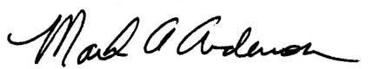 | This Functional Job Description has been reviewed by company representatives and is believed to be an accurate representation of most of the job content.
Mark A Anderson, MA, PT, CPE  Certified Professional Economist  Licensed Physical Therapist  ErgoSystems Consulting Group, Inc.  7421 W Shoreline Dr  Waconia, MN 55387  952-401-9296  mark.anderson@ergosystemsconsulting.com  www.ergosystemsconsulting.com | 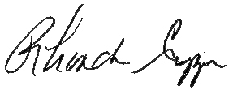  _______________________________________
Rhonda Crippen, Inbound Manager
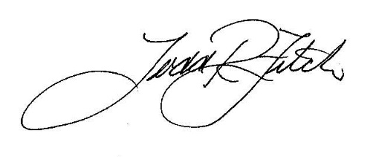
 | _______________________________________
 | Todd Fitch, Facilities Operations Director

