Functional Job Description: Picking

Company: | Bluestem Brands, Inc. | 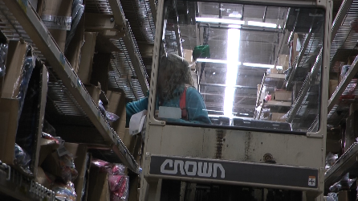
Job Title: | Picking
Date: | 11-13-17
Dept/Facility: | DC, Irvine, PA
Product Section: | Outbound
Electronic Doc. # | FJD Picking FINAL 11-13-17

Work Hours | Overtime: | Voluntary and/or mandatory per production requirements. | Breaks: | (2) 15 minute & (1) 30 minute lunch break
 | Shift: | Days of week: | Time:
 | First | Monday – Friday | 6:00 AM to 2:30 PM or 8:00 AM to 4:30 PM
 | Second | Sunday – Thursday | 9:30 PM to 6:00 AM

Job Rotation | Yes

Job Training or Credentials Required at Hire | Education/ training: | None required; high school diploma or GED preferred.
 | Knowledge/ cognitive skills: | Basic math, reading, writing and oral communication skills preferred. Ability to organize work tasks and work independently or as part of a team.

Machines, Tools and/or Equipment Used | Air Picker – order picker, carts, totes, assignment list, knife. Works from an order picker at elevated heights.  Floor Picker – cart, totes, assignment list, knife. Works from the floor with shelf heights at 6, 24, 40 56 and 72”.

Job Purpose/ Objectives | Fill orders.

Safety and Personal Protective Equipment Required  *Available | Hard Hat | Steel Toe Footwear | Safety Glasses | Gloves:
 | Face Shield  Battery change | Protective Clothing | Safety Glasses/Side Shields | Leather
 | Dust Mask | Safety Vest  Fall Protection  Harness: Air Picker | Safety Goggles  Hearing Protection*  Compensatory methods to mitigate heat | Rubberized/cloth*  Chemical

Safety/ Equipment Training/ Certification Required | Daily Meeting and Stretch Breaks (includes:) | Industrial Truck Training | OSHA Training (Rules and Regulations)
 | - Safety Topics | EZ-Go | New Hire Safety Orientation
 | - Safety Policies | Walkie-Rider | Right to Know
 | - Questions & Answers | Pallet Jack | Lockout/Tag Out
 | - Review Safety Committee Minutes | Forklift | Regulated Materials Training (ORM-D)  Supervisor Safety Updates
 |  | Stand-up Reach Truck
 |  | Order Picker

Functional Job Elements |  |  | % of Shift
- Picker - Air  - Loads cart with totes (three levels on the cart).  - Use order picker to pick product from elevated shelf levels placing items into the totes.  - Maximum weight of 30# with average weight of 5# or less.  - Returns to floor level, moves cart to conveyor and lift totes onto conveyor. | 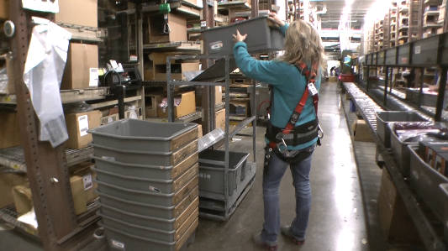 | 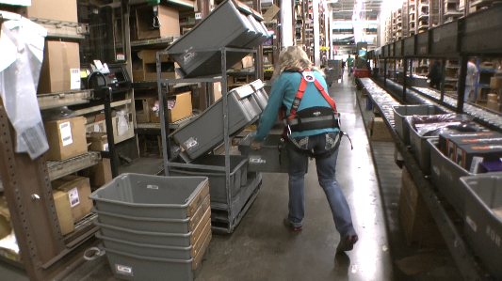 | 0  To 100
 | 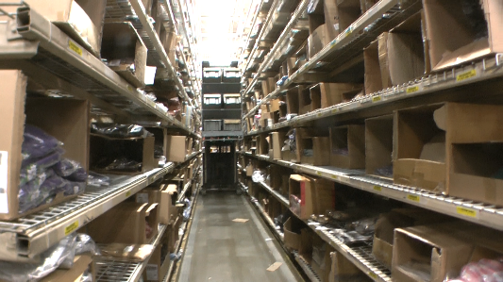 | 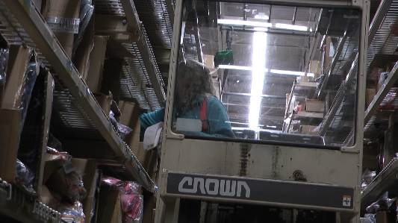
 | 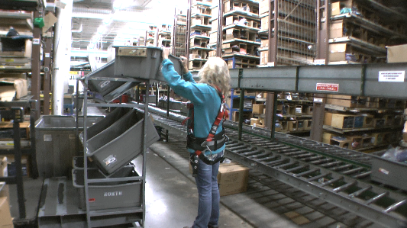 | 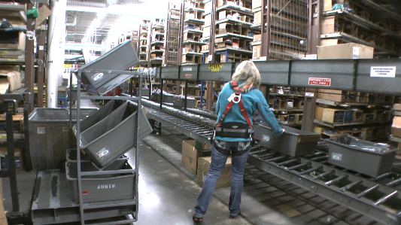
- Picker - Floor  - Preps totes at the conveyor.  - Picks items from floor level from shelf heights ranging from 6 to 72”.  - Maximum weight of 30# with average weight of 5# or less.  - Holds items in arms until arms are full, walks to the conveyor, places items to into the tote and pushes tote onto the conveyor. | 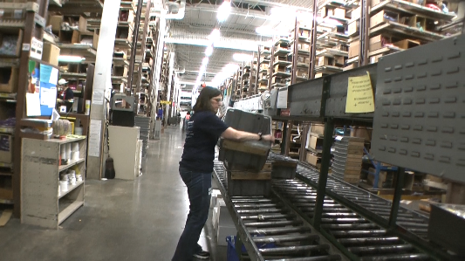 |  | 0  to 100
 | 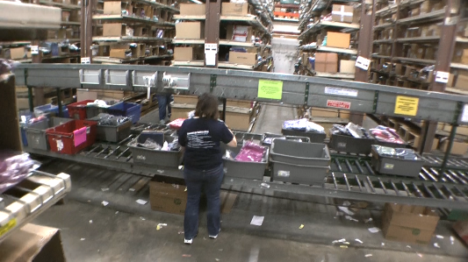 | 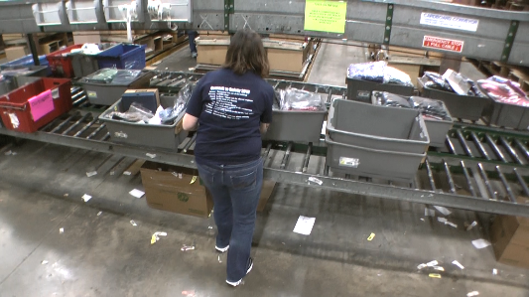

Physical Factors
Manual Material Handling – Air Picker
(lbs) | Floor-Knuckle (0” to 30”) |  |  |  |  |  | Knuckle-Chest (30” to 50’) |  |  |  |  |  | Chest-Overhead  ( > 50”) |  |  |  |  |  | Carry - Two Hands; Front |  |  |  |  |  | Carry - One Hand; Side |  |  |  |  |  | Push |  |  |  |  |  | Pull
100
75
50
30
15
10
5
0
Exp | N | R | O | F | C |  | N | R | O | F | C |  | N | R | O | F | C |  | N | R | O | F | C |  | N | R | O | F | C |  | N | R | O | F | C |  | N | R | O | F | C

Manual Material Handling – Floor Picker
(lbs) | Floor-Knuckle (0” to 30”) |  |  |  |  |  | Knuckle-Chest (30” to 50’) |  |  |  |  |  | Chest-Overhead  ( > 50”) |  |  |  |  |  | Carry - Two Hands; Front |  |  |  |  |  | Carry - One Hand; Side |  |  |  |  |  | Push |  |  |  |  |  | Pull
100
75
50
30
15
10
5
0
Exp | N | R | O | F | C |  | N | R | O | F | C |  | N | R | O | F | C |  | N | R | O | F | C |  | N | R | O | F | C |  | N | R | O | F | C |  | N | R | O | F | C

Postures/Movements – Air Picker |  |  |  |  |  |  |  |  |  |  |  |  |  |  |  | Head/Neck – Air Picker
Exp | Sit | Stand | Walk | Bal | Stairs | Lad-der | Foot contrl | Twist Waist | Bend Waist | Squat | Kneel | Crawl | Reach below 54” | Reach above 54” |  | Flex Static | Ext Static | Rot Static | Flex Dyn | Ext Dyn | Rot Dyn
C
F
O
R
N

Postures/Movements – Floor Picker |  |  |  |  |  |  |  |  |  |  |  |  |  |  |  | Head/Neck – Floor Picker
Exp | Sit | Stand | Walk | Bal | Stairs | Lad-der | Foot contrl | Twist Waist | Bend Waist | Squat | Kneel | Crawl | Reach below 54” | Reach above 54” |  | Flex Static | Ext Static | Rot Static | Flex Dyn | Ext Dyn | Rot Dyn
C
F
O
R
N

Hand Use |  |  |  |  | Sensory |  |  |  |  |  | Communication |  |  |  |  | Key C - Continuous: 67 to 100% of shift  F - Frequent: 34 to 66% of shift  O - Occasional: 6 to 33% of shift  R - Rarely: up to 5% of shift  N - Never: 0% of shift  Abbreviations: Bal=Bal, Exp=Exposure, Contrl=Control, Flex=Flexion, Ext=Extension, Dyn=Dynamic, Manip=Manipulation
Exp | Simple Grasp | Firm Grasp | Fine Manip | Bal | See | Hear | Touch Feel | Taste | Smell |  | Talk | Read | Write | Hand Signal
C
F
O
R
N

Environmental Factors | Exposure Level |  |  |  |  | Key/Comments
 | N | R | O | F | C
Outdoor Work |  |  |  |  |  | Key C - Continuous: 67 to 100% of shift  F - Frequent: 34 to 66% of shift  O - Occasional: 6 to 33% of shift  R - Rarely: up to 5% of shift  N - Never: 0% of shift  Comments:  Indoor Work: Primary work area is a large indoor warehouse complex.  Moving Objects: Be aware of and avoid moving objects including product and equipment.
Indoor Work
Heat
Cold
Wet/ Humid
Hearing Protection
Vibration
Fumes/Gases/Odors
Dust
Moving Objects
Electrical
Chemical
Protected Work Heights (Air Picker)
Unprotected Work Heights (air pick)
Flying Debris
Lighting (Inadequate/Excessive)

Position eligible to be considered for temporary modification in conjunction with a Return to Work transitional duty program agreement: Yes
This Functional Job Description was completed through an on-site job analysis by a certified professional ergonomist/licensed physical therapist. It is for the purpose of identifying and quantifying the physical functional requirements of this job. The Functional Job Description should not be construed as a detailed description of all specific job duties and/or tools, equipment and materials that may be necessary or incidental to the performance of this job. Further consideration may be necessary when applying the standards to the injured population in the medical management process.
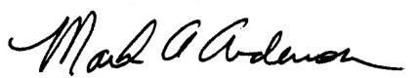 | This Functional Job Description has been reviewed by company representatives and is believed to be an accurate representation of most of the job content.
Mark A Anderson, MA, PT, CPE  Certified Professional Economist  Licensed Physical Therapist  ErgoSystems Consulting Group, Inc.  7421 W Shoreline Dr  Waconia, MN 55387  952-401-9296  mark.anderson@ergosystemsconsulting.com  www.ergosystemsconsulting.com | 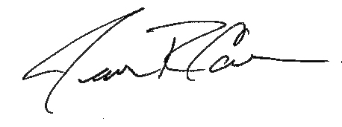  ___________________________________
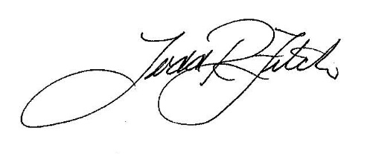
James Cowan, Production Manager

 | _______________________________________
 | Todd Fitch, Facilities Operations Director

